Performance evaluation of a novel multi-metal catalyst obtained from E-waste on oil upgrading and enhanced recovery
Kimia Faryadi, Arezou Jafari, Seyyed Mohammad Mousavi
Chemical Engineering Faculty, Tarbiat Modares University, Tehran, Iran
Abstract
Because of the high cost and high emissions of CO₂ associated with thermal methods, this study focuses on upgrading heavy oil and thereby enhancing oil recovery at reservoir temperatures. In this research, novel, low-cost, and environmentally friendly bioleaching metals extracted from E-waste are used as a multi-metal catalyst instead of the other catalysts that are usually expensive. Due to the interaction between temperature, time, and volume percentage of the multi-metal catalyst at optimum conditions: including 80 ° C, 12 h, and 0.288 Vol% of the multi-metal catalyst, the viscosity of heavy oil reduced from 687.2 to 580 mPa.s. The FTIR analysis of heavy oil before and after the process indicates that the multi-metal catalysts reduced the number of aromatic compounds, made hydrocarbon chains shorter, and reduced double and triple bonds. Micromodel tests were conducted by multi-metal catalyst at optimum temperature and time obtained from static experiments. Those showed an acceptable effect in enhanced oil recovery. Heavy oil recovery was 38% by catalyst flooding at optimum temperature and retention time. Oil recovery was increased by 10.5% in comparison to deionized water injection. Measurement of the contact angle of rock after contact with a multi-metal catalyst showed that our novel catalyst reduced the contact angle by 55 ° and changed the wettability of carbonate rock from oil-wet to water-wet. The absorption test of the multi-metal catalyst indicated that metals dissolve the rock partially due to the high pH of the multi-metal catalyst. So rock permeability may be increased due to the dissolution of the rock metals. The low cost and low damage by applying bioleaching metals extracted E-waste as a multi-metal catalyst make it a great way to enhance oil recovery for reservoirs that cannot use thermal methods extensively.

Keywords: Enhanced oil recovery; In- situ upgrading; Multi- metal catalyst; Heavy oil; Viscosity

- Introduction
According to a recent projection by the U.S Energy Information Administration (EIA), the world's energy demand will reach 8.6 ×${10}^{6}$ joules per annum by 2040. Not standing the increase in the growth of renewable energy, fossil fuel will still form 77% of energy consumption in 2040[1]. Today the rapid depletion of conventional oil sources leads global attention to unconventional reservoirs, such as bitumen, and heavy and extra-heavy oil. Heavy and extra-heavy oil reservoirs form 70% of the world's total oil reservoirs, and exploration and production from these reservoirs are essential[2]. Because of the heavy oil properties such as high viscosity, high H/C ratio, and high amount of heteroatom, the production of heavy oil reservoirs has faced many challenges[3]. The key mechanism for heavy oil recovery is viscosity reduction. Viscosity reduction improves oil mobility. Due to the dependence of viscosity on temperature, various methods including external energy sources are used to heat the oil[4]. Cyclic Steam Stimulation (CSS), steam flooding, Steam-Assisted Gravity Drainage (SAGD), and In-Situ Combustion (ISC) are effective thermal methods. The most commonly applied method of all these techniques is steam injection. Steam production is associated with high production of CO₂, which is not environmentally friendly. On the other hand, the high cost of production and injection of steam as a heat source reduces the profits in such processes[5]. In-situ upgrading heavy oil by the catalyst is one potential technology that reduces the environmental footprint of thermal methods and improves the quality of produced oil cost-effectively. In the catalytic process, long-chain hydrocarbons decompose into lighter fractions with smaller molecular weights, which cause viscosity reduction and mobility improvement to produce heavy oils[6-15].
So we look for a method to eliminate the external heat source by using a catalyst for oil upgrading and enhanced oil recovery. Research is being concentrated on the discovery of cheap, highly efficient, stable, and environmentally friendly catalysts at laboratory and field scales. Usually, catalysts for enhancing the recovery of heavy oil and bitumen can be categorized as (1) water-soluble catalysts[16-19], (2) oil-soluble catalysts[20-23], (3) amphiphilic catalysts[24-28], (4) minerals and zeolites[29-31], (5) dispersed NPs[14, 32-39]. Metals have been used as catalysts in most research in the catalytic upgrading of heavy oil. Rivas et al. found Ni (II) and Co (II) salts beneficial in aquathermolysis[40]. Clark et al. studied the impact of Al(III), first-row transition metal including Sr(III), VO(II), Cr(III), Ni(II), and Cu(II) and Group VIIIB metal including Fe(II), Co(II), Ni(II), Rh (III), Os(III), Ir(III), Ru(III), Pt(II) and Pt(IV) salts on aquathermolysis of thiophene and tetrahydrothiophene as an organosulfur molecular in heavy oils[18, 19]. They found out that Al (III) and first-row metal species and Pt (IV) in Group VIIIB have an impact on sulfur content reduction. They break the C-S bond and thus reduce molecular weight. Some of the metal catalysts are solved in oil called oil-soluble catalysts. Experimental results show that various oil-soluble forms of Ni (II), Co (II), Fe (II), and Fe (III) catalysts with various hydrogen donors such as tetralin, formamide, and formic acid have also performed significant efficiency in the reduction of heavy oil viscosity[23, 41-43]. Nanoparticles are made of metals on the nanoscale. Hashemi et al. studied micro-emulsions including trimetallic (W, Ni, and Mo) nanoparticles for oil upgrading[34]. Based on the research, most of the catalysts used in the oil upgrading process are heavy metals. Therefore, it is valuable to consider metals extracted from wastes, and evaluate their performance as an environmentally friendly catalyst.
According to the unprecedented growth of the electrical and electronics industries in recent decades, the generation of electrical and electronic waste is an inevitable fact. Developed and developing countries are the main producers of electronic waste. Europe and the United States are the largest generators of electrical waste. However, China, Eastern European countries, and Latin America are also becoming major producers of electrical waste[44]. The utilization of Electrical and Electronic Equipment (EEE) is strongly related to Extensive global economic growth. EEE has become necessary in the modern lifestyle. So its production and usage need more sources. Growing urbanization and industrialization cause the world to develop EEE. On average, the total weight (excluding photovoltaic panels) of global EEE usage increases annually by 2.5 million metric tons (Mt). After consumption, EEE is thrown away which generates a waste stream containing perilous and valuable materials. This waste stream is known as E-waste or Waste Electrical and Electronic Equipment (WEEE). Global E-waste production was almost 53.6 million tonnes (Mt) in 2019[45] or an average of 7.3 kg per capita[46]. Global E-waste production has increased by 9.2 Mt since 2014 and is forecasted to grow to 74.7 Mt by 2030. Asia produced 24.9 Mt of E-waste, the maximum amount in 2019. The United States with 13.1 Mt and Europe with 12 Mt are ranked 2nd and 3rd in waste generation, respectively. While Africa and Oceania generated 2.9 Mt and 0.7 Mt, respectively[45]. The disposal of generated waste worldwide is worrying. The best way to manage this waste is recycling. The chemical composition of electrical and electronic equipment waste is very heterogeneous according to the type of equipment, year of manufacture, manufacturer, country of manufacture, and other factors. Polymers, ceramics, and metals can be recycled from electronic waste. The existence of various metals has caused these wastes to be valuable economically. These metals exist in E-waste purely or alloys in different compositions and amounts. Printed circuit boards existing in all different types of electronic equipment are important. Because they are rich in copper and precious metals such as gold, silver, and palladium. For example, a cell phone contains large amounts of gold (24 mg), silver (250 mg), and palladium (9 mg)[47]. There are over 69 elements of Mendeleev table in e-waste such as gold, silver, copper, platinum, palladium, ruthenium, rhodium, iridium, osmium, cobalt, palladium, indium, germanium, bismuth, antimony and noncritical metals such as aluminum and iron. Countries could reduce their material requirement safely and stably by recycling e-waste[45]. There is a high amount of base metals (e.g. gold) in special devices such as cell phones and PCs for example 280 grams per ton of E-waste. Separating and recycling E-waste can be affordable. Especially if it’s manually, the material losses will be less than 5%[48]. Precious metals such as gold, silver, and nickel in E-waste make their recycling more economical and logical. As they are called artificial or secondary ores because they are richer than natural ores[49]. Therefore, E-waste recycling is very important because of management and economic importance. It is worth noting that the metals extracted from E-waste can be applied as the catalyst, and till now there is not any research about the performance of environmentally friendly catalysts on in situ heavy oil upgrading and enhanced oil recovery.
There are several technologies for extracting metals from industrial wastes, including pyrometallurgy, Hydrometallurgy, and biohydrometallurgy. The active participation of microorganisms in geochemical processes has developed technological processes called biohydrometallurgy. These processes are based on chemical or physical interactions between the micro-organisms, side products, and their substance. One of these processes is bioleaching. The bioleaching process involves the dissolving of metals from inorganic sources (such as minerals) using microorganisms[50]. Bioleaching takes place when certain organisms, like bacteria, extract metals from a source[51]. In other words, the conversion of solid metals to their soluble form by microorganisms is called bioleaching. The use of this method has been considered in recent decades. The bioleaching method has many advantages including ease to use, high safety, lack of environmental side effects, and low costs[52, 53]. The extracted metals are soluble. So one part of the recycling process is the method of extracting precious metals and another discussion is finding a way to use these soluble metals. So this study has found an effective method for the use of metals obtained from Bioleaching. As mentioned earlier, most of the catalysts used in the in-situ heavy oils upgrading are metals. Therefore in this study catalytic role of metals extracted from E-waste by bioleaching in in-situ upgrading of heavy oil and also enhanced oil recovery at reservoir temperature has been investigated. In addition, catalyst displacement in the porous medium, and the effect of the catalyst on wettability and adsorption on the rock have been investigated.
- Materials and Methods
The heavy oil feedstock used in this study has been collected from Iranian carbonate fields. The density and viscosity at 25$℃$ are 0.892 $\frac{g}{{cm}^{3}}$ and 687.2 mPa.s, respectively. The rate of viscosity reduction is calculated by the method Δη= ((η0−η)/η0) ×100%, where Δη (%) is the rate of viscosity reduction, η0 (mPa.s) is primary oil viscosity and η (mPa.s) is oil viscosity after the reaction.
2.1 Catalyst Preparation
First, the E-waste was collected and cut into small pieces (1 cm ×1 cm) with a cutter. Then, a micronizer was used to reduce the E-waste size. So the powder was sieved through the #200 mesh to obtain a powder particle with a size of fewer than 75 μm. There are different bacteria to use according to source and extracted metals The two main functions of these bacteria are the oxidation of ${Fe }^{+2}$ to ${Fe }^{+3}$and S to$H_{2}{SO}_{4}$, which are involved in bioleaching[54]. In this work acidophilic bacteria were used. The culture medium is 9K medium containing 3g of ${({NH}_{4})}_{2}{SO}_{4}$, 0.5 g of $K_{2}{HPO}_{4}$, 0.5 g of ${MgSO}_{4}.7H_{2}O$, 0.1 g of $KCl$, 0.01 g of ${Ca({NO}_{3})}_{2}$and 44.22 g of ${FeSO}_{4}.7H_{2}O$ in 1 L of distilled water. ${FeSO}_{4}.7H_{2}O$ is the energy source for bacteria growth and activity. The pH was adjusted by using 98%sulfuric acid. For bacteria adaptation, some bacteria were added to the Erlenmeyer flask including 100 mL of the medium, and incubated at 160 rpm in a shaker incubator (Wise Cube; South Korea) at 29- 30 °C[54-56]. For bioleaching, the main source of Fe is in the culture medium with a concentration of 0.3 – 16 g/L. Bacteria oxidize ${Fe}^{+2}$ and produce ${Fe}^{+3}$. Ferric ion is also a strong oxidizing agent and can dissolve metals (M) in water called bioleaching solution. The production from ${Fe}^{+3}$from oxidization of ${Fe}^{+2}$ is shown in the following reactions[53]. The reduction of ${Fe}^{+3}$ to ${Fe}^{+2}$ in the culture medium supplies energy to continue this ${Fe}^{+2}$-bacteria-${Fe}^{+3}$ cycle[57].
${2Fe}^{2+}+H^{+}+0.5 O_{2}⇌{2Fe}^{3+}+H_{2}O$ (1)
$M^{0}+ {2Fe}^{3+}⇌{Me}^{2+}+ {2Fe}^{2+}$ (2)
ICP-OES (Vista-pro; Varian; Australia) was used to measure the concentration of metals in the bioleaching solution. So this solution contains culture medium, bacterial metabolites, remaining bacteria, and extracted metals which are used as multi-metal catalysts. Therefore, to prevent the growth of fungi and bacteria, the multi-metal catalyst is kept in the refrigerator. Settled metals dissolve by stirring.
- Experimental Procedure
3.1 Heavy Oil Upgrading Experiments
All the experiments were conducted by adding the catalyst in the designed mass concentration to 40 g oil in reusable bottles and caps (Made of Duran borosilicate glass, type 3.3, for maximum chemical and thermal shock resistance). The sealed bottles have been heated in the oven. After the designated time was finished, the heating was stopped. Next, the mixture was cooled to be analyzed. The viscosity measurement of the oil samples before and after the reaction was conducted on Aton Paar Rheometer at 25$℃$, and the changes of crude oil before and after the reaction were characterized by FT‐IR.
All the experiments were carried out in an average reservoir temperature range. The range of the most reservoir temperature in the world is 60 to 100$℃$[58] and this temperature range has been considered for experiments. Preliminary studies have been conducted for choosing the amount of catalyst. According to the results, 0.2 to 1 volume percent has been selected. These kinds of research have been conducted in 24 to 36 hours. To see more details retention time was considered in 6 to 72 hours[9, 25, 26, 28]. Design of experiment (DOE) was used to design experiment conditions. The design of experiments is defined as a branch of applied statistics that deals with planning, conducting, analyzing, and interpreting controlled tests to evaluate the factors that control the value of a parameter or group of parameters. DOE is a powerful data collection and analysis tool that can be used in a variety of experimental situations. It saves cost by minimizing process variation and reducing rework and balances uncontrollable condition effects, decreases systematic errors, and increases the possibility of getting impartial and repeatable results by randomization. In addition, it also prepares optimal test conditions for considered responses[59]. In this research, the experimental design was performed by the Central Composite Design method (CCD). Table 1 shows the experimental conditions and the independent variables.
Table 1 Design of experiments: factors and levels for CCD designs
Factors | Unit | Low level | High level
Catalyst | %Vol | 0.2 | 1
Reservoir Temperature | $℃$ | 60 | 100
Retention Time | hour | 6 | 72

A series of tests presented in table 4 is designed by the Central Composite Design method (CCD) to investigate the effect of these factors on heavy oil viscosity.
  - Oil Displacement by Catalyst Injection
Micromodels are two-dimensional simplified porous mediums as a replacement for cores using fluid flow studies in porous media. Micromodel experiments are performed to observe the direction of fluid flow in a porous medium. The advantage of this model in comparison with cores obtained from drilling is the ability to observe the fluid's displacement which leads to preparing the best models for fluid flow in porous media. Many researchers conducted studies using micromodels[60-62]. In this study, a micromodel has been used to investigate the performance of the multi-metal catalyst in enhanced oil recovery.
A heterogeneous five-spot glass micromodel has been used to study the catalyst effect on oil displacement and calculate the oil recovery[63]. The micromodel is designed according to one of the Iranian carbonate reservoirs. The micromodel’s properties are given in table 2.
Table 2. Micromodel’s properties
Properties | Values
Porosity (%) | 38
Pore Volume (%) | 0.4
Permeability (md) | 890

Because the glasses are strongly water wet, it’s necessary to make them oil wet. So before each flooding test, the following steps are conducted[64]:
- Micromodel is saturated with sodium hydroxide solution for 1 hour.
- The micromodel is washed with distilled water and put in an oven at 200$℃$ for 30 minutes
- The micromodel is saturated by the mixture of TCMS (2%) and toluene (98%) for 3-5 minutes.
- For washing the micromodel, methanol is injected. Next, to evaporate methanol it is placed into the oven at 100$℃$.
After making the micromodel oil wet, it was saturated with heavy oil with a constant flow rate of 3 ml/h. Then the multi-metal catalyst was injected into the micromodel at the rate of 0.05 ml/h. During the injection, photos were taken every 60 seconds with a digital microscopic lens camera and the amount of oil recovery was calculated by computer image processing.
  - Catalyst-Rock Interaction
Optimal temperature and time conditions are used to investigate the adsorption of catalysts on the rock. 1 gram of powdered rock in the size of 200 to 300 microns is mixed with 10 cc of the multi-metal catalyst solution and is placed at the optimum temperature in the oven for optimal retention time. In the end, the catalyst is separated from the powdered rock by using filter paper and finally subjected to ICP analysis. The differences in metal concentrations between the primary multi-metal catalyst and after the test indicate metal adsorption on the oil-wet rock.
  - Wettability Measurement
In this study to measure the wettability of the rock the contact angle method has been used. The system for implementation of this process has been shown in figure 1. One of the usual methods of contact angle measurement is the sessile-drop technique that is used to calculate the contact angle in this study. To measure the contact angle the prepared sample is placed in a measuring chamber containing deionized water. In this system, the contact between the rock surface and the liquid environment is downwards. According to figure1 the drop oil is injected slowly and sticks to the rock surface, and microscopic images are captured with a high-resolution camera. The left and right angles of the drop are measured by Image J software and the average angles are reported.
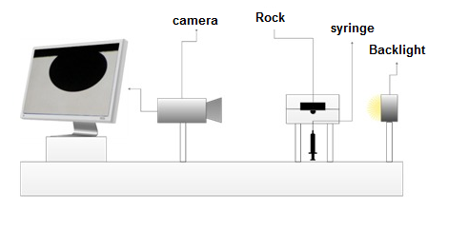
Figure1. Schematic of the system for measuring the contact angle

First, the oil contact angle on the rock is measured in the environment of deionized water. Then the rock-thin section is placed in 20 cc of multi-metal catalyst at the optimal time and temperature. Next, the rock-thin section is separated from the catalyst, and the oil contact angle is measured in the environment of deionized water. To interpret the results coming from the micromodels the glass type used to build the micromodel is made oil-wet and the process of measurement of contact angle is repeated for the oil-wet glass thin section.
- Results and Discussion
4.1 Characterization of Multi-Metal Catalyst and Rock
Metals concentration of bioleaching solution extracted from electronic waste is shown in table 3. The highest metal concentration in the bioleaching solution is copper.
Table 3. Metals concentration of bioleaching solution extracted electronic waste
lmg/l | metal | lmg/l | metal | /lmg/l | metal
0.28 | Dy | 0.73 | Si | 916.9 | Cu
0.22 | Au | 0.61 | Pr | 395.7 | K
0.2 | Fe | 0.6 | Ag | 107.5 | P
0.19 | Pd | 0.48 | Sn | 54.4 | Na
0.19 | Ba | 0.1 | Mn | 30.1 | Zn
<0.01 | Ga | 0.05 | Co | 5.95 | Ni
<0.01 | In | 0.46 | Al | 3.27 | Mg
<0.01 | Cr | 0.43 | Bi | 3.26 | Ca
<0.01 | Sr | 0.42 | Nd | 0.85 | Ce
According to figure 2, the rock mainly contains calcium carbonate so it is carbonate rock. Very small peaks are seen in figure 2 representing the rare metals within the calcium carbonate rock.
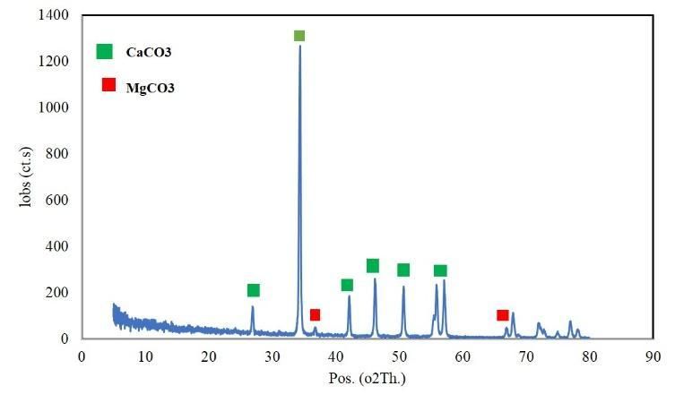
Figure 2. XRD patterns of calcium carbonate samples.
4.2 Analysis of Viscosity
One of the most important signs of oil upgrading is viscosity reduction. So the oil viscosity is measured after all designed experiments (Table 4).

Table 4 Results of designed experiments
Run | Catalyst (%Vol) | Reservoir Temperature ($℃$) | Retention Time (hour) | Rate of viscosity reduction Δη (%)
1 | 0.2 | 80 | 39 | 2.56
2 | 0.4 | 90 | 55.5 | 2.08
3 | 0.4 | 90 | 22.5 | 4.53
4 | 0.4 | 70 | 22.5 | 10.20
5 | 0.4 | 70 | 55.5 | -35.35
6 | 0.6 | 80 | 6 | 3.47
7 | 0.6 | 100 | 39 | -31.24
8 | 0.6 | 80 | 39 | 9.10
9 | 0.6 | 80 | 39 | 8.22
10 | 0.6 | 80 | 72 | 4.10
11 | 0.6 | 80 | 39 | 10.13
12 | 0.6 | 80 | 39 | 9.27
13 | 0.6 | 60 | 39 | 4.66
14 | 0.8 | 70 | 22.5 | 9.05
15 | 0.8 | 70 | 55.5 | 4.66
16 | 0.8 | 90 | 22.5 | 10.52
17 | 0.8 | 90 | 55.5 | 1.62
18 | 1 | 80 | 39 | 8.05

Negative numbers in the viscosity reduction column in table 4 indicate an increase in viscosity because of interaction between 55.5 hours, 70 ℃, and 0.4 %Vol Catalyst. Test 16 has the most viscosity reduction because of interaction between 22.5 hours, 90(℃), and 0.8 %Vol catalyst.
Also, Figure 3 shows the oil viscosity changes according to each parameter separately. As shown in Figure 3 there is an optimum value for the temperature and volume percentage of the catalyst. But for the time there is no optimum value. It means when time increases, oil viscosity increases. But in fact, these three parameters interact with each other and the effect of these three parameters at the same time leads to acceptable results.

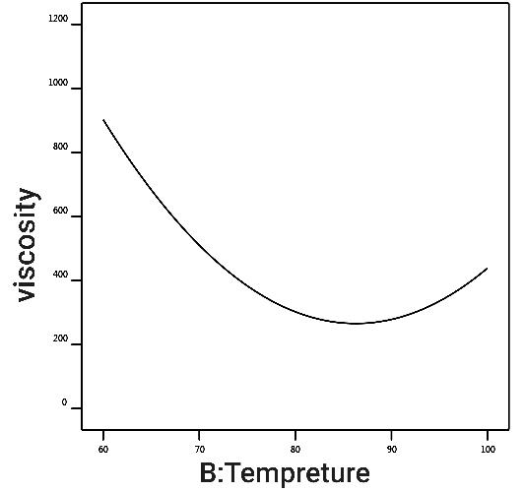
(a)
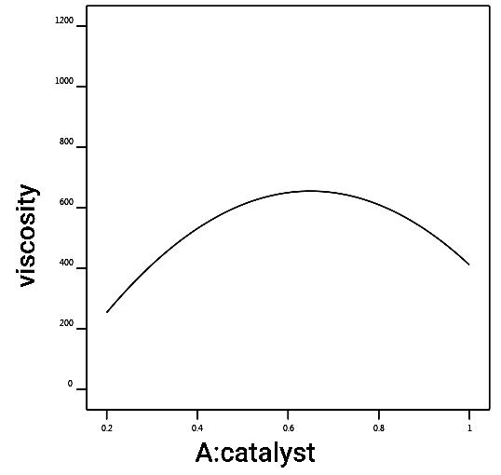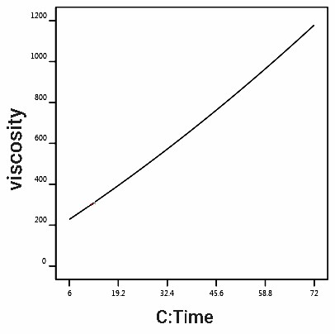
(b) (c)
Figure 3 The effect of each parameter on oil viscosity. a) Temperature. b) volume percentage of the multi-metal catalyst. c) Retention time

The considered parameters should have their optimum condition to effect viscosity reduction in the best way. Optimum conditions have been defined by the most viscosity reduction. These conditions have been achieved with a confidence level of 95% by the CCD method with DOE software. The other analyses for upgrading have been conducted at the optimum conditions. A confirmation test has been conducted at optimum conditions. ∆ μ is the amount of viscosity alteration after the confirmation test and Δη (%) is the rate of viscosity reduction (table 5).

Table 5. The optimal condition obtained by experiments
Catalyst (%Vol) | Temperature ($℃$) | Time (hr) | Original viscosity  (mPa.s) | Predicted Viscosity After Test (mPa.s) | Real Viscosity After Test (mPa.s) | $∆μ$(cp) | Δη (%) at 25$℃$
0.228 | 80 | 12 | 687.2 | 564.022 | 580 | 107.2 | 15.60

4.3 Characterization of Oil Composition
FTIR analyses of oil samples have been conducted before and after the test in optimal conditions. The purpose of FTIR analyses is an investigation of the change in bonds and compounds in crude oil due to upgrading. FTIR spectroscopic analyses show that the multi-metal catalyst has reformed some of the bonds.

Figure 4. The FTIR spectra of the heavy oil before and after upgrading
In the FTIR spectrum graph, the 2500–3700 cm−1 interval is called the Hydrogen Stretching Zone because the vibration frequencies of $N-H$, $N-H$, and $O-H$ appear in this region. The 2000–2300 cm−1 range refers to the Triple Bond Stretching Region because $C≡C$and $C≡N$bonds appear in this area. The 1600–2000 cm−1 interval is known as the Double Bond Stretching Region, because the bonds $C=C$, $C=N$and $C=O$ have existed in this region. The 1000–1600 cm−1 range is called the Fingerprint Region because various bonds such as$C-C$, $C-N$, $C-O$(single bonds), C-H bending bonds, and some benzene ring bonds determining functional groups are located in this area. The last range, 400–1000 cm−1 refers to the aromatic region[65-67]. The peak frequencies of 2926 ± 10 cm−1 and 2850 ± 10 cm−1 refer to the CH2 asymmetric bond and the CH2 symmetric bond, respectively. The CH3 asymmetric bond and CH3 symmetric bond exist at 2962 ± 10 cm−1 and 2872 ± 10 cm−1, respectively. In the fingerprint area, a couple of peak of the CH2 scissor bond is placed at 1455 ± 10 cm−1, the CH3 umbrella bond exists at 1375 ± 10 cm−1, and the CH2 rock bond exists at a frequency of 720 ± 10 cm−1. An increase in the intensity of the CH2 symmetric band, CH3 symmetric band, CH2 scissors mode, CH3 umbrella bond, and CH2 rock mode means an increase in alkane chain concentration in the sample. According to figure 4, due to the performance of the multi-metal catalyst, the intensities of the CH2 symmetric ، CH3 symmetric peaks have increased, which means an increase in the alkane chain in the oil. In other words, triple or double bonds have been reduced to single bonds, which is one of the aspects of oil upgrading. An increase of CH3 peak intensity more than the CH2 peak indicates that the oil sample is lighter[68]. As mentioned earlier, the 400–1000 cm−1 range indicates aromatic compounds. According to the FTIR spectroscopic analysis, the intensity of these peaks in the upgraded oil decreases which means a reduction in aromatic compounds. Because asphaltene contains aromatic compounds, reducing the intensity of these peaks in the upgraded oil means reducing the amount of asphaltene. The peak intensity of CH3 is more than CH2 in figure 4 which indicates the oil sample is lighter too[68]. Table 6 shows the ratio of CH2 scissors to CH3 umbrella and the ratio of CH2 asymmetric to CH3 asymmetric. These two ratios represent the average size of molecules and the number of carbons in their molecular chain. Reducing these ratios indicates a reduction in the number of carbons and a shorter carbon chain[69]. According to the figures and table 6 after the optimum experiment, both ratios are decreased indicating the carbon chain is shorter. It means an increase in light compounds due to the breaking and upgrading of crude oil.
Table 6. The ratio of CH2 scissor to CH3 umbrella and the ratio CH2 asymmetric to CH3 asymmetric for crude oil and upgraded oil
CH2 scissor/ CH3 umbrella | CH2 asymmetric / CH3 asymmetric | Oil sample
0.94 | 1.00 | Crude oil
0.87 | 0.98 | Upgraded oil

Therefore, the multi-metal catalysts reduce the number of aromatic compounds, make hydrocarbon chains shorter, and reduce double and triple bonds.
4.4 Analysis of Micromodel Flooding
Micromodel tests were conducted at optimal temperature and retention time obtained by static experiments. In the first scenario the multi-metal catalyst was injected until the breakthrough time in the first step; after keeping the micromodel at optimal temperature and time. Next, the multi-metal catalyst was injected again to remove the upgraded oil. In the second scenario, the initial injection is done with deionized water until breakthrough time. After that, the multi-metal catalyst is injected. Then, the micromodel is kept at optimal retention time and temperature. After the retention time, the catalyst is injected again. As shown in figure 5, the injection of the multi-metal catalyst caused the flow to be more steady and made the breakthrough longer. So the injected fluid improves sweep efficiency. As a result, the fluid moves more piston-like. By contrast, water flooding lets a greater volume of oil remain in the porous medium and the fingering phenomenon becomes more obvious, and also lateral diffusion is decreased. Therefore breakthrough of multi-metal catalyst injection happens later than water injection. Oil recovery of multi-metal catalyst is more than the oil recovery of water injection consequently. Oil recovery is 33.27% and 22.3% at the breakthrough time for multi-metal catalyst and water injection respectively. The results have been shown in figure 6 and table 7.
The observed phenomena in the microscopic images in figure 5 contain wettability alteration, emulsion formation (water-in-oil), and large emulsion drops. In contrast to water flooding, multi-metal catalyst flooding can reduce the oil layer thickness on the wall of pores causing wettability alteration to approach water-wet conditions.
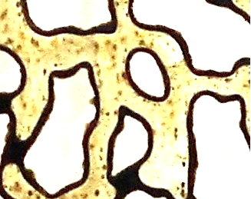

(a)
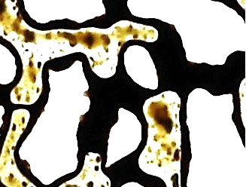
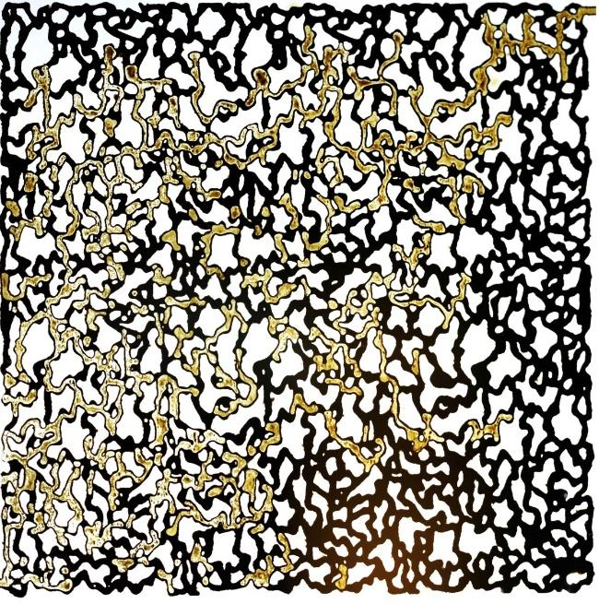

(b)
Figure 5. Macroscopic and microscopic oil displacement at the breakthrough time: (a) multi-metal catalyst flooding (b) deionized water flooding

Figure 6. Oil recovery versus pore volume of injected fluid

Table7. Micromodel flooding results
Water flooding | Multi-metal catalyst flooding | Factor
0.54 | 0.72 | Breakthrough time (PV)
185 | 249 | Breakthrough time (minute)
22.3 | 33.27 | Oil recovery at the breakthrough time (%)
27.5 | 38 | Oil recovery after applying the optimum temperature and retention time (%)

4.5 Effect of Multi-Metal Catalyst on Wettability Alteration
In general, the pressure decreases after the breakthrough so the displacement mechanism occurs due to capillary forces, and this phenomenon changes the water and oil saturation. When heavy oil is in a static state, asphaltene molecules produce viscous structures by self-aggregation and physical interaction with the porous medium. To break these viscous structures and move through heavy oil some force is needed. But the motive force at both ends of the micromodel or reservoir is insignificant and oil displacement cannot break these structures alone. While the main mechanism is capillary force, if the system is water-wet, it can provide the energy needed to break down viscous structures[70]. Therefore, one of the factors to increase recovery is making rock water-wet. The contact angle is a quantity to express the wettability of a solid surface by a liquid. Depending on whether the angle is smaller or larger than 90$℃$, the solid surface is water-wet or oil wet respectively[71]. Then, to investigate the wettability alteration of the rock by the multi-metal catalyst, an oil-wet rock thin section was placed in the multi-metal catalyst at the optimum temperature and time conditions obtained in static testing. So that the surface of the rock thin section is completely covered by the catalyst. The first average contact angle of the initial oil-wet rock was 138.7$°$. Then after covering the rock with the catalyst, the average contact angle was 83.6$°$. Measurement of the contact angle of rock after contact with a multi-metal catalyst shows that this multi-metal solution extracted from E-waste reduces the contact angle and changes the wettability of carbonate rock from oil-wet to water-wet (figure 7).
(a) (b)
Figure 7. Measurement of the contact angle of the rock. (a) oil-wet rock before the test. (b) After contact with the multi-metal catalyst at optimal condition
The dynamics test has been conducted by injection into the oil-wet micromodel. To examine the mechanisms within the micromodel accurately, the wettability test has been conducted by using oil-wet glass. For this purpose, the oil-wet glass is placed in a multi-metal catalyst under optimal temperature and time conditions. After that contact angle is measured. First, the measured contact angle of oil-wet glass had been 153.5$°$. The measured contact angle was 129.5$°$ average after covering by catalyst (figure 8). Covering the glass with the catalyst slightly alters wettability to water-wet. This little wettability alteration can affect enhanced oil recovery.
(a) (b)
Figure 8. Measurement of contact angle of glass. (a) oil-wet glass before the test. (b)Glass after contact with multi-metal in optimal condition
Wettability depends on the electrical charges of the carbonate rock surface[72]. Carbonate rock surfaces absorb negative charges from oil components such as carboxylic acid, asphaltene, and naphthenic acid compounds due to positive charges on carbonate rock surfaces. Absorption of these compounds is one of the main factors for making carbonate rocks oil-wet. So reducing the amount of these compounds in oil causes the wettability to become water-wet. As mentioned, according to figure 4, the asphaltene compounds of oil upgraded are reduced. Therefore, one of the factors to reduce the contact angle in the presence of multi-metal catalysts is to reduce the amount of crude oil asphaltene compounds. Also, the multi-metal catalyst can reduce asphaltene on the rock surface containing oil which leads the rock to become water-wet. Therefore, both the asphaltene reduction in rock surface and oil change the wettability of the rock.
As mentioned, wettability depends on the electrical surface charges of carbonate rock so by changing these electrical charges, wettability can change. The following chemical process occurs between the fluid and the rock[73].
${CaCO}_{3}+H_{2}O⇌{Ca}^{2+}+{HCO}_{3}^{-}+{OH}^{-}$ (3)
The acidic and alkaline properties of the environment depend on the presence of ${OH}^{-}$ and $H^{+}$ions, and the high level of hydroxide ions indicates the alkaline environment. The pH of the multi-metal catalyst is equal to 9 (pH=9) and adding it to rock and oil increases the number of hydroxide ions in the environment. According to Le Chatelier's principle in thermodynamic concepts, adding a substance to a reaction causes the reaction to proceed to reduce that substance[74]. According to principle, an increase in the pH of the reaction environment which means an increase of ${OH}^{-}$ causes equation (3) to go backward and the amount of ${Ca}^{2+}$on the rock surface decreases meaning a decrease in the positive charges on the surface of the carbonate rock. Therefore, the absorption of negative charges of oil components should be reduced, and consequently, the carbonate rock should become water wet.
Another reason for changing the contact angle can be changing the capillary pressure. In water injection cases interfacial tension between water and oil is high. The high interfacial tension between oil and water means high capillary forces which cause oil to remain in continuous phases. To increase the oil recovery capillary pressure must be reduced. The capillary number indicates the ratio of viscous forces to capillary forces. Therefore, reducing capillary pressure increases the capillary number. The oil emulsion formation in water often causes interfacial tension between two phases to decrease which increases the capillary number and the trapped oil produces in this way. Emulsion formation increases microscopic displacement. On the other hand, as described in Section 3.3 multi-metal catalyst converts long hydrocarbon chains into shorter chains. Since the vapor pressure of the lighter hydrocarbons is higher, according to equation (4), an increase in the amount of lighter hydrocarbons raises the vapor pressure and consequently rises partial pressure and finally increases the total pressure[75].
$P_{i}=X_{i}P_{vi}$ (4)
According to equation (5), an increase in the oil pressure reduces the pressure difference between wet (oil) and non-wet (water) and thus reduces the capillary pressure between the two fluids[76].
$P_{c}=P_{nw}-P_{w}=P_{w}-P_{o}$ (5)
$N_{c}=\frac{F_{v}}{F_{c}}$ (6)
According to equation (6), the reduction of capillary pressure increases the capillary number and consequently produces more oil. So one of the reasons for the reduction in capillary forces is the increase in vapor pressure through the upgrading process. The reduction of capillary pressure causes wettability to improve.

4.6 Absorption of Multi-Metal Catalyst on Rock
One of the important objects of chemical flooding is reservoir damage. Researchers try to use chemical material that does not block the pore throats[77]. Measurement of metal concentrations after contacting powdered rock with multi-metal catalysts shows that the concentration of most metals has increased after the absorption test. As figure 9 shows silicon, iron, calcium, magnesium, and sodium had the highest increase in comparison to other metals. The increase in metal concentration shows that there has not been the absorption of multi-metal catalysts on the rock. So the multi-metal catalyst dissolves the rock partially due to the high pH, and it may increase the permeability of the rock due to the dissolution of the rock metals.

Figure 9. The rate of change in the concentration of the metals (mg/l) of multi-metal catalyst before and after contact with rock powder
The low cost and low damage of using bioleaching metals extracted E-waste as a multi-metal catalyst make it a great way to upgrade oil and enhance oil recovery for reservoirs that cannot use thermal methods extensively.
- Conclusions
Multi-metal catalysts obtained from E-Waste are investigated in heavy oil in situ upgrading and enhancing oil recovery at reservoir temperatures. So the first environmental and economic advantage is using recycled metals extracted from E-waste instead of paying too much for catalytic metals. This multi-metal catalyst showed acceptable catalytic effects in the heavy oil upgrading process.
- Due to the interaction between temperature, time, and volume percentage of the catalyst at optimum conditions including 80 ° C, 12 h, and 0.288 Vol% of the catalyst, the viscosity of heavy oil was reduced (from 687.2 to 580 mPa.s). So this novel multi-metal catalyst can upgrade oil in low temperatures (reservoir temperature).
- The FTIR analysis of heavy oil before and after the process indicated that multi-metal catalysts reduced the number of aromatic compounds, made hydrocarbon chains shorter, and reduced double and triple bonds.
Micromodel tests were conducted by multi-metal catalyst at optimal temperature and time obtained by static experiments and it also showed a great effect in enhanced oil recovery. Heavy oil recovery was 38% by multi-metal flooding and applying optimum temperature and retention time. Oil recovery has been increased by 10.5% in comparison to deionized water injection. The measurement of the contact angle of rock after contact with a multi-metal catalyst showed that this multi-metal catalyst extracted E-waste reduces the contact angle by 55 $°$ and changes the wettability of carbonate rock from oil-wet to water-wet. The absorption test of the multi-metal catalyst indicated that the multi-metal catalyst dissolves the rock partially due to the high pH, and it may increase the rock permeability due to the dissolution of the rock metals.

References
1. EIA, U., Energy Information Administration," International Energy Outlook 2017," 2017. 2017.
2. Alboudwarej, H., Highlighting heavy oil. Oilfield Review, 2006: p. 34-53.
3. Speight, J.G., Heavy and extra-heavy oil upgrading technologies. 2013: Gulf Professional Publishing.
4. Shah, A., et al., A review of novel techniques for heavy oil and bitumen extraction and upgrading. Energy & Environmental Science, 2010. 3(6): p. 700-714.
5. Jiang, Q., et al., Review of thermal recovery technologies for the clearwater and lower grand rapids formations in the cold lake area in Alberta. Journal of Canadian Petroleum Technology, 2010. 49(09): p. 2-13.
6. Wen, S., et al. A study on catalytic aquathermolysis of heavy crude oil during steam stimulation. in International symposium on oilfield chemistry. 2007. Society of Petroleum Engineers.
7. Webb, K.J., C.J.J. Black, and G. Tjetland. A laboratory study investigating methods for improving oil recovery in carbonates. in International petroleum technology conference. 2005. International Petroleum Technology Conference.
8. Zhong, L., et al. Liaohe extra-heavy crude oil underground aquathermolytic treatments using catalyst and hydrogen donors under steam injection conditions. in SPE international improved oil recovery conference in Asia Pacific. 2003. Society of Petroleum Engineers.
9. Zhao, F., et al., Study of catalytic aquathermolysis of heavy oil in the presence of a hydrogen donor. Chemistry and Technology of Fuels and Oils, 2012. 48(4): p. 273-282.
10. Wang, Y., et al., Mechanism of catalytic aquathermolysis: Influences on heavy oil by two types of efficient catalytic ions: Fe3+ and Mo6+. Energy & Fuels, 2010. 24(3): p. 1502-1510.
11. Wang, J., et al., Aquathermolysis of heavy crude oil with amphiphilic nickel and iron catalysts. Energy & fuels, 2014. 28(12): p. 7440-7447.
12. Tumanyan, B.P., et al., Aquathermolysis of crude oils and natural bitumen: chemistry, catalysts and prospects for industrial implementation. Russian Chemical Reviews, 2015. 84(11): p. 1145-1175.
13. Clark, P.D., et al., The chemistry of organosulphur compound types occurring in heavy oils: 4. the high-temperature reaction of thiophene and tetrahydrothiophene with aqueous solutions of aluminium and first-row transition-metal cations. Fuel, 1987. 66(10): p. 1353-1357.
14. Elahi, S.M., et al. Enhanced Recovery of Heavy Oil by a Nano-Catalytic In-Situ Upgrading Process. in SPE Europec featured at 81st EAGE Conference and Exhibition. 2019. Society of Petroleum Engineers.
15. Guo, K., H. Li, and Z. Yu, In-situ heavy and extra-heavy oil recovery: A review. Fuel, 2016. 185: p. 886-902.
16. Shaban, S., et al., Upgrading and viscosity reduction of heavy oil by catalytic ionic liquid. Energy & fuels, 2014. 28(10): p. 6545-6553.
17. Li, J., et al., Influences on the Aquathermolysis of Heavy Oil Catalyzed by Two Different Catalytic Ions: Cu2+ and Fe3+. Energy & Fuels, 2013. 27(5): p. 2555-2562.
18. Clark, P.D. and J.B. Hyne, Chemistry of organosulphur compound types occurring in heavy oil sands: 3. Reaction of thiophene and tetrahydrothiophene with vanadyl and nickel salts. Fuel, 1984. 63(12): p. 1649-1654.
19. Clark, P.D., et al., Chemistry of organosulphur compound types occurring in heavy oil sands: 5. Reaction of thiophene and tetrahydrothiophene with aqueous Group VIIIB metal species at high temperature. Fuel, 1987. 66(12): p. 1699-1702.
20. Petrukhina, N.N., et al., Conversion Processes for High-Viscosity Heavy Crude Oil in Catalytic and Noncatalytic Aquathermolysis. Chemistry and Technology of Fuels and Oils, 2014. 50(4): p. 315-326.
21. Jeon, S.G., et al., Preparation and application of an oil-soluble CoMo bimetallic catalyst for the hydrocracking of oil sands bitumen. Energy & Fuels, 2011. 25(10): p. 4256-4260.
22. Galukhin, A.V., A.A. Erokhin, and D.K. Nurgaliev, Effect of Catalytic Aquathermolysis on High-Molecular-Weight Components of Heavy Oil in the Ashal’cha Field. Chemistry and Technology of Fuels and Oils, 2015. 50(6): p. 555-560.
23. Bdwi, E.A., et al., Kinetics of promotional effects of oil-soluble dispersed metal (Mo, Co, and Fe) catalysts on slurry phase hydrocracking of vacuum gas oil. Energy & Fuels, 2017. 31(3): p. 3132-3142.
24. Yuanqing, W., et al., Mechanism of catalytic aquathermolysis: influences on heavy oil by two types of efficient catalytic ions: Fe3þ and Mo6þ. Energy Fuels, 2010. 24: p. 1502-10.
25. Chen, Y., C. Yang, and Y. Wang, Gemini catalyst for catalytic aquathermolysis of heavy oil. Journal of Analytical and Applied Pyrolysis, 2010. 89(2): p. 159-165.
26. Chuan, W., et al., Mechanism for reducing the viscosity of extra-heavy oil by aquathermolysis with an amphiphilic catalyst. Journal of Fuel Chemistry and Technology, 2010. 38(6): p. 684-690.
27. Chao, K., et al., Laboratory experiments and field test of a difunctional catalyst for catalytic aquathermolysis of heavy oil. Energy & Fuels, 2012. 26(2): p. 1152-1159.
28. Chao, K., et al., Upgrading and visbreaking of super‐heavy oil by catalytic aquathermolysis with aromatic sulfonic copper. Fuel Processing Technology, 2012. 104: p. 174-180.
29. Junaid, A., et al., Natural zeolite catalyzed cracking-assisted light hydrocarbon extraction of bitumen from Athabasca oilsands. Applied Catalysis A: General, 2009. 354(1-2): p. 44-49.
30. Junaid, A., et al., Integrated extraction and low severity upgrading of oilsands bitumen by activated natural zeolite catalysts. Fuel, 2012. 94: p. 457-464.
31. Junaid, A., et al., On the role of water in natural-zeolite-catalyzed cracking of athabasca oilsands bitumen. Energy & Fuels, 2014. 28(5): p. 3367-3376.
32. Zamani, A., B. Maini, and P. Pereira-Almao, Experimental Study on Transport of Ultra-Dispersed Catalyst Particles in Porous Media. Energy & Fuels, 2010. 24(9): p. 4980-4988.
33. Hashemi, R., N.N. Nassar, and P. Pereira-Almao, Transport behavior of multimetallic ultradispersed nanoparticles in an oil-sands-packed bed column at a high temperature and pressure. Energy & Fuels, 2012. 26(3): p. 1645-1655.
34. Hashemi, R., N.N. Nassar, and P. Pereira Almao, In situ upgrading of Athabasca bitumen using multimetallic ultradispersed nanocatalysts in an oil sands packed-bed column: Part 1. Produced liquid quality enhancement. Energy & Fuels, 2013. 28(2): p. 1338-1350.
35. Hamedi Shokrlu, Y. and T. Babadagli, In-situ upgrading of heavy oil/bitumen during steam injection by use of metal nanoparticles: A study on in-situ catalysis and catalyst transportation. SPE Reservoir Evaluation & Engineering, 2013. 16(03): p. 333-344.
36. Guo, K., et al., Monodispersed nickel and cobalt nanoparticles in desulfurization of thiophene for in-situ upgrading of heavy crude oil. Fuel, 2018. 211: p. 697-703.
37. Elahi, S.M., et al., In-situ upgrading and enhanced recovery of heavy oil from carbonate reservoirs using nano-catalysts: Upgrading reactions analysis. Fuel, 2019. 252: p. 262-271.
38. Elahi, S.M., et al., In‐situ upgrading of heavy oil using nano‐catalysts: A computational fluid dynamics study of hydrogen and vacuum residue injection. The Canadian Journal of Chemical Engineering, 2019. 97: p. 1352-1360.
39. Al-Attas, T., et al., Recent Advances in Heavy Oil Upgrading using Dispersed Catalysts. Energy & Fuels, 2019.
40. Rivas, O., R. Campos, and L. Borges. Experimental evaluation of transition metals salt solutions as additives in steam recovery processes. in SPE Annual Technical Conference and Exhibition. 1988. Society of Petroleum Engineers.
41. Wu, C., et al., The use of amphiphilic nickel chelate for catalytic aquathermolysis of extra-heavy oil under steam injection conditions. Energy Sources, Part A: Recovery, Utilization, and Environmental Effects, 2014. 36(13): p. 1437-1444.
42. Zhao, X., X. Tan, and Y. Liu, Behaviors of oil-soluble catalyst for aquathermolysis of heavy oil. Ind Catal, 2008. 11: p. 31-4.
43. Yi, Y., et al., Change of asphaltene and resin properties after catalytic aquathermolysis. Petroleum Science, 2009. 6(2): p. 194-200.
44. Robinson, B.H., E-waste: an assessment of global production and environmental impacts. Science of the total environment, 2009. 408(2): p. 183-191.
45. Forti, V., et al., The Global E-waste Monitor 2020: Quantities, flows and the circular economy potential. 2020.
46. Baldé, C.P., et al., The global e-waste monitor 2017: Quantities, flows and resources. 2017: United Nations University, International Telecommunication Union, and ….
47. Kim, E.-y., et al., Selective recovery of gold from waste mobile phone PCBs by hydrometallurgical process. Journal of hazardous materials, 2011. 198: p. 206-215.
48. Deubzer, O., Explorative study into the sustainable use and substitution of soldering metals in electronics: ecological and economical consequences of the ban of lead in electronics and lessons to be learned for the future. 2007.
49. Lim, S.-R. and J.M. Schoenung, Human health and ecological toxicity potentials due to heavy metal content in waste electronic devices with flat panel displays. Journal of Hazardous Materials, 2010. 177(1-3): p. 251-259.
50. Brandl, H., Microbial leaching of metals. Biotechnology, 2001. 10: p. 191-224.
51. Atlas, R. and R. Bartha, Microbial ecology fundamentals and principles. 1997, Benjamin/Cummings Science Publishing Company, Menlo Park, CA, USA.
52. Lee, J.-c. and B.D. Pandey, Bio-processing of solid wastes and secondary resources for metal extraction–a review. Waste management, 2012. 32(1): p. 3-18.
53. Mishra, D., et al., Bioleaching: a microbial process of metal recovery; a review. Metals and Materials International, 2005. 11(3): p. 249-256.
54. Shahrabi-Farahani, M., et al., Bioleaching of heavy metals from a petroleum spent catalyst using Acidithiobacillus thiooxidans in a slurry bubble column bioreactor. Separation and Purification Technology, 2014. 132: p. 41-49.
55. Park, H.-S., J.-U. Lee, and J.-W. Ahn, The effects of Acidithiobacillus ferrooxidans on the leaching of cobalt and strontium adsorbed onto soil particles. Environmental geochemistry and health, 2007. 29(4): p. 303-312.
56. Pourhossein, F., et al., Bioleaching of critical metals from waste OLED touch screens using adapted acidophilic bacteria. Journal of Environmental Health Science and Engineering, 2021. 19(1): p. 893-906.
57. Gu, T., et al., Advances in bioleaching for recovery of metals and bioremediation of fuel ash and sewage sludge. 2018. 261: p. 428-440.
58. Bjorkum, P. and P.H. Nadeau, Temperature controlled porosity/permeability reduction, fluid migration, and petroleum exploration in sedimentary basins. The APPEA Journal, 1998. 38(1): p. 453-465.
59. Salehi, M., et al., Parameter optimization for a laboratory friction tester to predict tire ABS braking distance using design of experiments. Materials & Design, 2020. 194: p. 108879.
60. Farzaneh, S.A., et al. A comparative study of WAS, SWAS and solvent-soak scenarios applied to heavy oil reservoirs using 5-spot glass micromodels. in Canadian International Petroleum Conference. 2009. OnePetro.
61. Hossein Sedaghat, M., et al., Experimental investigation of microscopic/macroscopic efficiency of polymer flooding in fractured heavy oil five-spot systems. Journal of Energy Resources Technology, 2013. 135(3).
62. Dehshibi, R.R., et al., Visualization study of the effects of oil type and model geometry on oil recovery under ultrasonic irradiation in a glass micro-model. Fuel, 2019. 239: p. 709-716.
63. Abedi, B., M.H. Ghazanfari, and R. Kharrat, Experimental study of polymer flooding in fractured systems using five-spot glass micromodel: the role of fracture geometrical properties. Energy exploration & exploitation, 2012. 30(5): p. 689-705.
64. Ghalamizade Elyaderani, S.M., A. Jafari, and J. Razavinezhad, Experimental investigation of mechanisms in functionalized multiwalled carbon nanotube flooding for enhancing the recovery from heavy-oil reservoirs. SPE Journal, 2019. 24(06): p. 2681-2694.
65. Smith, B.C., Infrared spectral interpretation: a systematic approach. 2018: CRC press.
66. Silverstein, R.M. and G.C. Bassler, Spectrometric identification of organic compounds. Journal of Chemical Education, 1962. 39(11): p. 546.
67. Taheri-Shakib, J., A. Shekarifard, and H. Naderi, Heavy crude oil upgrading using nanoparticles by applying electromagnetic technique. Fuel, 2018. 232: p. 704-711.
68. Savage, P.E. and M.T. Klein, Discrimination between molecular and free-radical models of 1-phenyldodecane pyrolysis. Industrial & engineering chemistry research, 1987. 26(2): p. 374-376.
69. Taheri-Shakib, J., A. Shekarifard, and H. Naderi, Characterization of the wax precipitation in Iranian crude oil based on Wax Appearance Temperature (WAT): Part 1. The influence of electromagnetic waves. Journal of Petroleum Science and Engineering, 2018. 161: p. 530-540.
70. Salathiel, R., Oil recovery by surface film drainage in mixed-wettability rocks. Journal of Petroleum Technology, 1973. 25(10): p. 1,216-1,224.
71. Alqam, M.H., et al., An investigation of factors influencing carbonate rock wettability. Energy Reports, 2021. 7: p. 1125-1132.
72. Buckley, J., K. Takamura, and N. Morrow, Influence of electrical surface charges on the wetting properties of crude oils. SPE Reservoir Engineering, 1989. 4(03): p. 332-340.
73. Hamouda, A.A. and R. Abhishek, Effect of salinity on silica nanoparticle adsorption kinetics and mechanisms for fluid/rock interaction with calcite. Nanomaterials, 2019. 9(2): p. 213.
74. Jenkins, H.D.B., Chemical thermodynamics at a glance. 2008: John Wiley & Sons.
75. Ahmed, T., Reservoir engineering handbook. 2018: Gulf professional publishing.
76. Green, D.W. and G.P. Willhite, Enhanced oil recovery. Vol. 6. 1998: Henry L. Doherty Memorial Fund of AIME, Society of Petroleum Engineers ….
77. Zhao, X., et al., Formation damage mechanisms associated with drilling and completion fluids for deepwater reservoirs. Journal of Petroleum Science and Engineering, 2019. 173: p. 112-121.

Corresponding author: ajafari@modares.ac.ir

