موارد زیر در فصل اصلاح شوند:

1. اصلاحات همپوشانی انجام شود
2. در خصوص شکل ها و جداول لطفا عینا شکل ها و جداول دیگران استفاده نشود شکل ها و جداول را خودتان تهیه کنید و از شکل های دیگران در شکل های خودتان استفاده کنید تا عین شکل دیگر مراجع استفاده نشود.
3. **از مقالات خودمان در مراجع در صورت استفاده شود.**
4. فصل شامل نتیجه گیری در انتها باشد conclusion

**Chapter 9**

**Adsorption of Antibiotics**

**Farid Maleki, Hadiseh Masoumi**

**9.1. Introduction**

Various studies have identified pharmaceutical substances at low concentrations in purified and unpurified wastewaters, surface water, and underground water [1]. Researchers determined medicinal chemicals have mutagenic and genotoxic effects on aquatic organisms and people [2]. Antibiotics have attracted a growing amount of notice in various fields, such as medicine, public health, and environmental protection, because of the rapid global expansion of antibiotics usage for animals and people [3, 4]. The estimated usage of antibiotics globally is between 1 × 105 and 2 × 105 tons yearly [5, 6]. For instance, the annual use of antibiotics in China was predicted to reach 162,000 tons, also 13,000 and 10000 tons in the United States and Europe, respectively [7]. After ingestion, antibiotics are only partially digested in the body, with 50–80% of the antibiotics discharged into the environment through feces and urine [4, 8].

Due to incorrect disposal, poor metabolism, and inefficient treatment, antibiotics infiltrate the aquatic environment through wastewater effluent and agricultural runoff [9]. In addition, conventional wastewater treatment procedures cannot effectively eliminate these pollutants [10]. The existence of antibiotic contamination in the environment has emerged as a concern to human health and the ecosystem owing to their entry into water sources, promotion of antibiotic-resistant microorganisms, and disruption of ecological equilibrium [11-13].

Several strategies for antibiotic elimination have been documented (advanced oxidation, ozonation, reverse osmosis, membrane filtration, electrochemical techniques, and biological medications) [14, 15]. The majority of these procedures are more expensive, produce by-products, or are less successful [14]. The high cost of manufacture, maintenance, and lack of environmental friendliness necessitate studying a proper and practical technique for antibiotic elimination. Among the current approaches in nature, adsorption technologies are regarded to be one of the most effective for removing various contaminants from aquatic bodies due to their low starting cost, a simple structure (reactor/adsorber), straightforward function, and the potential to be selective or non-selective [16, 17]. Multiwall carbon nanotubes [18], activated carbons [19], zeolites [20], $β$-cyclodextrin polymer [21], clay [22], and metal organic frameworks [23] are among the adsorbents that have been effectively produced for the antibiotic eliminations from aquatic environments.

**9.1.1. Different sources of antibiotics: aquatic pollution**

Major environmental concerns include the overuse and misuse of antibiotics and their careless disposal. Due to the chemical structure of antibiotics, they are either entirely or partly unmetabolized in the body. As a result, the environment becomes contaminated, and antibiotics threaten the health of plants and animals [24]. Antibiotics reach the aquatic environment and, ultimately, the human food chain via the principal routes shown in Figure1.

Antibiotics are fundamental to contemporary medicine and treat infections [25]. These treat illnesses resulting from fungus, bacteria, and viruses. Antibiotics are widely utilized in human medicine [24, 26], veterinary medicine [27], and aquaculture[28] to stimulate growth. However, their presence in the environment is due to their indiscriminate usage, inappropriate treatment, and disposal. In addition to municipal and hospital waste, human and animal excretions regularly add partly digested drugs to the environment. The following points illustrate how the leakage and addition of antibiotics to aquatic ecosystems pose contemporary hazards to the global community by fostering the increase of antibiotic resistance as a grave issue [24].

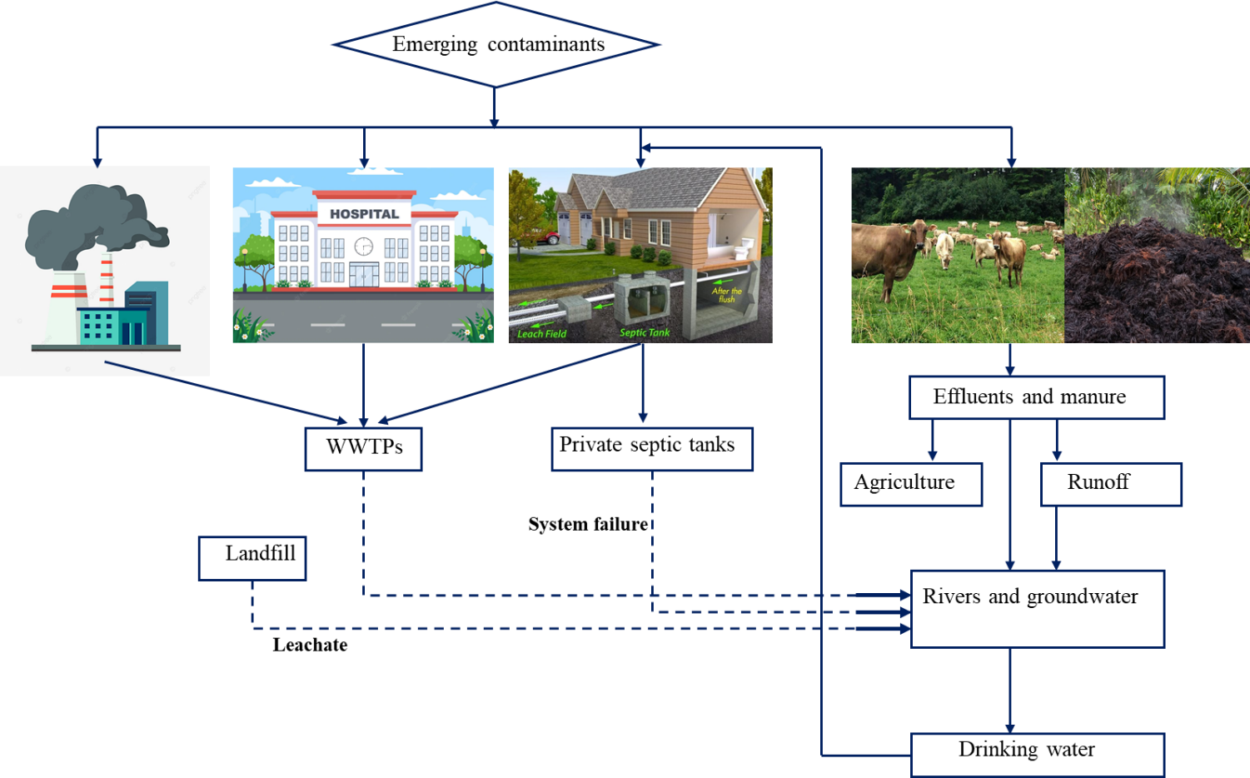

**Figure 1.** Various pharmaceutical sources released into the environment [29].

**9.1.1.1. Hospital effluents**

Most hospital-administered antibiotics are partly metabolized in the body, with the remainder excreted into hospital effluents [30]. Regarding pharmaceutical load, hospital effluents constitute the principal supplier of antibiotics in the environment [31]. The hospital's wastewater is constituted of effluents from many departments and services, including labs, radiology, outpatient care, transfusion centers, and wards. Hospital wastes are released directly into metropolitan sewage systems, along with wastes from other health care facilities [26]. Hospitals discarded approximately 1,250 million pounds of old or unused medications annually as trash. There is a more significant concentration of pharmaceuticals in hospital effluent than in municipal sewage [32]. Numerous hospital-used chemical substances, such as pharmaceuticals, disinfectants, and medicinal solvents are resistant to Wastewater Treatment Plants. Uncertain impacts on the environment and human health of emerging contaminants in hospital effluents are a rising concern. Some hazardous compounds generated by healthcare facilities are regulated as trash and disposed of as such. Concerns have developed, however, concerning medications without regulatory statuses, such as antibiotics [30, 33].

**9.1.1.1.1. COVID-19 mediation**

After the COVID-19 pandemic, the need for antibiotics has grown for the necessity to treat bacterial or fungal infections in 95% of COVID-19 patients for COVID-19 therapy. However, a large number of COVID-19 patients are treated with antibiotics needlessly [34, 35]. Recent research conducted at a hospital in the United Kingdom proposes using antibiotics such as doxycycline and amoxicillin strategically. In addition, it forecasts the increase in drug residues released by UK WWTPs into rivers and coastal waterways [36]. Antibiotic use has grown as a result of the decision by many individuals to self-medicate against the infection [37]. Macrolides are a group of antibiotics against Gram-positive bacteria one of the leading causes of respiratory tract infections. They have immunomodulatory and anti-inflammatory properties, and are also offered as treatment choices for viral respiratory infections. Clinical trials have been evaluated the effectiveness and risk-benefit profile of azithromycin in conjunction with hydroxychloroquine for the treatment of COVID-19 [38, 39]. In addition, the usage of antibacterial and disinfection chemicals, which include biocides that enter the wastewater, has grown [35].

**9.1.1.2. Veterinary wastes**

Antibiotics are used in livestock farms to increase cow production, decrease parasites, and prevent bacterial infections [25]. Emerging toxins are discharged into the environment without being entirely digested [27]. They contaminate nature through animal excrement, wastewater discharge, or aquaculture manure application [30]. The predicted global usage of veterinary antibiotics in 2030 is 106,600 tons, up from at least 63,000 tons in 2010. [30]. Approximately 30–80 percent of antibiotics are excreted through feces [40].

**9.1.1.3. Municipal wastes**

Human excreta, home wastes, and wash-off of the human body are the three primary entry points for medicines into municipal wastewater. Typically, unused or expired medications are flushed down the toilet. According to a survey conducted in Germany and Austria, one-third of medications are disposed of as garbage down the sink [41]. Therefore, the approach that requires the greatest caution is flushing unused prescriptions down the toilet or throwing them away with household rubbish. Incompletely digested medications are expelled in the sewage treatment plant after administration of these beneficial pharmaceuticals (STP) [42]. As 10–25 percent of antibiotics ingested by patients originate directly from hospitals, municipal wastewaters represent a significant supply of antibiotics [43]. Pharmaceuticals used for human medical treatment may be present in groundwater due to leachates from landfills. Growing evidence suggests that antibiotic chemicals leak into groundwater and deeper soil layers [44]. There have been instances of antibiotic-containing leaking from municipal landfills that have reached aquatic bodies. Sulfadimethoxine and sulfamethazine have been detected in six private wells serving as drinking water supplies for Washington County residents. In the United States Geological Survey, sulfamethoxazole is identified at a high relevance ratio of 23 percent, and in 164 unique groundwater samples from 23 European nations, the ratio is 24 percent [45]. Numerous more significant antibiotic classes have been detected in water sources. Antibiotics from crops often enter aquatic systems via surface runoff.

**9.1.1.4. Wastes from agriculture**

Antimicrobial usage nutrition is subdivided into animal products, aquaculture, and agriculture products [28]. Antibiotic usage in aquaculture is a progressive problem because of detecting antibiotic residues in fish products [24, 28]. The aquatic environment facilitates the rapid spread of antibiotics. Antibiotics administered to fish are estimated to be excreted in 70-80% of cases [46]. Since the 1950s, preventing vegetable, high-value fruit, and ornamental plant diseases has been common practice [47]. Antibiotics are continually detected and released into the environment due to their widespread usage in agriculture. Antibiotics found in wastewater and through irrigation can be used on crops [48]. Antibiotics are frequently included in the manure and sludge used as fertilizers on agricultural land [49]. The wastewater treatment plants remove antibiotics insufficiently, resulting in their presence in surface waters [30].

**9.2. Antibiotic presence in water bodies**

It has been stated that every water source is polluted with various chemicals, including antibiotics, in the majority of the world's nations. Antibiotics are frequently detected in every environmental matrix due to the manufacture, usage, and improper disposal of antibiotics [50]. Multiple studies have observed the antibiotics’ existence in various water compartments, including WWTP effluents, sediments, surface water, groundwater, and saltwater [32]. Table 1 provides a summary of the various articles published about the detection of a different class of antibiotics in aquatic systems.

**Table 1.** The concentration of various antibiotic groups in aquatic environments.

|  |  |  |  |
| --- | --- | --- | --- |
| ***Antibiotics*** | ***Concentration (${μg}/l$)*** |  | ***Ref*** |
| **Fluoroquinolones** |  |  |  |
| Ofloxacin | 1119.0, 66.0 |  | [32, 51] |
| Enrofloxacin | 4.6, 49.0 |  | [51, 52] |
| Ciprofloxacin | 185.14, 18.0 |  | [32, 53] |
| Norfloxacin | 703.0, 9.6 |  | [51, 54] |
| Lomefloxacin | 9.3, 159.0 |  | [51, 55] |
| Difloxacin | 23.0 |  | [51] |
| Sparfloxacin | 0.58 |  | [24, 32] |
| Moxifloxacin | 224.0 |  | [24, 32] |
| Gemifloxacin | 0.2 |  | [32] |
| **Tetracyclines** |  |  |  |
| Minocycline | 531.7 |  | [56] |
| Epitetracycline | 18.9 |  | [56] |
| Tetracycline | 48.0 |  | [51] |
| Doxycycline | 191.0 |  | [52] |
| Chlorotetracycline | 46.7, 76.0 |  | [51, 52] |
| Oxytetracycline | 4.5, 80.0 |  | [45, 51] |
| **Sulfonamides** |  |  |  |
| Sulfamerazine | 9.3 |  | [55] |
| Sulfamethoxazole | 8.3 |  | [57] |
| Sulfathiazole | 10.57 |  | [25] |
| Lincomycin | 0.045 |  | [58] |
| Cefotiam | 2.4 |  | [45] |
| Sulfaquinoxaline | 23.5 |  | [59] |
| Sulfadimethoxine | 0.16 |  | [53] |
| Sulfamethazine | 9.60 |  | [25] |
| Sulfachloropyradizine | 58.29 |  | [60] |
| Sulfadiazine | 37.4, |  | [53] |
| Streptozocin | 0.5 |  | [60] |
| Sulfapyradine | 103.1 |  | [52] |
| Sulfaquinooxaline | 64.2 |  | [52] |
| Sulfacetamide | 12.25 |  | [53] |
| Sulfadimidine | 5.91 |  | [53] |
| Sulfamethoxypyridazine | 8.04 |  | [53] |
| Sulfachinoxaline | 14.59 |  | [53] |
| **Macrolides** |  |  |  |
| Erythromycin | 0.30 |  | [55] |
| Roxithromycin | 4.1 |  | [52] |
| Azithromycin | 153.0 |  | [61] |
| Clarithromycin | 100 |  | [61] |
| Tylosin | 0.0004 |  | [42] |
| **Lincosamides** |  |  |  |
| Lincomycin | 110 |  | [55] |

**9.3. The effects of antibiotics on aquatic organism**

Antibiotics are synthetic, semisynthetic, and natural compounds that suppress microorganisms' growth or metabolic activities. These are biologically active chemicals with antifungal, antibacterial, antiparasitic, and antiviral capabilities, and their potential influence on non-target organisms has made these qualities of antibiotics a source of worry [62]. Variations in aquatic environments may result from alterations in bacterial ecology over time [63].

**9.3.1. Antibiotic resistance development: a significant cause for concern**

Antibiotics in water expose pathogens to them for an extended time, promoting the development of resistance among bacteria [64]. Recent data indicates that these microorganisms have developed resistance to conventional antimicrobials [24]. According to research, infections are growing due to antibiotic-resistant bacteria, making the treatment of urinary tract infections (UTI) more challenging [65]. Fluoroquinolones such as ciprofloxacin, norfloxacin, ofloxacin, and lomefloxacin are the most effective medications for the emergence of drug-resistant bacteria [65]. Numerous genes for fluoroquinolone resistance have been found and are believed to have been transmitted to humans by water-dwelling bacteria [66]. It has been observed that other medications, such as sulfonamides as a crucial medication to treat bacterial and protozoal infections, have been linked to resistance. Reports say tetracycline is a broad-spectrum antibiotic that causes many bacteria to become resistant [54]. The environmental presence of metabolized and unmetabolized antibiotics leads to the increase of antibiotic resistance through the production of destructive enzymes, mutation (drugs cannot recognize them), pumping antimicrobial by reflux, decreasing permeability to antibiotics, and the creation of bypasses [67]. Water spreads antibiotic-resistant microbes throughout human and animal populations. Antibiotic-resistant bacteria could spread to people through other ways, such as exposure to the environment, person-to-person contact, and direct contact with animals. This is called the "food chain" [30].

Selective pressure and resistance development are two fundamental components in the evolution of antibiotic-resistant bacteria. The vast antibiotic utilization has led to resistant bacterial strains in animals, and antibiotics have been observed to impact the community structure and enzymatic and respiratory activities of soil bacteria [49]. It was discovered that bacterial populations obtained from animal guts were more resistant [68]. Other plausible processes through which microbes acquire resistance, such as R plasmids, Antibiotic resistance makes treating infections exceedingly tricky, expensive, and, in many circumstances, fatal, resulting in a high rate of morbidity and mortality [68]. From 25,000 to 700,000 fatalities yearly result from antibiotic resistance [69]. Antibiotics may contribute to the rise of human allergies [70]. Some antibiotics in the environment may be more dangerous to human health than others because they could be toxic or cause antibiotics to stop working.

**9.2. Adsorption technology**

Adsorption is popularly recognized as an efficient and cost-effective method for removing multiple pollutants from aqueous solutions in water contamination applications due to its easy operation, structure, adaptability, competency for batch and continuous procedures, low capital cost, and the possibility of regeneration and reuse. The likelihood of achieving a high pollutant removal percentage is higher than other wastewater treatment technologies [71]. Various adsorbents have been created to date, and some economical adsorbents for various utilizations, such as sawdust [72], biochar [73], cellulose [30], date palm leaves [74], zeolites [20], β-cyclodextrin polymer [21], activated carbons [19], multiwall carbon nanotubes [18], corn bracts [75], and metal-organic frameworks [23]. Agricultural wastes [76], lotus stalk [77], and rice husk [49] are used as inexpensive replacements for costly adsorbents. Some of these adsorbents need a prior activation treatment (including chemical or thermal activation) to improve their surface areas and, consequently, their adsorption performance. Among these adsorbents, zeolite and activated carbon are the most researched due to their microporous (2 nm pore size) and mesoporous (2–50 nm pore size) geometries, which make them particularly active and suitable for antibiotic removal [3, 78]. Creating adsorbents that can imitate zeolite and activated carbon is an active field of study that encompasses a vast array of organic and inorganic hybrid materials. Table 2 lists the different materials used to extract antibiotics.

**Table 2.** Utilizing a variety of adsorbents to remove antibiotics

|  |  |  |  |
| --- | --- | --- | --- |
| ***Antibiotics*** | ***Material used*** | ***Results*** | ***Ref*** |
| Norfloxacin | Lotus stalk/iron doped activated alumina (LAC) | * The average size of LAC pores was measured to be 3.41 nm, while that of 23 was 5.33 nm. * At ambient temperature and pH 6.5, 23 had the highest adsorption capacity (21.58 $mol/g$ and 922.70 $mol/g$); however, pH 5.5 was optimal for LAC. * Conformed to the model of pseudo-second-order * At pH 6.53 and 5.48, the pHpzc values of 23 and LAC were determined. | [77] |
| Ciprofloxacin | Saw dust | * 64% of the antibiotic was adsorbed at an adsorbent dose of 40 $mg/$ 20 $ml$, which remained consistent while increasing adsorbent dosage. * At pH 5.8, the maximum adsorption of 11.6 $mg/g$ was recorded. * Conformed to pseudo-second-order kinetic models. * The pore size of adsorbents was close to 10 $μm$. * At pH 5.4, the adsorbent's point zero charge value (pHpzc) was recorded. * Adsorption mechanism includes an intraparticle diffusion process. | [72] |
| Ciprofloxacin | Date palm leaflets | * At 45 $℃$, the maximum adsorption capacity was recorded for dry adsorbent at 133.3 $mg/g$ and for wet adsorbent at 125 $mg/g$. * Conformed to the model of pseudo-second-order kinetics. * At pH 6.0, the maximum adsorption is found. * Conformed to the Langmuir isotherm model. * Endothermic and spontaneous adsorption. * The detection of hydroxyl, carboxyl and other carbon-oxygen species. * As ionic strength increases, adsorption capability decreases. | [79] |
| Gatifloxacin | Sludge biochar | * Antibiotics rapidly adsorbed to sludge biochar. * 19.80 $mg/g$ was the highest adsorption measured on biochar. * Conformed to the Freundlich isotherm model. | [80] |
| Amoxicillin (AMX) | Magnetic activated carbon (MAC) | * For MAC $-1$ and MAC $-2$, the highest adsorption capacities of AMX were found to be 280.9 $mg/g$ and 444.2 $mg/g$, respectively. * Conformed to the model of general order kinetics and the Liu isotherm model. | [81] |
|  |  |  | ***Continued*** |
| ***Table 2.******Continued*** | | | |
| Gatifloxacin | Nano particles | * Within 15 minutes, more than 90% of antibiotic was adsorbed by g-BN, but only 10% was absorbed by commercial BN adsorbent. * Adsorption independent to pH. * Conformed to the Langmuir isotherm model with 88.5 mg/g adsorption at 288 K. * Process of spontaneous and exothermic adsorption. * Electrostatic and $π-π$ interactions control the adsorption of GTF onto g-BN. * As ionic strength increased, adsorption capacity decreased. | [82] |
| Ciprofloxacin (CIP) Norfloxacin (NOR) | Activated carbon | * The activated adsorbent surface area was 1,824.88 m2, the volume of the micropores was 0.64 cm3, and the volume of the mesopores was 0.137 cm3. * 96.12% of CIP was removed at an initial antibiotic dosage of 20 $mg/l$, a contact duration of 90 minutes, and a pH of 9.0, whereas 98.13% of NOR was eliminated at a pH of 5.0, an initial NOR concentration of 20 $mg/l$, and a contact time of 60 minutes. * Conformed to the model of pseudo-second-order. * The adsorption of ciprofloxacin was endothermic, and norfloxacin was exothermic. * CIP and NOR conformed to the Langmuir isotherm model with maximal adsorption capacities of 131.14 $mg/g$ and 166.99 $mg/g$, respectively. * For both antibiotics, conformed to the pseudo-second-order model. * The measured equilibrium time for CIP was 90 minutes while for NOR it was 60 min * The pH value pKa2 (8.7) regarded optimal for maximal antibiotic clearance. | [83] |
| Ciprofloxacin (CIP) | Kandira stone | * 68.5% of CIP was removed at a dose of 12 $g/l$ adsorbent. * Attained equilibrium adsorption in 30 minutes. * The removal of antibiotics decreases as pH increases. * Conformed to the Freundlich isotherm model. * Conformed to the model of pseudo-second-order kinetics. * Maximum removal detected at 20 $℃$. * Exothermic adsorption. | [84] |
| Levofloxacin | Corn bracts | * Adsorption capability was observed in Zr-modified CBs ( $Q_{max}$ = 73 $mg/g$). * The optimal pH for adsorption is 7.0. * Conformed to the Freundlich isotherm model. * Conformed to the model of pseudo-second-order kinetics. | [75] |
| ***Continued*** | | | |
| ***Table 2.******Continued*** | | | |
| Ciprofloxacin | Biochar  (herbal residue) | * The optimal adsorption capacity measured for biochar generated at 800 $℃$ was 37.6 $±$ 0.87 $mg/g$. * At a pH of 7.0, ciprofloxacin adsorption was highest. * Conformed to the Freundlich isotherm model. * Conformed to the model of pseudo-second-order kinetics. | [85] |
| Ciprofloxacin (CIP) Norfloxacin (NOR) Ofloxacin (OFL) | Graphene oxide | * At pH 7 for NOR and CIP, and at pH 4 for OFL, maximum removal was found. * OFL adsorption was highest at pH 4. * Conformed to the Langmuir isotherm model. * Conformed to the model of pseudo-second-order kinetics. * Adsorption equilibrium reached after 50 minutes. | [86] |
| Ciprofloxacin | Magnetic Biochar (M-BC) | * At pH 6.0, the maximum adsorption capacity of 68.9 $±$ 3.23 $mg/g$ was recorded. * The adsorption capacity decreases as the dose of the adsorbent increases. * Conformed to the Langmuir isotherm model. * Conformed to the model of pseudo-second-order kinetics. | [87] |
| Penicillin-G | Fe + 3-TiO2/UV-A process | * At pH 3.0, penicillin G removal was at its highest rate. * Penicillin G's elimination amount reduced as its primary condensation increased. * Due to UV's impact on catalyst activation in the Fe + 3-TiO2/UV-A process, a notable growth in the amount of antibiotic removal has been observed. | [88] |
| Ciprofloxacin | Activated carbon | * The adsorbent possessed a mesoporous structure with a maximum surface area of 1,435 m2/g. * The highest antibiotic adsorption capability at 40 $℃$ is 335,8 $mg/g$. * Liu follow better isotherm model. * Conformed to the model of Avrami kinetics. * Endothermic and spontaneous sorption. | [89] |
| Oxytetracycline | NaOH- activated carbon (Guava seeds) | * The initial sorption rate was 100 $mg/g.h$ at 2,000 $mg/l$. * Conformed to the model of pseudo-second-order kinetic. * The existence of Cu2+ affected OTC adsorption. * Surface complexity, cation $-π$ interactions, cation exchange, and metal bridging are all components of the adsorption process. * At pH 5.0, the highest adsorption had been seen. | [90] |
| ***Continued*** | | | |
| ***Table 2.******Continued*** | | | |
| Cephalexin | Mesoporous silica | * MCM-41 was found to have a pore width of 2.0 nm, a surface area of 1,097 m2/g, and an average size of crystallite 75 nm. * The FTIR study confirmed the formation of $H-O-H$, $Si-OH$, and $Si-O-Si$ bonds. * At an initial pH of 3.0, an adsorbent dose of 800 $mg/L$, an initial antibiotic concentration of 50 $mg/L$, 40.0 $℃$, and an adsorption duration of 30.0 minutes, the antibiotic removal rate was 90.3%. | [91] |
| Ciprofloxacin | ICDW-APTES | * ICDW-APTES was able to remove 71.0 and 69.0% of two synthetic effluents, respectively. * Liu kinetic model demonstrated superior fitness. * Antibiotic adsorption ability ( $Q_{max}$ value of 138.3 $mg/g$) rose with the rise in temperature. * Mechanism applies electrostatic interaction. | [92] |
| Tetracycline Chloramphenicol | Bamboo charcoal (BC) | * CAP and TC adsorption capacity on BC rose as bed height grew and reduced as flow rate and influent concentration increased. * The adsorption process comprises interactions including $π-π$ electro-donor–acceptor, cation- bond, and hydrogen bonding. * Follow pseudo first order kinetic model. * Conformed to the Langmuir isotherm and Dubinin– Radushkevich model. | [93] |
| Tetracycline Ciprofloxacin | Graphene-soy protein (GS) aerogel | * The GS specific surface area was 30.07 m2/g, and it had an abundance of microspores. * In comparison to other adsorbents, the absorption capabilities of GS for both antibiotics were reported to be 500 $mg/g$. * Follow both the Freundlich and Langmuir isotherm models. | [94] |
| Tetracycline | Activated carbon (macadamia nutshell) | * ACM had a surface area of 1,524 m2/g, 78.2% micropores content, and a pHpzc value of 8.74. * The highest adsorption capacity attained was 455.33 mg/g. * Conformed to the model of Elovich kinetics and the Temkin isotherm model. | [95] |
| ***Continued*** | | | |
|  | | | |
| ***Table 2.******Continued*** | | | |
| Amoxicillin | Organ bentonite | * The adsorption percentages for DK1, DK1N, DK2, and bentonite were respectively 97.9, 61.5, 53.1, and 13.8%. * Conformed to the pseudo-second-order kinetic model. * 99% of amoxicillin is adsorbed at pH 6. * Follow both the Freundlich and Langmuir isotherm models. * Ion-exchange and partition play a role in the adsorption process. | [96] |
| Amoxicillin (AMX) | NH4Cl-induced activated carbon (NAC) Standard activated carbon (SAC) | * The synthesized adsorbent has an average pore volume of 2.46 nm and a surface area of 1,029 m2/g. * At pH 6.0, 50 $mg/L$ starting antibiotic condensation, and 0.4 g NAC/L adsorbent, the adsorption amount of amoxicillin was more than 99%, whereas standard activated carbon (SAC) could only adsorb around 55% under same testing circumstances. * Temperature increases enhance absorption. * Follow pseudo second order kinetics and Langmuir isotherm model. * AMX has a maximum adsorption capacity of 262 $mg/g$ on SAC and 437 $mg/g$ on NAC. | [81] |
| Tetracycline | Activated carbon | * The highest Cu-13X adsorption capacity at pH 7.0 was 455.33 mg/g. * Conformed to the model of pseudo-second-order kinetics and the Langmuir isotherm model. * Adsorption is dependent on the strong complexation of Cu (II) with the NH2 radical in the amide group of TC. | [97] |
| Amoxicillin, Tetracycline Penicillin G Cephalexin | Activated carbon (vine wood) | * The adsorbent's surface area and pore volume were 13.397 m2/g and 54.79 cm3/g, in order. * The removal of 20 $mg/g$ of antibiotics was effective at pH 2.0, during 8 $h$, and adsorbent of 0.4 $g/l$. * Conformed to the model of pseudo-second-order kinetics, and Freundlich isotherm. | [98] |
| Amoxicillin | Wheat grains | * Maximum adsorption was determined to be 84.0% at conditions of 150 $μg$ adsorbent particle size, 25 $°C$ temperature, pH 7,4 $mg/L$ antibiotic concentration, and 5 min contact duration. * Conformed to the pseudo-second-order kinetics and the Temkin isotherm models. | [99] |
| ***Continued*** | | | |
| ***Table 2.******Continued*** | | | |
| Tetracycline (TC) | Multi-walled carbon nanotubes (MWCNTs) | * Fe3+ ions on the MWCNT greatly reduced antibiotic adsorption. * The TC adsorption is unaffected by other cations and anions. * On MWCNT, the highest adsorption capacity of 253.38 mg/g was reported. * Beads with oxygen-containing functional groups are a promising option for the adsorption process, according to FTIR study of oxidized MWCNT. * Conformed to the model of Avrami fractionary-order kinetics and the Liu isotherm. * Adsorption pH is optimal around 5-7, and equilibrium is attained in 120 minutes. | [100] |
| Tetracycline (TC) | Zinc chloride impregnated activated carbon (Zn-AC) | * Conformed to the model of general order kinetics and the Redlich–Peterson model. * After 120 minutes, equilibrium in the TC adsorption onto the adsorbent was attained. * The TC adsorption was not significantly impacted by pH. * Adsorbent specific surface area of 224 m2/g was discovered. * Adsorption of TC onto the Zn-AC was greatly reduced by cations and anions. * TC adsorbed amount onto the Zn-AC was 282.06 mg/g ($Q_{max})$. | [101] |
| Chlortetracycline | Biochar (Pine wood) | * Raw and activated biochar's adsorption capacities were found to be 2.1 and 208.3 mg/g, respectively. * At pH 1.0, adsorption was at its maximum. * Conformed to the model of Langmuir isotherm. * The average particle size of activated biochar was 19.1 $μm$, while the average particle size of raw biochar was 25.7 $μm$. | [102] |
| Ciprofloxacin (CF) Doxycycline (DC) Hydrochlorid Tetracycline hydrochloride (TC) | Rice husk biochar | * Fe3+ ions on the MWCNT greatly reduced antibiotic adsorption. * The TC adsorption is unaffected by other cations and anions. * On MWCNT, the highest adsorption capacity of 253.38 $mg/g$ was reported. * Beads with oxygen-containing functional groups are a promising option for the adsorption process, according to FTIR study of oxidized MWCNT. * Conformed to the model of Avrami fractionary-order kinetics and the Liu isotherm. * Adsorption pH is optimal around 5-7, and equilibrium is attained in 120 minutes. | [103] |
| Tetracycline | High surface area porous carbon material | * At temperatures of 30, 40, and 50 $℃$, the maximum antibiotic adsorption was measured to be 128.52, 162.62, and 210.18 $mg/g$, respectively. * Conformed to the model of pseudo-first order kinetic. | [76] |
| ***Continued*** | | | |
| ***Table 2.******Continued*** | | | |
| Sulfamethoxazole | Biochar (rice straw) | * The sorption of rice straw biochar was heightened by the presence of Cadmium. * At pH 3.0, the maximum adsorption was seen. | [104] |
| Chloramphenicol | Activated carbon | * The most effective adsorptive surfaces were activated carbon ROW 08 supra (94.7%) and F $-$ 300 (94.7%) from solutions with pHs of 7.0 and 2.0, respectively. * Adapted with the model of pseudo-second-order kinetics and the Langmuir isotherm. | [105] |
| Sulfonamide | Reduced graphene oxide ferrite hybrids | * The pH 6.0 level produced the highest extraction efficiency. * From 5 to 15 minutes, there was an improvement in extraction efficiency. | [106] |
| Sulfamethoxaole Ttylosin | Triazine frameworks | * Sulfamethoxazole's adsorption coefficient increased for Tylosin as the pH rose from 5 to 10, but it slightly reduced for sulfamethoxazole between pH 3-5. | [107] |
| Tylosin | Porous resins | * Adsorption that is pH-dependent is seen. * Four adsorbents were shown to have varying adsorption rates. * Intermolecular interactions were part of the mechanism. * Adapted with the model of pseudo-second-order kinetics and the Langmuir isotherm. | [108] |
| Linezolid | MgO nano particles ZnO-MgO nanocomposites | * MgO nanoparticles and ZnO-MgO removed 123.45 $mg/g$ and 140.28 $m/g$ of antibiotic at an initial adsorbent concentration of 0.5 $g/l$, 308 K, and pH 10.0. * Conformed to the model of pseudo-second-order kinetics and the Langmuir isotherm. | [109] |
| Metronidazole | Canola stalk | * Maximum capacity for adsorption is 21.42 mg/g. * Within 90 minutes, the maximum antibiotic adsorption was achieved. * Conformed to the models of Langmuir and Temkin isotherm. | [110] |
| Chloramphenicol | Activated carbon | * AC had surface area of 794.8 m2 /g. * The active groups on AC were 2.078 and 0.995 mmol/g for acidic and basic, respectively. * Hydrophobic interaction, $π-π$ electron-donor acceptor (EDA) interaction, and hydrogen-bonding interaction all have functions in the adsorption mechanism. * Conformed to the model of pseudo-second-order kinetics and the Freundlich isotherm. * The highest reported antibiotic adsorption capability was 0.424 mmol/g. * The CAP adsorption was mostly unaffected by pH and ionic strength. | [111] |

**9.3. PIMs usage to remove antibiotics from wastewater**

In recent times, a new group of polymeric materials with inherent microporosity in their molecular architectures has developed. The Polymer of Intrinsic Microporosity (PIM) class, exhibits similar properties to crystalline and amorphous microporous and mesoporous substances in various usages, such as gas separation, adsorption, and catalysis [112-114]. PIM has peculiar building characteristics, including a backbone formed of fused rings and a site of deformation, which results in a large free volume since they are not able to pack space effectively [115]. Because it is soluble in common organic solvents and can be easily processed into several application-driven forms, such as powders, membranes, and fibers, this material was found to have a wide surface area, high thermal and chemical stability, and a potential utility in adsorption [116]. PIMs are organic compounds with a porous structure that do not generate hazardous byproducts. Therefore, there is a need for more study on the utilization of amorphous polymers and their inherent microporous qualities in order to evaluate their feasibility for treating polluted water as a more ecologically acceptable alternative [117]. PIMs are a kind of porous organic polymer with inflexible and twisted molecular chains that cannot pack effectively; as a result of these qualities, solids with microporous properties may develop [118]. Current approaches for creating PIMs include the production of dibenzodiazepine, Troger's base, or imide, all of which have shown beneficial for preparing solution processable compounds [118].

PIM-1 has a BET specific surface area of 850 m2/g and a pore diameter in the range of 0.4-0.8 nm, making it the PIM with the highest antibiotic affinity among those investigated [118]. It is produced by the synthesis of dibenzodiazepine [118]. PIM-1 is efficient in removing antibiotics in large-scale adsorption methods [119]. Reaction temperature affects the molecular weight and pore configuration of PIMs. Research on the best temperature for synthesizing PIM-1 to remove fluoroquinolones from wastewater and comparing the effectiveness of extracting antibiotics from wastewater using PIM-1 vs commercial activated carbon might be feasible. First, synthesize the PIMs to study this issue. There is a gap in the literature regarding the most effective temperature in the synthesis of PIM-1 for adsorption of the four most popular fluoroquinolone antibiotics (ciprofloxacin, norfloxacin, ofloxacin, and lomefloxacin) [120, 121]. Fluoroquinolones are among the antibiotics that contribute most to developing resistant microbes. PIM-1's efficacy compared to activated carbon's adsorption filtering is also interesting. Based on current studies, Ye et al. reported that the PIM-1 synthesized at 60°C should be more effective at adsorbing antibiotics owing to its more efficient pore organization and spatial capacity [122].

McGuinty et al. reported that the PIM-1 should be more successful in removing fluoroquinolones from wastewater than commercial activated carbon because of its microporosity compared to activated carbon's wide pores and poor antibiotic affinity, which does not filter subnanometer antibiotics [121]. They also investigated the performance of PMI-1 at various three temperatures of 50°C, 55°C, and 60°C. They reported that it is unclear if the ideal synthesis temperature of PIM-1 for removing antibiotics from wastewater is 60°C and whether it is more effective than activated carbon at removing antibiotics [121]. Additionally, the use of PIM-1 in wastewater filtration would offer a strategy for mainly targeting medications and reducing the spread of bacteria that are resistant to them [122].

Alnajrani et al. reported that the adsorption of four common antibiotics (doxycycline, ciprofloxacin, penicillin G, and amoxicillin) was studied and discovered that at least 80% of the starting condensations were removed under the optimal circumstances. The batch experimental findings showed that the Freundlich model highly conformed with the isothermal finding. Kinetic investigations indicated that the pseudo-second-order model well describes kinetic data. The structures of the examined antibiotics and PIM-1 are shown in Figure 2. In addition, they reported that PIM-1's removal of antibiotics from water is likely governed by surface and pore-filling adsorption, which may be aided by electrostatic interactions between aromatic rings and charged functional groups as the creation of hydrogen bonds between the adsorbent and the adsorbate. With future improvements in large-scale adsorption methods, adopting such a new microporous material might aid in eliminating complex and persistent pollutants from wastewater [119].

|  |
| --- |
|  |

**Figure 2.** [Antibiotic elimination from Water by](https://www.nature.com/articles/s41598-020-57616-4) PIMs [119].

They reported that, because of the intricate chemical composition of the antibiotics under consideration, it is anticipated that unique adsorption behaviors for each molecule will be observed under varied experimental conditions, as documented. As illustrated in Fig.

3, Doxycycline adsorption prefers neutral pH over acidic pH, while both conditions achieve roughly the same clearance percentage (75%) if sufficient adsorption time is supplied. In contrast, at pH 2, ciprofloxacin, penicillin G, and amoxicillin were absorbed more efficiently than at other pH levels. At this pH, PIM-1 is positively charged with a surface potential of 16.4mV; this feature may enhance the hydrophobicity of PIM-1 in acidic solution, hence facilitating the adsorption of mildly hydrophobic antibiotics (seen in Fig.3).

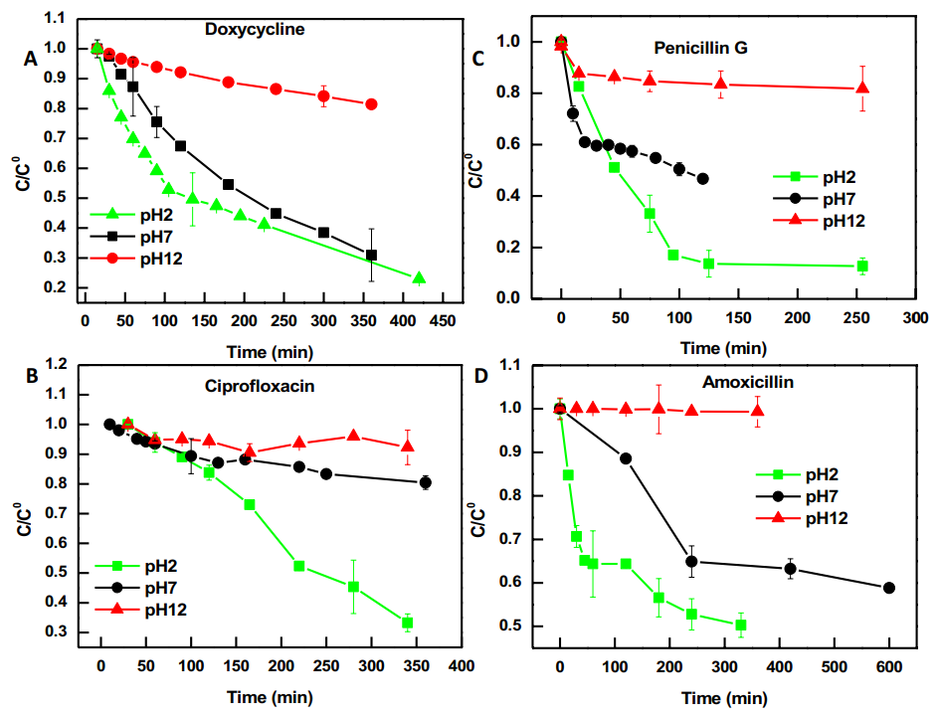

**Figure 3.** Studies of the adsorption of doxycycline (A), ciprofoxacin (B), penicillin G (C), and amoxicillin (D) at various pH conditions. The error bars depict the standard deviation of the mean of three separate experiments [119].

**9.4. Micro-plastic**

The production of plastics has dramatically enhanced from 0.5 million tons in 1950 to 311 million tons in 2014 [123], which is associated with growing the discharge of plastic waste into the ecosystem. Approximately, 4.8-12.7 million tons of plastic waste existed on the beach in 2010 alone [124]. Newly, micro-plastics (MPs) have been received much attention from the researchers because of their poisoning effect on the fishes and other animals in the sea or ocean. MPs are typically found in water sources [125], water columns [126], and bottom sediments [127]. According to the literatures, polyethylene (PE), polystyrene (PS), polypropylene (PP), polyamide (PA), and polyvinyl chloride (PVC) have been recognized as the most MPs in the aquatic ecosystem [128]. It is detected that several poisoning and chemical contaminants can penetrate the MPs and act as a carrier for long-range transport [129].

The features of the adsorbent and the sorbate considerably effect on the yield of the adsorption. In the case of MPs, their features like polarity, abundance of rubbery, and levels of crystallinity dramatically influences on adsorption capabilities of contaminants [130]. Antibiotics have been recognized as the emerging contaminants which attracted much focus owing to the creation of microbial resistance in the human body [131]. Several tons of antibiotics have been discarded in nature each year [132], For instance, 53,800 tons of antibiotics were released to nature in 2013 in China alone. With respect to the works of literature, tetracyclines, macrolides, ﬂuoroquinolones, and sulfonamides are the most antibiotics observed in the aquatic media [133]. Additionally, trimethoprim, ﬂuoroquinolones, and sulfonamides have been detected as the most resistant antibiotics in surface water [134]. More significantly, the residual antibiotics can create a great risk for the aquatic animals [135].

In order to study the performance of different MPs on the attraction of antibiotics, we describe the results of Li et al. in both sea and freshwater [136]. Initially, seawater was passed from membranes the size of 0.45mm and exposed to the ultraviolet lamp for decreasing the impacts of dissolved organic reagents as much as feasible. TC (tetracycline), AMX (amoxicillin), and TMP (trimethoprim) have been dissolved in the considered media (i.e. ultrapure water and ﬁltered seawater) for generating the stock solutions. Also, SDZ (sulfadiazine) and CIP (ciproﬂoxacin), have been combined with methanol for increasing their desolvation potential in the considered solutions. All the stock solutions have been maintained in the temperature of 4℃ out of the light for lesser than one week. Prior using, stock solutions have been diluted to the certain concentrations. Then, the adsorption of antibiotics toward MPs was conducted in the batch mode with the five diverse concentrations (i.e. 0.5, 1, 5, 10, and 15 mg/L) in the normal temperature. Afterward, 0.02 g of plastics was incorporated into the Erlenmeyer. Diverse contents of back- ground solution (ultrapure water or ﬁltered seawater) have been introduced into the Erlenmeyer. Then, antibiotic stock solution with a concentration of 50 mg/L was introduced to prepare the suspension with the content of 5mL in each Erlenmeyer covered with a teﬂon gasket. The suspensions in the Erlenmeyers were agitated in a temperature-controlled shaking incubator (HZS-HA, Harbin, China) with the speed of 180 rpm at the normal temperature for 4 days. After reaching to saturation sate, the samples were passed through the 0.22 mm syringe ﬁlter prior of analyzing. The adsorbed antibiotics were determined with exploiting high-performance liquid chromatography (Exformma 1600, USA) equipped with a UV detector.

**9.4.1. MPs Characteristication**

Figure 4 exhibits the SEM images of PE, PVC, PS, PP, and PA, respectively. The morphology of PE particles was almost flat, while multiple particles with a range of micro were observed on the structure of PVC. Reticular generation was expanded in the architecture of PS. Also, several pores with the shape spherical and size micro were detected in the architecture of PP. Finally, the structure of PA was coarse with higher porosity. The XRD images imply the crystallinity of plastic materials. Typically, the intense peak belongs to the polymer with a considerable level of crystallinity. Li et al. observed in the XRD pattern, that one intense peak exhibited in the XRD image of PE, implying PE posed a considerable level of crystalline. Like in PE, three considerable peaks with high values were detected in the XRD image of PP. The XRD pattern in the PS and PA were similar to each other. Whereas for PVC, there was no apparent diffraction peak in the 2θ range of 5-90o. Thus, the level of crystallinity obeyed the following arrangement: PE > PP > PA ∽ PS > PVC.

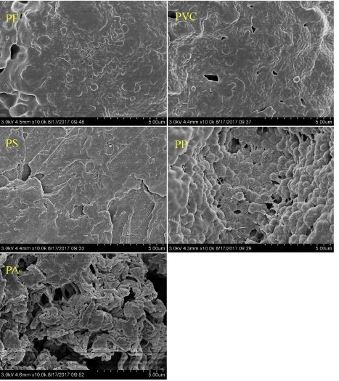

**Figure 4.** SEM micrographs of polyethylene (PE), polystyrene (PS), polypropylene (PP), polyamide (PA), and polyvinyl chloride (PVC) [136].

**9.4.2. Effects of microplastic properties**

Some features of MPs can directly impact the uptake capability like speciﬁc surface area, polarity, and level of crystallinity. Wang et al. [137] indicated that the polarity of MPs affects the uptake capability of polar materials. The examined antibiotics belong to the class of the polar materials [138] and are believed to tend to penetrate the polar MPs via the formation of the polar-polar bond. According to Table 3, only polar PA has a considerably larger uptake capability for 4 antibiotics (CIP, TMP, AMX, and TC) in the freshwater media, while polar PVC exhibits a slight tendency toward polar antibiotics. This case demonstrated that the polarity of MPs was not the only effective parameter for adsorption of the antibiotics. As mentioned in [137, 139], the rubbery plastic PE revealed more uptake capability to organic contaminants than the glassier plastics (i.e. PP, PS, and PVC). Nevertheless, the adsorption potential of PE toward the mentioned antibiotics was poor. Guo et al. proposed that the plastic with the slight crystallinity adsorb more hydrophobic organic contaminants [140]. The intensity of crystallinity for ﬁve different MPs has obeyed the following arrangement: PE > PP > PA $≈$ PS > PVC. Nevertheless, this order was not consistent with the order of sorption capacity of any type of antibiotic, implying the crystallinity of MPs was not an adequate parameter influencing antibiotic uptake. The uptake efficiency of CIP, TMP, and SDZ on PS is more than those on PE (Table 3). The reason may be that PS can undergo non- speciﬁc van der Waals interactions and $π-π$ interactions at the aromatic surface, while PE can only undergo the van der Waals interactions [129]. Moreover, PA showed high uptake toward AMX, TC, and CIP, which is due to the existence of certain functional moiety (i.e. amide particles). Hydrogen linking is generated between amide particles (proton donor group) of PA and carbonyl particles (proton acceptor group) of AMX, TC, and CIP [141]. Other works also proved that hydrogen linking between antibiotics (e.g. TC and CIP) and organic compound (e.g. humic substance and organic carbon) surfaces may help the diffusion of antibiotics [142]. Hence, the researchers proposed that the generation of hydrogen links as the mechanism underlying the excellent uptake of AMX, TC, and CIP on PA. Also, the features of MPs subjected to the nature may alter owing to the environmental parameters and thus impact their uptake mechanisms [143]. For instance, the polar functional moieties, carbonyl particles, have been detected in the old plastic materials collected from beaches [144]. The existence of polar functional moieties can lead to the creation of H- linking. Besides, the old plastic matters tend to have a larger surface area through photo-oxidation, weathering, and aging [143], and this case also desires the uptake of the pollutants.

**Table 3.** Estimated Linear, Freundlich, and Langmuir parameters for antibiotics adsorption on MPs in the freshwater system [136].

|  |  |  |  |  |  |  |  |  |  |  |
| --- | --- | --- | --- | --- | --- | --- | --- | --- | --- | --- |
| **MP** | **Linear** |  |  | **Freundlich** | | |  | **Langmuir** | | |
| $$K_{d} (L/kg)$$ | $$r^{2}$$ |  | $$K_{f} (L/kg)$$ | $$n$$ | $$r^{2}$$ |  | $$q_{max} (mg/g)$$ | $$K_{L} (L/mg)$$ | $$r^{2}$$ |
|  | **CIP** |  |  |  |  |  |  |  |  |  |
| **PP** | 57.1 ± 11.5 | 0.827 |  | 252 ± 33.3 | 0.345 | 0.938 |  | 0.615 ± 0.0299 | 0.844 | 0.990 |
| **PS** | 51.5 ± 7.76 | 0.846 |  | 205 ± 17.0 | 0.316 | 0.968 |  | 0.416 ± 0.0427 | 1.67 | 0.903 |
| **PVC** | 41.5 ± 7.83 | 0.844 |  | 184 ± 6.19 | 0.371 | 0.998 |  | 0.453 ± 0.00863 | 1.15 | 0.996 |
| **PE** | 55.1 ± 7.94 | 0.904 |  | 222 ± 6.59 | 0.393 | 0.994 |  | 0.200 ± 0.0143 | 0.443 | 0.990 |
| **PA** | 96.5 ± 7.81 | 0.968 |  | 170 ± 45.2 | 0.741 | 0.963 |  | 2.20 ± 0.657 | 0.0740 | 0.980 |
|  | **TMP** |  |  |  |  |  |  |  |  |  |
| **PP** | 9.71 ± 2.28 | 0.851 |  | 32.3 ± 4.01 | 0.450 | 0.964 |  | 0.102 ± 0.0142 | 0.498 | 0.934 |
| **PS** | 9.51 ± 1.07 | 0.963 |  | 32.1 ± 2.48 | 0.507 | 0.992 |  | 0.174 ± 0.0385 | 0.158 | 0.932 |
| **PVC** | 8.41 ± 1.20 | 0.941 |  | 13.4 ± 6.58 | 0.842 | 0.939 |  | 0.481 ± 0.496 | 0.0259 | 0.944 |
| **PE** | 8.38 ± 1.32 | 0.908 |  | 22.0 ± 2.59 | 0.560 | 0.986 |  | 0.154 ± 0.0413 | 0.116 | 0.939 |
| **PA** | 17.1 ± 1.24 | 0.974 |  | 36.0 ± 6.15 | 0.696 | 0.985 |  | 0.468 ± 0.128 | 0.0646 | 0.979 |
|  | **SDZ** |  |  |  |  |  |  |  |  |  |
| **PP** | 7.85 ± 0.679 | 0.985 |  | 8.00 ± 7.14 | 0.939 | 0.884 |  | na | na | na |
| **PS** | 7.39 ± 0.308 | 0.995 |  | 4.10 ± 2.18 | 1.22 | 0.972 |  | na | na | na |
| **PVC** | 6.61 ± 0.549 | 0.973 |  | 3.20 ± 2.91 | 1.27 | 0.918 |  | na | na | na |
| **PE** | 6.19 ± 0.238 | 0.996 |  | 2.20 ± 3.13 | 1.40 | 0.962 |  | na | na | na |
| **PA** | 7.36 ± 0.257 | 0.996 |  | 1.10 ± 0.196 | 1.71 | 0.999 |  | na | na | na |
|  | **AMX** |  |  |  |  |  |  |  |  |  |
| **PP** | 17.5 ± 3.39 | 0.895 |  | 60.0 ± 6.55 | 0.540 | 0.720 |  | 0.294 ± 0.0702 | 0.376 | 0.930 |
| **PS** | $$-$$ | $$-$$ |  | $$-$$ | $$-$$ | $$-$$ |  | $$-$$ | $$-$$ | $$-$$ |
| **PVC** | 24.7 ± 1.20 | 0.991 |  | 20.0 ± 8.86 | 1.07 | 0.969 |  | 0.523 ± 0.368 | 0.0657 | 0.953 |
| **PE** | 8.40 ± 0.675 | 0.968 |  | 18.0 ± 2.27 | 0.637 | 0.930 |  | 0.131 ± 0.0284 | 0.174 | 0.920 |
| **PA** | 756 ± 48.0 | 0.980 |  | 700 ± 31.8 | 0.900 | 0.991 |  | 22.7 ± 22.6 | 0.0361 | 0.992 |
|  | ***TC*** |  |  |  |  |  |  |  |  |  |
| **PA** | 356 ± 38.2 | 0.945 |  | 588 ± 128 | 0.699 | 0.943 |  | 3.84 ± 0.839 | 0.189 | 0.977 |

**9.4.3. Effects of antibiotic properties**

Table 3 implies that a certain plastic has diverse uptake capability in the different antibiotics. Except for PA, the other plastics tend to adsorb the antibiotics with the following arrangement from the highest to the lowest: CIP > AMX > TMP > SDZ > TC. With respect to the results, it is derived that the features of antibiotics can affect the uptake ability of MPs. Previous investigations described that the partition coefficient of octanol-water (Log $K_{ow}$) of solutes was an essential factor in determining the adsorption potential of MPs [129]. That is, the Log $K_{d}$ values of investigated sorbates were positively correlated with their Log $K_{ow}$ values. The amount of log $K_{ow}$ for the examined antibiotics was reduced with respect to the following arrangement: CIP > TMP > AMX > SDZ > TC. It was observed that a considerable positive behavior exists between the Log Kow of the antibiotics and their average $K_{f}$ amounts on PP, PS, PE, and PVC (p < 0.05). The observations exhibited that hydrophobic antibiotics (with a greater amount of Log Kow) had more reliability than PP, PS, PE, and PVC. Nevertheless, this correlation did not apply to PA, implying hydrophobic interaction was not important for the removal of antibiotics using PA. Antibiotics are ionizable materials, but the ionization parameter (p $K_{a}$) of different antibiotics typically varied dramatically owing to their speciﬁc functional moieties. Hence, different antibiotics will reveal various speciation of the cation, zwitterion, and anion at a certain pH value. The speciation of ionic chemicals impacts the adsorption capability of MPs. According to the work of Wang et al. [137], the anionic states of PFOS exhibited a greater uptake capability on PE with a positive charge at slight pH than the nonionic states of FOSA. In the freshwater media, the entire examined antibiotics were zwitterions and anions; However, a number of cations exist in CIP. In the seawater media, zwitterions and anions were the important species for 5 antibiotics. Since the tested pH was more than the PZC of 5 MPs, the entire 5 MPs posed a net negative charge. Therefore, for CIP in the freshwater media, the cations of CIP increased its uptake capability on negatively charged MPs surfaces because of the electrostatic attraction.

**9.4.4. Freshwater and Seawater Systems**

The results of Li et al. proved that uptake of antibiotics on MPs varied in freshwater and seawater media. With respect to Fig. 5, uptake of CIP and AMX was not feasible in the seawater media. The uptake capabilities of TMP, SDZ, and TC were lower than those of the freshwater media. Variations in ionic potential and pH amounts are probably applied to describe the diverse uptake capabilities in the freshwater and seawater media. The acidity of seawater media was lower than in the freshwater media; also, the anionic speciation of antibiotics in the seawater media was greater than in the freshwater media. Meanwhile, the entire 5 MPs had a net negative charge since the alkaline state in seawater was more than in the PZC of MPs. Consequently, the increased electrostatic repulsions between MPs and antibiotics will decrease uptake ability. The novel investigation revealed that adsorption of PFOS on PE, PS, and PVC reduced with enhancing pH [137]. Tizaoui et al. [145] also explained that enhancing the pH of reaction media can decrease endocrine-disrupting chemicals (EDCs) penetration on PA dramatically. Or, ionic strength, to a specific amount, could impact the electrostatic interactions because the electrolytes can compete with adsorbate for electrostatic places [145]. As the ionic potential is enhanced, cations like Na+ and Ca2+ may be attracted electrostatically to the MPs surface. Moreover, the inorganic exchangeable cations (e.g. Na+) replace the hydrogen particles of acidic moieties and then restrain the generation of H- links [138]. These detections proposed that adsorption places may reduce when expose to the strong ionic potential case. Thus, penetration of the examined antibiotics on MPs decreased at high ionic strength levels. This conclusion was adapted from previous investigations which proved that the uptake capabilities of different antibiotics on various types of resins (e.g. marine sediments and soils) reduced with enhancing of ionic potential [139]. The enhancement of uptake capacity of antibiotics on MPs in the freshwater media may increase their bioavailability and accumulation in the food chain.

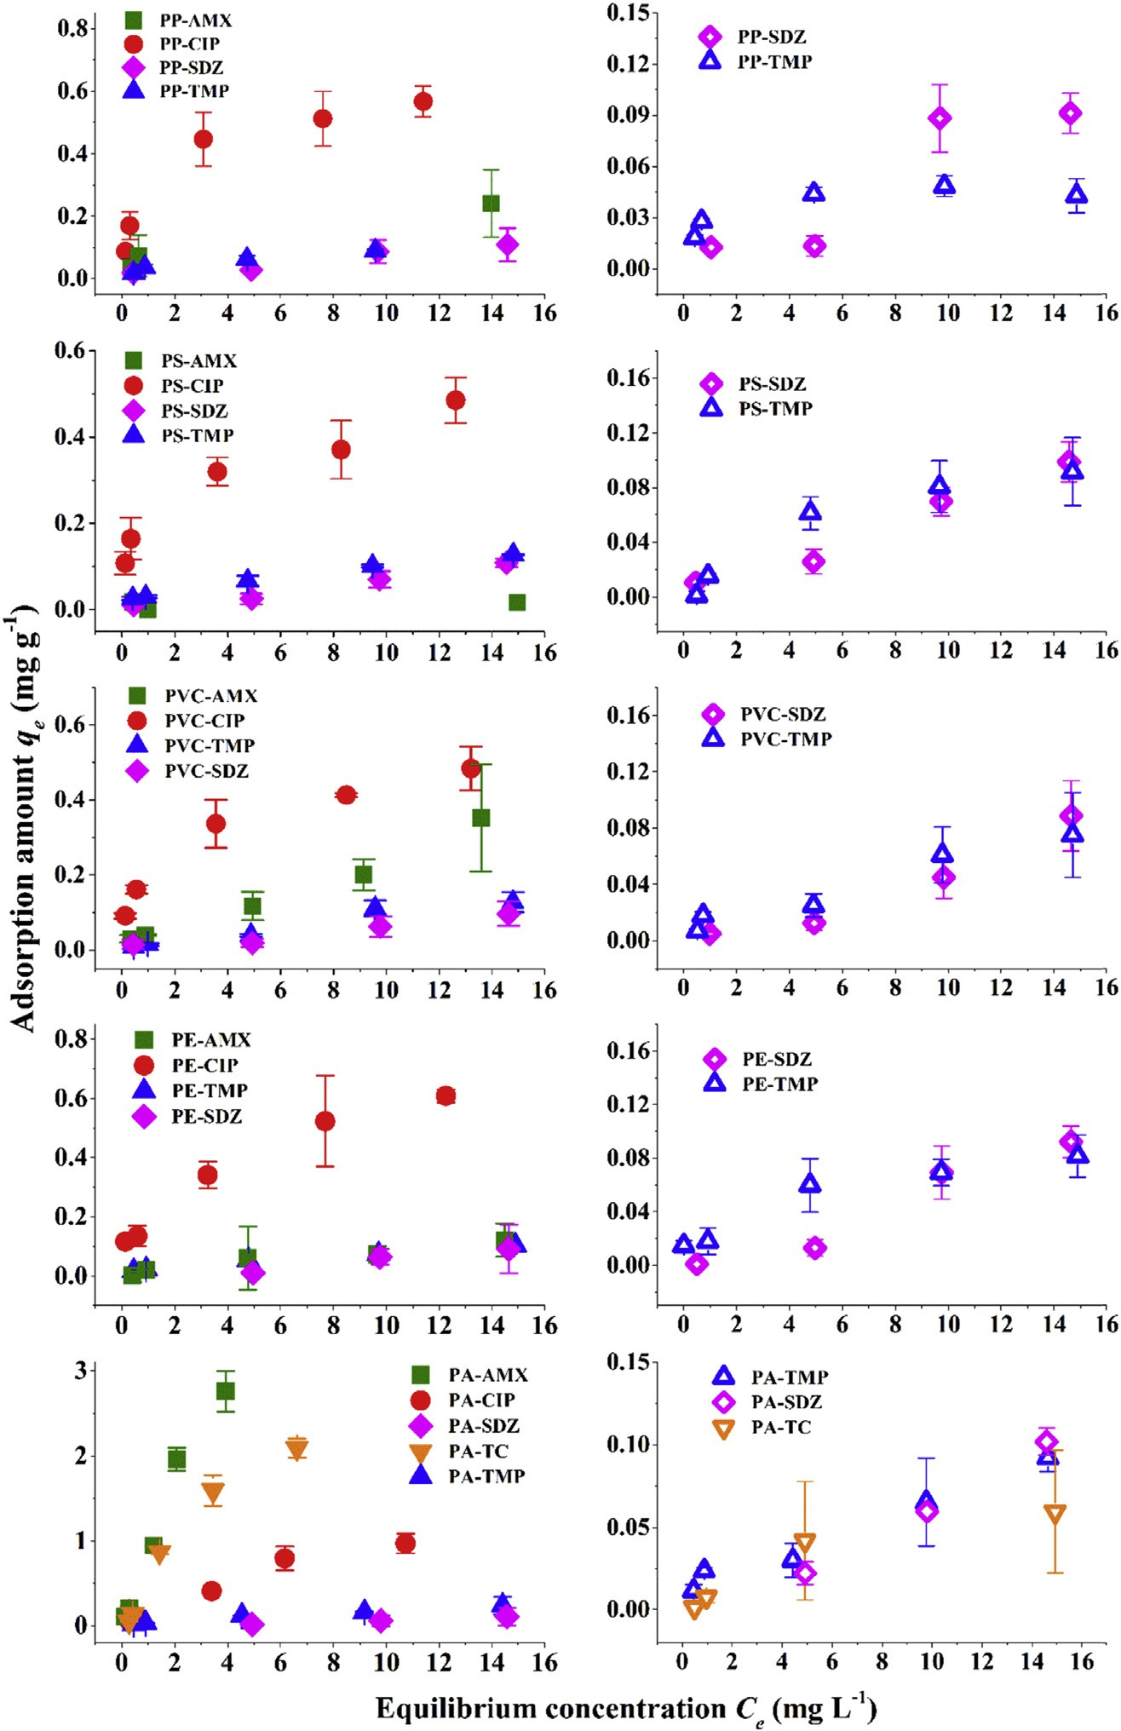

**Figure 5.** Adsorption of antibiotics on MPs in the freshwater system (left column) and in the seawater system (right column). Note: the values of qe less than 0 were not shown in this ﬁgure [136].

**9.5. Cyclodextrin (CD)**

Several works such as Taha et al. implied that CD was suitable material for covering the drugs for improving the profile of the drug release of different implant components [137]. The interesting property of CD was its potential in forming complexes with the drugs via its hydrophobic cavity. Additionally, in the case of drug delivery aspect, the CD can remarkably join to the implant plane and has good adaption with the multiple species of the drug because of its negatively charged reticulated architectures. In order to survey the ability of CD in adsorbing antibiotics, the work of Taha et al. in adsorption of tobramycin and rifampicin toward the Ti-HA and Ti-HA-MeβCD was studied in this section of this book.

**9.5.1. The Batch adsorption**

In order to perform the batch adsorption of antibiotics, the following cases were carried out:

a) Initially, Ti-HA and Ti-HA-MeβCD have been immersed in 50 mg/mL of tobramycin at a pH of 3.9 and in 60 mg/mL of rifampicin at a pH of 8.6 in the normal heat degree and mixed with the agitation speed of 160 rpm.

b) For evaluating both time and pH effect on the uptake capacity, time was tuned from 5 min to 24 h and the pH of tobramycin and rifampicin was adjusted in the range of 1.9-6.9 and 6-9.6, respectively.

c) Afterward, both adsorbents were isolated from the antibiotic solution and washed twice with the deionized water for discarding the non-absorbed drugs.

d) For conducting the desorption process, Ti-HA-MeβCD with its loaded antibiotics has been introduced into the sodium hydroxide with a certain concentration (0.1 N).

e) The content of the desorbed rifampicin was determined using spectrophotometry at 319 nm. Besides, the desorbed tobramycin was calculated via the reaction between the primary amines in the structure of tobramycin and 2-mercaptoethanol/o-phthaladehyde.

**9.5.2. Characterization of modified Ti-HA with raw Ti-HA**

Fig. 6a shows the TGA graph of the Ti-HA grafted to CD (Ti-HA-MeβCD). According to this figure, the primary drop of mass in the sorbent was observed at 150℃ which was due to the loss of water in CD. The other drop of mass was found in the temperature range of 250-500℃ which corresponded to the precipitation of CD. Thus, only % 0.61 of the mass drop was related to the fracturing of CD covering on Ti-HA. Fig. 6b is the FTIR graph of Ti-HA and Ti-HA-MeβCD. The bands of Ti-HA were 1023 Cm-1, 1087 Cm-1, and 962 Cm-1 which were related to the phosphate particles of HA. The additional bands in Ti-HA-MeβCD were mentioned including a) 1721 Cm-1 for stretching of C=O in ester groups, and b) 950-910 Cm-1 which was attributed to C-O stretching in alcohols, carboxylic acids, and esters, and c) 1320-1000 Cm-1 wavelength for ether groups. Also, Fig. 6c reveals the morphology of Ti-HA and Ti-HA-MeβCD. According to the morphology of Ti-HA, its surface contains pores in the range of micro with an almost loose architecture. Also, HA leads to forming both amorphous and crystalline covering on Ti-HA. While CD in Ti-HA-MeβCD caused forming smooth covering on the valleys of HA which makes it smoother than Ti-HA. But, the topology of Ti-HA-MeβCD was almost similar to the Ti-HA [146].

|  |
| --- |
| **(a)** |
| **(b)** |
| **(c)** |

**Figure 6.** The characterization of Ti-HA and Ti-HA-MeβCD. (a) TGA of Ti-HA and Ti-HA-MeβCD. (b) FTIR of Ti-HA and Ti-HA-MeβCD. c) The SEM of Ti-HA and Ti-HA-MeβCD(Ti–HA (A–C) and Ti–HA-MebCD (D–F) samples at magnification of 700x, 1000x, and 2000x, respectively) [146].

**9.5.3. Sorption comparison between Ti-HA and Ti-HA-MeβCD**

Figure 7 shows the adsorption potential of Ti-HA and Ti-HA-MeβCD toward the antibiotics such as tobramycin and rifampicin. With respect to this figure, the adsorption capacity of Ti-HA and Ti-HA-MeβCD for tobramycin has been determined 85 𝞵g/Cm2 and 595 𝞵g/Cm2, respectively. This result revealed that the inclusion of CD in the structure of Ti-HA has a remarkable effect on the penetration of tobramycin in the pores of the Ti-HA-MeβCD. Moreover, the adsorption capacity of Ti-HA-MeβCD for rifampicin has also greater amount than Ti-HA which was 283 𝞵g/Cm2 and 138 𝞵g/Cm2 for Ti-HA-MeβCD and Ti-HA, respectively. It appears that the Ti-HA-MeβCD has a lower impact in adsorbing the rifampicin, nevertheless, the adsorption capacity was 2-fold in the Ti-HA-MeβCD. Therefore, it is derived that the dispersion of CD in the network of Ti-HA can grow the adhesion of antibiotics on the surface of the sorbent.

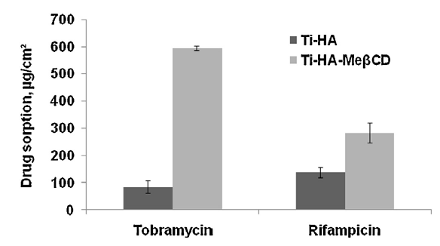

**Figure 7.** Comparison the effect of Ti-HA and Ti-HA-MeβCD in adsorption of two different antibiotics [146].

**9.5.4. pH effect**

Figure 8 shows the effect of pH on the adsorption capacity of both tobramycin and rifampicin. According to Fig. 8a, increasing the pH of the solution from 1.9 to 6.9 could contribute to the enhancement of tobramycin adsorption toward the Ti-HA-MeβCD from 375 𝞵g/Cm2 to 840 𝞵g/Cm2, respectively. This trend can be attributed to the transformation of the carboxylic particles into the carboxylate particles via pH increasing which caused bind formation between the carboxylate and amino moieties of the Ti-HA-MeβCD. Unlike tobramycin, pH growth was not promising for the adsorption of rifampicin onto the Ti-HA-MeβCD, because the adsorption capacity of rifampicin has decreased from 179 𝞵g/Cm2 in pH of 7.6 to 112 𝞵g/Cm2 in pH of 9.66 (Fig. 8b) which proved that the acid-base interactions were not participated in the diffusion of rifampicin onto the Ti-HA-MeβCD surface, because of the poor protonation of piperazinyl particles in the alkaline media. In another word, the complexation process between the piperazinyl of the rifampicin and CD in the Ti-HA-MeβCD was the main reason for the adsorption of this antibiotic toward the Ti-HA-MeβCD. The sorption mechanism of tobramycin and rifampicin has been illustrated in Scheme 1.

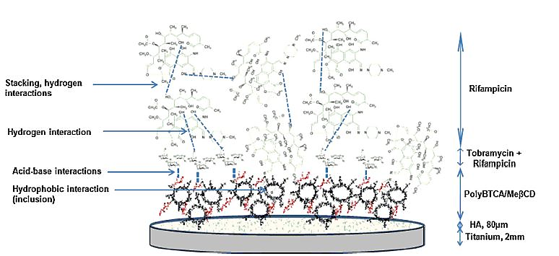

**Scheme 1.** Schematic exhibiting the interactions between poly $BTCA-MeβCD$ and Tobramycin, as well as between tobramycin and rifampicin in the dual impregnation RT procedure.

|  |
| --- |
| **(a)** |
| **(b)** |

**Figure 8.** The pH effect on the adsorption capacity of (a) tobramycin and (b) rifampicin [146].

**9.5.5. Kinetic and Isotherm studies**

The changes in the adsorption capacity of antibiotics with time have been drawn in Fig. 9. In this figure, it was observed that the adsorption capacity of tobramycin toward the Ti-HA-MeβCD reached the %65 of its saturation efficiency only after 5 min which was 600 𝞵g/Cm2. The saturation situation was found after 24 h which obtained 920 𝞵g/Cm2. In the case of rifampicin, it could penetrate the sorbent structure and reach the equilibrium state only in 5 min which was lesser than the equilibrium state of tobramycin. The uptake capability of rifampicin has been acquired at 280 𝞵g/Cm2 after 5 min. In contrast to tobramycin, rifampicin adsorption has decreased by time enhancement. However, both antibiotics have exhibited desired uptake capability in a short time (5 min).



**Figure 9.** The effect of time on the adsorption of two different antibiotics on the Ti-HA-MeβCD [146]**.**

Moreover, Fig. 10 displays the uptake changes of antibiotics with the concentration. According to Fig. 10a, increasing the concentration of tobramycin could enhance the uptake capability to 5 g/L, and after this value, the adsorption amount became relatively constant. Rifampicin showed against behavior. The adsorption capacity of rifampicin continuously increased with the concentration even after the 120 g/L (Fig. 10b). This case demonstrated the different mechanisms of antibiotics toward the Ti-HA-MeβCD. Also, diverse isotherm relations were employed for indicating the adsorption behavior. It was detected that the empirical data of tobramycin was accommodated with the Langmuir relation with the regression of 0.995 (Fig. 10c). Besides, Fig. 10d exhibited that the Freundlich relation had a favorable agreement with the experimental results of rifampicin with the suitable correlation (0.985). As a result, the adsorption of tobramycin and rifampicin was mono- and multi-layer, respectively.

|  |  |
| --- | --- |
| **(a)** | **(b)** |
| **(c)** | **(d)** |

**Figure 10.** The effect of concentration on the sorption capacity of (a) tobramycin, and (b) rifampicin. (c) The Langmuir graph of tobramycin. (d) The Freundlich graph of rifampicin [146].

**9.5.6. Effect of antibiotic mixture**

The combination of rifampicin with the other antibiotics was used in the vascular cases [147]. The combination of antibiotics can contribute to the adsorption capacity of antibiotics toward the adsorbents. Also, the arrangement of antibiotic inclusion is very important. For instance, Taha et al. were prepared three antibiotic solutions including: a) TR which means that the tobramycin first poured into the vessel and after rifampicin was added, b) RT which means that the rifampicin first poured into the vessel and after tobramycin was added, and c) R which means that the rifampicin was introduced into the vessel. Then, the Ti-HA-MeβCD was added to the TR, RT, and R solutions, and the sorbent stayed in the above three solutions for 5 min, and then the polluted Ti-HA-MeβCD was transported into the vessel containing 0.1N sodium hydroxide for the desorption test of the rifampicin and the results were shown in Fig. 11. According to this figure, TR solution has shown the highest adsorption capacity for rifampicin. In another word, the adsorption capacity of rifampicin in RT and TR solutions were 300 𝞵g/Cm2 and 700 𝞵g/Cm2, respectively.

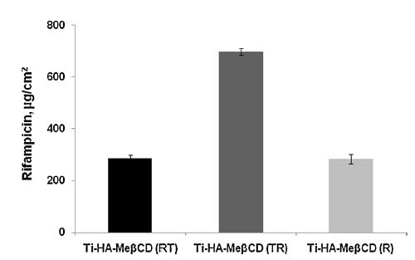

**Figure 11.** The adsorption capacity of rifampicin onto the Ti-HA-MeβCD in the three different antibiotic solutions [148].

**9.6. Polyethylenimine**

The materials containing the extra content of carbon groups and also with the low price of preparation have been recognized as the appropriate adsorbents [149]. The researchers still focus on detecting the adsorbents which are low-cost, and easily accessible with a high amount of carbons. Among these materials, polyethylene terephthalate (PET) was selected as the remarkable candidate. PET puts into the plastic group which has been synthesized via the combination of ethylene glycol and terephthalic acid as the precursors. These components are conventionally employed in the packaging and keeping the food, drugs, etc. It is reported that the amount of carbons in the activated carbon PET has been determined % 99 [150]. Additionally, PET possesses remarkable chemical features and is abundantly found in the ecosystem as solid waste. PET generated a serious threat and problem all over the world. For instance, 5.0 million tons of PET are observed only in India [151]. PET wastes can harm soil, water, and air via choking, leaching of pollutants, and releasing the carcinogens on burning, respectively. For solving this issue, the PET wastes can be converted into functional components for adsorbing the hazardous particles [152]. The activated carbon of PET is an effective material for adsorbing the contaminants because of possessing many pores with the size of the micro and high surface area. Cephalexin (CEX) puts into the classes of cephalosporin family of beta-lactam antibiotics which is typically applied for treatment the illness of people and animal because of its vast antimicrobial applications. CEX in the level of 𝞵g/L is dangerous for the aquatic ecosystem [153]. The full name of CEX is 7-[(aminophenylacetyl) amino]-3-methyl-8-oxo-5- thia-1-azabicyclo [4.2.0] oct-2-ene- 2-carboxylic acid, and its structure is shown in Fig. 12.

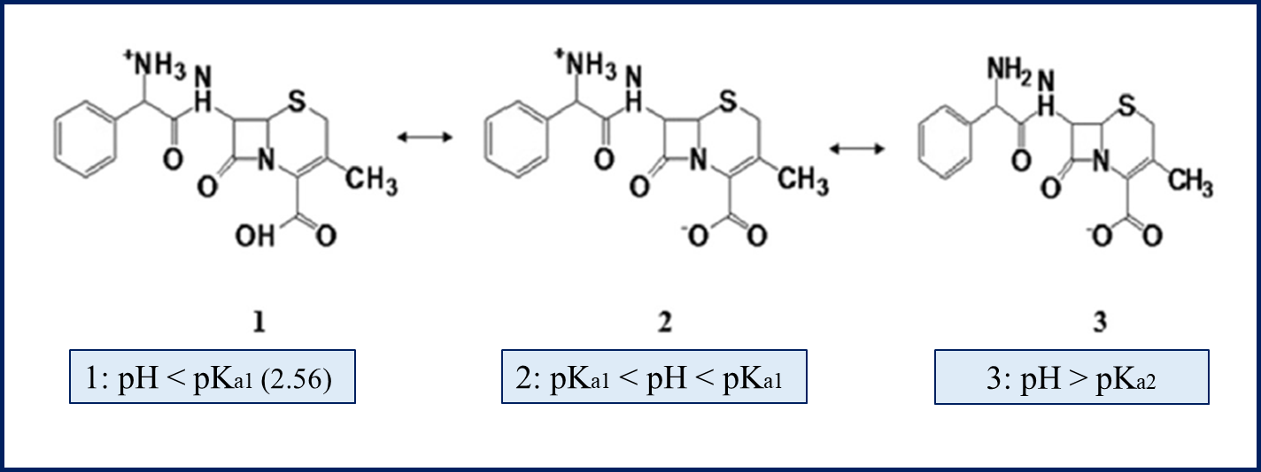

**Figure 12.** The chemical architecture of CEX [154].

**9.6.1. Preparation the activated carbon of PET (PETAC)**

The waste PET was provided by collecting the bottles and jars. Then, they were completely rinsed with deionized water for eliminating the dust particles. After, they were dried and cut into tiny pieces with the dimension of 2 ⨯ 2 Cm. Subsequently, the PET pieces were pyrolyzed by exposure to the nitrogen flow at a certain rate (200 Cm3/min) at 400℃ and stayed at this heat degree for 1h. After passing this duration, the heat degree has been elevated to 725℃ and retained for 2h. The carbonized coal became cold and sieved to a size of lesser than 0.15mm. In order to active the coal, the coal has been put into the muffle furnace. The activation was initiated in the existence of the nitrogen stream with the speed of 10 Cm3/min at 925℃ and kept this heat degree for 1h. Ultimately, the CO2 flow was blown to the material.

The researchers for enhancing the adsorption potential of PET proposed to modify them with the magnetic substances which are explained below.

**9.6.2. Modification with magnetic particles (M-PETAC)**

For modification of the activated carbon of PET, the following experiments should be conducted. Firstly, 0.50M FeCl3 was fabricated in the deionized water and 60mL of ethanol has been introduced to the iron solution. Afterward, 4g of PETAC was added to the solution and combined for 2h for penetrating the iron moieties into the architecture of PETAC. After the complete blend, 3M of sodium hydroxide has been added to the mixture for adjusting the pH to 8.0. This case fortifies the electrostatic attraction between the positive charges of the ferric hydroxide and negative charges of the PETAC surface. Then, 1M of NaBH4 has been added dropwise for the reduction of the iron atoms. Finally, the bead was rinsed with ethanol and dried at 80℃ for 30min. The modification of PETAC was drawn in Fig. 13.

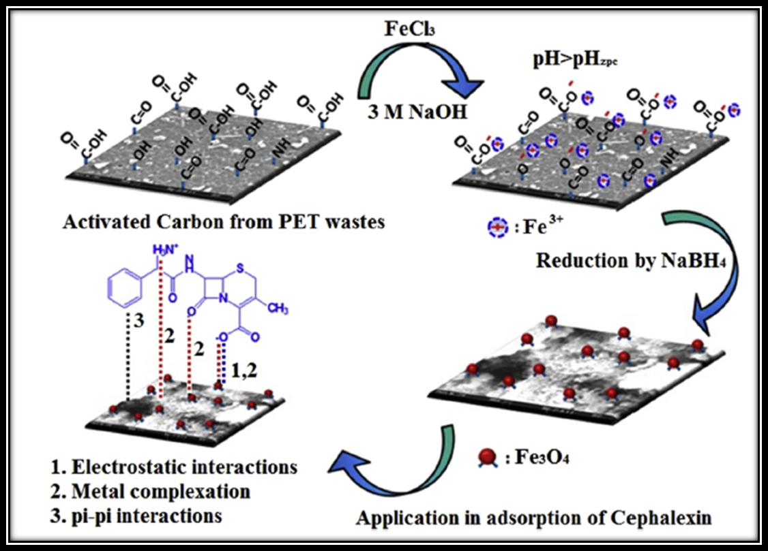

**Figure 13.** The synthesize of magnetic PETAC [154].

**9.6.3. Textural Characteristics**

Fig. 14a represents the N2 adsorption-desorption diagram for the PETAC and M-PETAC. Regarding these curves in Fig. 14a, the variation trend became constant at the high pressure ratio which demonstrates that the intrinsic of these sorbents was microporous. The BET surface area of PETAC and M-PETAC has been found 659.60 and 288.80 m2/g, respectively. The reason for this difference is ascribed to the distribution of Fe3O4 moieties in the PETAC network which led to a diminishing in the surface area. The total pore volume has also decreased in M-PETAC which were acquired at 0.36 and 0.17 Cm3/g for PETAC and M-PETAC, respectively, on account of blocking the pores with Fe3O4 moieties. Fig. 14b also confirmed the microporous nature of PETAC and M-PETAC, because the sharp peaks have been observed in the pore diameter of 1.4nm for both PETAC and M-PETAC. Fig. 14c illustrates the XRD diagram of the PETAC and M-PETAC. The peak of 002 in the PETAC is due to the presence of the graphene layers in this matrix. The 2θ of 29.72o, 35.24o, 42.80o, 56.68o and 62.58o, is ascribed to the crystalline mode of the iron oxide in the M-PETAC that are identified as 220, 311, 400, 511, and 440, respectively. Figs. 14 d&e display the Raman spectroscopy for both PETAC and M-PETAC, respectively. According to this figure, the two strong peaks were detected at 1350 Cm-1 and 1600 Cm-1 which correspond to the “disordered” or “D” band and “graphitic” or “G” band, respectively. Besides, the two poor peaks have been labeled as the 2D and D+G bands in the wavelength of 2680 Cm-1 and 2950 Cm-1, respectively. Moreover, a new band was observed in Fig. 14e which is owing to the stretching of Fe-O bind of iron oxide [150, 155-157]. The morphologies of PETAC and M-PETAC were brought in Figs. 15. With respect to Fig. 15a, the activated carbon of PET consists of several pores with disordered forms and sharp edges. Also, Fig. 15b proves that the surface of the PETAC is flat with a plurality of particles with the size of nano that occupied its surface homogeneously. The SEM images of M-PETAC (Figs. 15 c&d) indicate the almost rough or coarse structures of this bead because of the inclusion of the iron oxide moieties. Fig. 14f reveals the magnification property of the M-PETAC at the normal heat degree. The magnetic hysteresis loop has the shape of an S letter and the saturation magnification has been found 35.40 emu/g. Amplification at the origin of the graph showed a poor hysteresis implying the remanence magnetization value was 1.98 emu/g. Consequently, M-PETAC represents the ferromagnetic trend. The TGA diagrams of PETAC and M-PETAC were displayed in Fig. 14g and Fig. 14h, respectively, which proves the desired thermal resistance because the total mass drop has been observed at %13.42 for the PETAC and %9.02 for the M-PETAC. Also, the highest mass drop has been found in the primary step prior to 200℃ because of the water loss. The second mass drop was observed in the range of 200-600℃ which were %1.50 and %2.34 for the PETAC and M-PETAC, respectively. The third mass drop was found after the 600℃ for the PETAC which was %4.18. Additionally, several functional groups were found in the structure of PETAC and M-PETAC. The peak in the wavelength of 3400 Cm-1 for both sorbents was owing to the stretching of hydroxyl groups in the alcohol, phenol, and carboxylic acids. The intensive wavelength at 1634 Cm-1 corresponds to the stretching of C=C in the aromatic rings. The wavelength at 2850 Cm-1 and 2920 Cm-1 is ascribed to vibration of the methane groups. An intensive peak of medium wavelength at 1217 Cm-1 is owing to the stretched vibrations of C-O (epoxy) particles in PETAC and M-PETAC. Also, the wavelength of 613 Cm-1 is due to the vibration of Fe-O moieties in the M-PETAC.

|  |  |
| --- | --- |
| **(a)** | **(b)** |
| **(c)** | **(d)** |
| **(e)** | **(f)** |
| **(g)** | **(h)** |

**Figure 14.** The diagram of the (a) N2 adsorption-desorption, (b) Pore size distribution, (c) XRD diagram, (d) Raman spectroscopy of PETAC, (e) Raman spectroscopy of M-PETAC, (f) VSM diagram of M-PETAC, (g) TGA diagram of PETAC, and (h) TGA diagram of M-PETAC [154].

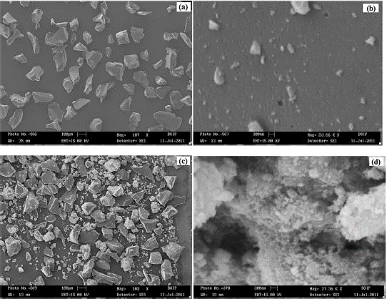

**Figure 15.** The SEM images of PETAC (a) 107X and (b) 23.66 kX. The SEM images of M-PETAC (c) 103X and (d) 27.36 kX[154].

**9.6.4. Isotherm and Kinetic Study**

The behavior of PETAC and M-PETAC for the adsorption of CEX has been shown in Fig. 16a. Regarding this figure, increasing the CEX concentration can progress the adsorption capacity of CEX. Of course, the growth of the adsorption capacity was limited to the certain CEX content and after this point, the adsorption capacity became constant because of filling the empty spaces of the adsorbents. With respect to the Giles system, the curves in Fig. 16a have been put into the classes of the Langmuir (L) adsorption isotherm. The L-curve proposed the chemical contact between the sorbate and sorbent. According to the isotherm results, both Langmuir and Freundlich relations have an appropriate agreement with the empirical data in the adsorption of the CEX by the PETAC. In the case of the M-PETAC, Langmuir was the best model. Besides, for both sorbents, the RL value has been determined in the range of 0 and 1 which implies the adsorption occurred suitably. The value of n in the Freundlich relation for the PETAC and M-PETAC was higher than one which proves the intensive interactions between the CEX and composite (Table 4). In terms of the adsorption capacity amount, M-PETAC revealed a greater adsorption capacity than the PETAC which indicates that the iron oxides act as the additional binding site. Fig. 16b displays the effect of time on the adsorption capacity of the CEX using PETAC and M-PETAC. The kinetic results said that the pseudo-second-order has been determined as the best model (Table 5). This model indicates that the chemical interaction is dominant over the adsorption such as the valence forces. The sorption speed (k2) for the M-PETAC is lower than the PETAC because of the lesser mesopore volume of the M-PETAC relative to the PETAC. However, the initial adsorption rate and half-life time for the M-PETAC was greater than the PETAC which demonstrates that the porosity is not the only main factor in estimating the adsorption amount. Besides, the diagram of the intraparticle in Fig. 16c shows that the intraparticle penetration is not the only rate-controlling stage, and film diffusion contributes to the process. The mechanism of the M-PETAC for the adsorption of the CEX returns to the three cases:

1. At a pH lower than pHZPC (6.80), more hydrogen ions occupied the surface of the adsorbent, and the charge of the M-PETAC becomes more positive while the CEX exists as a zwitterion. Therefore, the electrostatic interaction creates between the [M-PETAC]+ and the carboxylate moiety of the CEX [COO]-.
2. The other sorption factor is ascribed to the complexation between the iron ions and carboxylic and amine groups of the CEX.
3. The other case returns to the 𝛑-𝛑 attraction between the benzene ring of this antibiotic and the aromatic ring of the carbon matrix in the M-PETAC.

**Table 4.** The isotherm results of the CEX adsorption [154].

|  |  |  |  |  |  |  |  |
| --- | --- | --- | --- | --- | --- | --- | --- |
| ***Adsorbent*** | ***Langmuir*** | | |  | ***Freundlich*** | | |
| $$Qo (mg/g)$$ | $$b (L/mg)$$ | $$R^{2}$$ |  | $$k_{f}$$ | $$n$$ | $$R^{2}$$ |
| *PETAC* | 21.27 | 0.025 | 0.999 |  | 1.076 | 1.60 | 0.991 |
| *M-PETAC* | 71.42 | 0.057 | 0.967 |  | 7.06 | 1.82 | 0.934 |

|  |  |
| --- | --- |
| **(a)** | **(b)** |
| **(c)** | |

**Figure 16.** The effect of the (a) CEX concentration, (b) time on the adsorption of the CEX. (c) The intraparticle diffusion model [154].

**Table 5.** The kinetic results of the CEX adsorption [154].

|  |  |  |  |  |  |  |  |  |  |  |
| --- | --- | --- | --- | --- | --- | --- | --- | --- | --- | --- |
| **Adsorbent** | ***Pseudo-First-Order*** | | | | ***Pseudo-Second-Order*** | | | ***Intraparticle Diffusion*** | | |
|  | **k1 ⨯ 10-2** |  |  | **k2 ⨯ 10-3** |  |  | **C** |  |  |
| PETAC | 29.15 | 1.61 | 20.18 | 0.881 | 1.95 | 31.25 | 0.991 | 7.09 | 1.609 | 0.918 |
| M-PETAC | 49.39 | 1.15 | 33.26 | 0.938 | 1.29 | 50.00 | 0.990 | 10.71 | 2.753 | 0.901 |

نتیجه گیری

conclusion

**References**

[1] S. Webb, T. Ternes, M. Gibert, K. Olejniczak, Indirect human exposure to pharmaceuticals via drinking water, Toxicology letters, 142 (2003) 157-167.

[2] M.C. Tonucci, L.V.A. Gurgel, S.F. de Aquino, Activated carbons from agricultural byproducts (pine tree and coconut shell), coal, and carbon nanotubes as adsorbents for removal of sulfamethoxazole from spiked aqueous solutions: kinetic and thermodynamic studies, Industrial crops and products, 74 (2015) 111-121.

[3] M.B. Ahmed, J.L. Zhou, H.H. Ngo, W. Guo, Adsorptive removal of antibiotics from water and wastewater: progress and challenges, Science of the Total Environment, 532 (2015) 112-126.

[4] A. Göbel, A. Thomsen, C.S. McArdell, A. Joss, W. Giger, Occurrence and sorption behavior of sulfonamides, macrolides, and trimethoprim in activated sludge treatment, Environmental science & technology, 39 (2005) 3981-3989.

[5] T. Wang, S. Ai, Y. Zhou, Z. Luo, C. Dai, Y. Yang, J. Zhang, H. Huang, S. Luo, L. Luo, Adsorption of agricultural wastewater contaminated with antibiotics, pesticides and toxic metals by functionalized magnetic nanoparticles, Journal of environmental chemical engineering, 6 (2018) 6468-6478.

[6] A. Ahmad, J. Dutta, Ecotoxicological studies of cephalosporin antibiotics on Daphnia magna, Toxicol. Int, 25 (2018) 21-30.

[7] K. Kümmerer, Pharmaceuticals in the environment: sources, fate, effects and risks, Springer Science & Business Media, 2008.

[8] F. Baquero, J.-L. Martínez, R. Cantón, Antibiotics and antibiotic resistance in water environments, Current opinion in biotechnology, 19 (2008) 260-265.

[9] C.-H. Huang, J.E. Renew, K.L. Smeby, K. Pinkston, D.L. Sedlak, Assessment of potential antibiotic contaminants in water and preliminary occurrence analysis, Journal of contemporary water research and education, 120 (2011) 4.

[10] P. Westerhoff, Y. Yoon, S. Snyder, E. Wert, Fate of endocrine-disruptor, pharmaceutical, and personal care product chemicals during simulated drinking water treatment processes, Environmental science & technology, 39 (2005) 6649-6663.

[11] A. Osińska, M. Harnisz, E. Korzeniewska, Prevalence of plasmid-mediated multidrug resistance determinants in fluoroquinolone-resistant bacteria isolated from sewage and surface water, Environmental Science and Pollution Research, 23 (2016) 10818-10831.

[12] I. Michael, L. Rizzo, C. McArdell, C. Manaia, C. Merlin, T. Schwartz, C. Dagot, D. Fatta-Kassinos, Urban wastewater treatment plants as hotspots for the release of antibiotics in the environment: a review, Water research, 47 (2013) 957-995.

[13] H. Sanderson, R.A. Brain, D.J. Johnson, C.J. Wilson, K.R. Solomon, Toxicity classification and evaluation of four pharmaceuticals classes: antibiotics, antineoplastics, cardiovascular, and sex hormones, Toxicology, 203 (2004) 27-40.

[14] S. Liu, M. Pan, Z. Feng, Y. Qin, Y. Wang, L. Tan, T. Sun, Ultra-high adsorption of tetracycline antibiotics on garlic skin-derived porous biomass carbon with high surface area, New Journal of Chemistry, 44 (2020) 1097-1106.

[15] M. Rojewska, W. Smułek, E. Kaczorek, K. Prochaska, Langmuir Monolayer Techniques for the Investigation of Model Bacterial Membranes and Antibiotic Biodegradation Mechanisms, Membranes, 11 (2021) 707.

[16] J. Akhtar, N.A.S. Amin, K. Shahzad, A review on removal of pharmaceuticals from water by adsorption, Desalination and Water Treatment, 57 (2016) 12842-12860.

[17] M. Ahmed, B. Hameed, Removal of emerging pharmaceutical contaminants by adsorption in a fixed-bed column: a review, Ecotoxicology and Environmental Safety, 149 (2018) 257-266.

[18] Y. Patiño, E. Díaz, S. Ordóñez, E. Gallegos-Suarez, A. Guerrero-Ruiz, I. Rodríguez-Ramos, Adsorption of emerging pollutants on functionalized multiwall carbon nanotubes, Chemosphere, 136 (2015) 174-180.

[19] V. Rakić, V. Rac, M. Krmar, O. Otman, A. Auroux, The adsorption of pharmaceutically active compounds from aqueous solutions onto activated carbons, Journal of hazardous materials, 282 (2015) 141-149.

[20] D.J. De Ridder, J. Verberk, S.G. Heijman, G.L. Amy, J.C. Van Dijk, Zeolites for nitrosamine and pharmaceutical removal from demineralised and surface water: mechanisms and efficacy, Separation and purification technology, 89 (2012) 71-77.

[21] A. Alsbaiee, B.J. Smith, L. Xiao, Y. Ling, D.E. Helbling, W.R. Dichtel, Rapid removal of organic micropollutants from water by a porous β-cyclodextrin polymer, nature, 529 (2016) 190-194.

[22] V. Lozano-Morales, I. Gardi, S. Nir, T. Undabeytia, Removal of pharmaceuticals from water by clay-cationic starch sorbents, Journal of Cleaner Production, 190 (2018) 703-711.

[23] M.R. Azhar, H.R. Abid, H. Sun, V. Periasamy, M.O. Tadé, S. Wang, Excellent performance of copper based metal organic framework in adsorptive removal of toxic sulfonamide antibiotics from wastewater, Journal of colloid and interface science, 478 (2016) 344-352.

[24] J. Dutta, A.A. Mala, Removal of antibiotic from the water environment by the adsorption technologies: A review, Water Science and Technology, 82 (2020) 401-426.

[25] Y.M. Awad, S.-C. Kim, A. El-Azeem, A. Samy, K.-H. Kim, K.-R. Kim, K. Kim, C. Jeon, S.S. Lee, Y.S. Ok, Veterinary antibiotics contamination in water, sediment, and soil near a swine manure composting facility, Environmental earth sciences, 71 (2014) 1433-1440.

[26] L.K. Sharma, N. Nyola, S. Kant, G. Jeyabalan, Stability indicating RP-HPLC method for the Ceftaroline Fosamil, Hygeia: Journal for Drugs and Medicines, 5 (2013) 97-103.

[27] C. Rodríguez-Navas, E. Björklund, S.A. Bak, M. Hansen, K.A. Krogh, F. Maya, R. Forteza, V. Cerdà, Pollution pathways of pharmaceutical residues in the aquatic environment on the island of Mallorca, Spain, Archives of environmental contamination and toxicology, 65 (2013) 56-66.

[28] M. Caniça, V. Manageiro, H. Abriouel, J. Moran-Gilad, C.M. Franz, Antibiotic resistance in foodborne bacteria, Trends in Food Science & Technology, 84 (2019) 41-44.

[29] E.C. Lima, Removal of emerging contaminants from the environment by adsorption, Ecotoxicology and environmental safety, 150 (2018) 1-17.

[30] N.J. Vickers, Animal communication: when i’m calling you, will you answer too?, Current biology, 27 (2017) R713-R715.

[31] V. Diwan, A.J. Tamhankar, M. Aggarwal, S. Sen, R.K. Khandal, C.S. Lundborg, Detection of antibiotics in hospital effluents in India, Current Science, (2009) 1752-1755.

[32] M. Ashfaq, K.N. Khan, S. Rasool, G. Mustafa, M. Saif-Ur-Rehman, M.F. Nazar, Q. Sun, C.-P. Yu, Occurrence and ecological risk assessment of fluoroquinolone antibiotics in hospital waste of Lahore, Pakistan, Environmental toxicology and pharmacology, 42 (2016) 16-22.

[33] J.E. Sosa-Hernández, L.I. Rodas-Zuluaga, I.Y. López-Pacheco, E.M. Melchor-Martínez, Z. Aghalari, D.S. Limón, H.M. Iqbal, R. Parra-Saldívar, Sources of antibiotics pollutants in the aquatic environment under SARS-CoV-2 pandemic situation, Case studies in chemical and environmental engineering, 4 (2021) 100127.

[34] F. Zhou, Y u T, Du R, Fan G, Liu Y, Liu Z, et al. Clinical course and risk factors for mortality of adult inpatients with COVID19 in Wuhan, China: a retrospective cohort study, Lancet, 395 (2020) 1054-1062.

[35] M. Usman, M. Farooq, K. Hanna, Environmental side effects of the injudicious use of antimicrobials in the era of COVID-19, Science of the Total Environment, 745 (2020) 141053.

[36] S.D. Comber, M. Upton, S. Lewin, N. Powell, T.H. Hutchinson, COVID-19, antibiotics and One Health: a UK environmental risk assessment, Journal of Antimicrobial Chemotherapy, 75 (2020) 3411-3412.

[37] M. Malik, M.J. Tahir, R. Jabbar, A. Ahmed, R. Hussain, Self-medication during Covid-19 pandemic: challenges and opportunities, Drugs & Therapy Perspectives, 36 (2020) 565-567.

[38] S. Arshad, P. Kilgore, Z.S. Chaudhry, G. Jacobsen, D.D. Wang, K. Huitsing, I. Brar, G.J. Alangaden, M.S. Ramesh, J.E. McKinnon, Treatment with hydroxychloroquine, azithromycin, and combination in patients hospitalized with COVID-19, International journal of infectious diseases, 97 (2020) 396-403.

[39] A. Pani, M. Lauriola, A. Romandini, F. Scaglione, Macrolides and viral infections: focus on azithromycin in COVID-19 pathology, International journal of antimicrobial agents, 56 (2020) 106053.

[40] J. Feng, R. Liu, P. Chen, S. Yuan, D. Zhao, J. Zhang, Z. Zheng, Degradation of aqueous 3, 4-dichloroaniline by a novel dielectric barrier discharge plasma reactor, Environmental Science and Pollution Research, 22 (2015) 4447-4459.

[41] S.S. Placide, B. Mohamed, L.E.M. Hélène, A.F.T. Auguste, G.C. Quand-Meme, I. Sanogo, L. Ouattara, Assessment of the Physicochemical and Microbiological Parameters of a Teaching Hospital’s Wastewaters in Abidjan in Côte d’Ivoire, Journal of Water Resource and Protection, 8 (2016) 1251-1265.

[42] Y. Gao, Y. Li, L. Zhang, H. Huang, J. Hu, S.M. Shah, X. Su, Adsorption and removal of tetracycline antibiotics from aqueous solution by graphene oxide, Journal of colloid and interface science, 368 (2012) 540-546.

[43] P. Välitalo, A. Kruglova, A. Mikola, R. Vahala, Toxicological impacts of antibiotics on aquatic micro-organisms: a mini-review, International Journal of Hygiene and Environmental Health, 220 (2017) 558-569.

[44] W.C. Li, Occurrence, sources, and fate of pharmaceuticals in aquatic environment and soil, Environmental pollution, 187 (2014) 193-201.

[45] L. Tong, S. Huang, Y. Wang, H. Liu, M. Li, Occurrence of antibiotics in the aquatic environment of Jianghan Plain, central China, Science of the Total Environment, 497 (2014) 180-187.

[46] A. Bridle, P. Crosbie, K. Cadoret, B. Nowak, Rapid detection and quantification of Neoparamoeba perurans in the marine environment, Aquaculture, 309 (2010) 56-61.

[47] K. Klaus, Antibiotics in the aquatic environment–A review–Part II, Chemosphere, 75 (2009) 435-441.

[48] S. Zhou, X. Li, Y. Shi, A. Alshameri, C. Yan, Preparation, characterization, and Ce (III) adsorption performance of poly (allylamine)/silica composite, Desalination and Water Treatment, 56 (2015) 1321-1334.

[49] J.P. Fry, D.C. Love, G.K. MacDonald, P.C. West, P.M. Engstrom, K.E. Nachman, R.S. Lawrence, Environmental health impacts of feeding crops to farmed fish, Environment international, 91 (2016) 201-214.

[50] R. Gothwal, T. Shashidhar, Antibiotic pollution in the environment: a review, Clean–Soil, Air, Water, 43 (2015) 479-489.

[51] Y. Ma, M. Li, M. Wu, Z. Li, X. Liu, Occurrences and regional distributions of 20 antibiotics in water bodies during groundwater recharge, Science of the Total Environment, 518 (2015) 498-506.

[52] K. Chen, J. Zhou, Occurrence and behavior of antibiotics in water and sediments from the Huangpu River, Shanghai, China, Chemosphere, 95 (2014) 604-612.

[53] Y. Bai, W. Meng, J. Xu, Y. Zhang, C. Guo, Occurrence, distribution and bioaccumulation of antibiotics in the Liao River Basin in China, Environmental Science: Processes & Impacts, 16 (2014) 586-593.

[54] A.T. Vo, E. Van Duijkeren, W. Gaastra, A.C. Fluit, Antimicrobial resistance, class 1 integrons, and genomic island 1 in Salmonella isolates from Vietnam, PloS one, 5 (2010) e9440.

[55] P. Guerra, M. Kim, A. Shah, M. Alaee, S. Smyth, Occurrence and fate of antibiotic, analgesic/anti-inflammatory, and antifungal compounds in five wastewater treatment processes, Science of the Total Environment, 473 (2014) 235-243.

[56] A. Pena, M. Paulo, L. Silva, M. Seifrtová, C. Lino, P. Solich, Tetracycline antibiotics in hospital and municipal wastewaters: a pilot study in Portugal, Analytical and bioanalytical chemistry, 396 (2010) 2929-2936.

[57] R. Zhang, J. Tang, J. Li, Q. Zheng, D. Liu, Y. Chen, Y. Zou, X. Chen, C. Luo, G. Zhang, Antibiotics in the offshore waters of the Bohai Sea and the Yellow Sea in China: occurrence, distribution and ecological risks, Environmental Pollution, 174 (2013) 71-77.

[58] M.J. Bernot, L. Smith, J. Frey, Human and veterinary pharmaceutical abundance and transport in a rural central Indiana stream influenced by confined animal feeding operations (CAFOs), Science of the total environment, 445 (2013) 219-230.

[59] Y.C.Y.Y.Z. JL, Liu M. Nie MH Shi H, Environ. Pollut, 175 (2013) 22-29.

[60] L. Jiang, X. Hu, D. Yin, H. Zhang, Z. Yu, Occurrence, distribution and seasonal variation of antibiotics in the Huangpu River, Shanghai, China, Chemosphere, 82 (2011) 822-828.

[61] N. Collado, S. Rodriguez-Mozaz, M. Gros, A. Rubirola, D. Barceló, J. Comas, I. Rodriguez-Roda, G. Buttiglieri, Pharmaceuticals occurrence in a WWTP with significant industrial contribution and its input into the river system, Environmental pollution, 185 (2014) 202-212.

[62] M.D. Machado, E.V. Soares, Impact of erythromycin on a non-target organism: Cellular effects on the freshwater microalga Pseudokirchneriella subcapitata, Aquatic Toxicology, 208 (2019) 179-186.

[63] Q. Xiong, L.-X. Hu, Y.-S. Liu, T.-T. Wang, G.-G. Ying, New insight into the toxic effects of chloramphenicol and roxithromycin to algae using FTIR spectroscopy, Aquatic Toxicology, 207 (2019) 197-207.

[64] M. Ågerstrand, C. Berg, B. Björlenius, M. Breitholtz, B.r. Brunström, J. Fick, L. Gunnarsson, D.J. Larsson, J.P. Sumpter, M. Tysklind, Improving environmental risk assessment of human pharmaceuticals, Environmental Science & Technology, 49 (2015) 5336-5345.

[65] M. Arslan, T. Timocin, H.B. Ila, In vitro potential cytogenetic and oxidative stress effects of roxithromycin, Drug and Chemical Toxicology, 40 (2017) 463-469.

[66] X.-X. Zhang, T. Zhang, H.H. Fang, Antibiotic resistance genes in water environment, Applied microbiology and biotechnology, 82 (2009) 397-414.

[67] H. Gelband, P. Miller, Molly, S. Pant, S. Gandra, J. Levinson, D. Barter, A. White, R. Laxminarayan, The state of the world's antibiotics 2015, Wound healing southern africa, 8 (2015) 30-34.

[68] K. Kemp, J. Griffiths, S. Campbell, K. Lovell, An exploration of the follow-up up needs of patients with inflammatory bowel disease, Journal of Crohn's and Colitis, 7 (2013) e386-e395.

[69] S. Augusto, C. Máguas, J. Matos, M.J. Pereira, C. Branquinho, Lichens as an integrating tool for monitoring PAH atmospheric deposition: a comparison with soil, air and pine needles, Environmental Pollution, 158 (2010) 483-489.

[70] E. Zuccato, S. Castiglioni, R. Bagnati, M. Melis, R. Fanelli, Source, occurrence and fate of antibiotics in the Italian aquatic environment, Journal of hazardous materials, 179 (2010) 1042-1048.

[71] P. Amouzgar, B. Salamatinia, A short review on presence of pharmaceuticals in water bodies and the potential of chitosan and chitosan derivatives for elimination of pharmaceuticals, J. Mol. Genet. Med, 4 (2015).

[72] S.K. Bajpai, M. Bajpai, N. Rai, Sorptive removal of ciprofloxacin hydrochloride from simulated wastewater using sawdust: Kinetic study and effect of pH, Water Sa, 38 (2012) 673-682.

[73] H. Zheng, Z. Wang, J. Zhao, S. Herbert, B. Xing, Sorption of antibiotic sulfamethoxazole varies with biochars produced at different temperatures, Environmental Pollution, 181 (2013) 60-67.

[74] J. Baltazar, J. Falcão de Campos, An iteratively coupled solution of the cavitating flow on marine propellers using BEM, Journal of Hydrodynamics, 22 (2010) 796-801.

[75] Y. Yu, W. Wang, J. Shi, S. Zhu, Y. Yan, Enhanced levofloxacin removal from water using zirconium (IV) loaded corn bracts, Environmental Science and Pollution Research, 24 (2017) 10685-10694.

[76] J.L.d.A.A. Ferraz, L.O. Souza, G.A. Soares, J.P. Coutinho, J.R. de Oliveira, E. Aguiar-Oliveira, M. Franco, Enzymatic saccharification of lignocellulosic residues using cellulolytic enzyme extract produced by Penicillium roqueforti ATCC 10110 cultivated on residue of yellow mombin fruit, Bioresource technology, 248 (2018) 214-220.

[77] W. Liu, J. Zhang, C. Zhang, L. Ren, Sorption of norfloxacin by lotus stalk-based activated carbon and iron-doped activated alumina: mechanisms, isotherms and kinetics, Chemical Engineering Journal, 171 (2011) 431-438.

[78] M. Ek, C. Baresel, J. Magnér, R. Bergström, M. Harding, Activated carbon for the removal of pharmaceutical residues from treated wastewater, Water Science and Technology, 69 (2014) 2372-2380.

[79] E.-S.I. El-Shafey, H. Al-Lawati, A.S. Al-Sumri, Ciprofloxacin adsorption from aqueous solution onto chemically prepared carbon from date palm leaflets, Journal of Environmental Sciences, 24 (2012) 1579-1586.

[80] H. Yao, J. Lu, J. Wu, Z. Lu, P.C. Wilson, Y. Shen, Adsorption of fluoroquinolone antibiotics by wastewater sludge biochar: role of the sludge source, Water, Air, & Soil Pollution, 224 (2013) 1-9.

[81] G. Moussavi, A. Alahabadi, K. Yaghmaeian, M. Eskandari, Preparation, characterization and adsorption potential of the NH4Cl-induced activated carbon for the removal of amoxicillin antibiotic from water, Chemical engineering journal, 217 (2013) 119-128.

[82] Y. Chao, W. Zhu, J. Chen, P. Wu, X. Wu, H. Li, C. Han, S. Yan, Development of novel graphene-like layered hexagonal boron nitride for adsorptive removal of antibiotic gatifloxacin from aqueous solution, Green Chemistry Letters and Reviews, 7 (2014) 330-336.

[83] M.J. Ahmed, S.K. Theydan, Fluoroquinolones antibiotics adsorption onto microporous activated carbon from lignocellulosic biomass by microwave pyrolysis, Journal of the Taiwan Institute of Chemical Engineers, 45 (2014) 219-226.

[84] N. Genc, Removal of antibiotic ciprofloxacin hydrochloride from water by kandira stone: kinetic models and thermodynamic, Global NEST Journal, 17 (2015) 498-507.

[85] J. Shang, X. Kong, L. He, W. Li, Q. Liao, Low-cost biochar derived from herbal residue: characterization and application for ciprofloxacin adsorption, International journal of environmental science and technology, 13 (2016) 2449-2458.

[86] S. Yadav, N. Goel, V. Kumar, K. Tikoo, S. Singhal, Removal of fluoroquinolone from aqueous solution using graphene oxide: experimental and computational elucidation, Environmental Science and Pollution Research, 25 (2018) 2942-2957.

[87] X. Kong, Y. Liu, J. Pi, W. Li, Q. Liao, J. Shang, Low-cost magnetic herbal biochar: characterization and application for antibiotic removal, Environmental Science and Pollution Research, 24 (2017) 6679-6687.

[88] M. Dehghani, S. Nasseri, M. Ahmadi, M.R. Samaei, A. Anushiravani, Removal of penicillin G from aqueous phase by Fe+ 3-TiO2/UV-A process, Journal of Environmental Health Science and Engineering, 12 (2014) 1-7.

[89] O. dos Santos Escobar, C.F. de Azevedo, A. Swarowsky, M.A. Adebayo, M.S. Netto, F.M. Machado, Utilization of different parts of Moringa oleifera Lam. seeds as biosorbents to remove Acid Blue 9 synthetic dye, Journal of Environmental Chemical Engineering, 9 (2021) 105553.

[90] S. Xiancai, L. Dongfang, Z. Lejun, Adsorption mechanisms and impact factors of oxytetracycline on activated sludge, in: IOP Conference Series: Earth and Environmental Science, IOP Publishing, 2017, pp. 012068.

[91] A.H. Panahi, S.D. Ashrafi, H. Kamani, M. Khodadadi, E.C. Lima, F.K. Mostafapour, A.H. Mahvi, Removal of cephalexin from artificial wastewater by mesoporous silica materials using Box-Behnken response surface methodology, Desalin Water Treat, 159 (2019) 169-180.

[92] D.F. Caicedo, G.S. dos Reis, E.C. Lima, I.A. De Brum, P.S. Thue, B.G. Cazacliu, D.R. Lima, A.H. dos Santos, G.L. Dotto, Efficient adsorbent based on construction and demolition wastes functionalized with 3-aminopropyltriethoxysilane (APTES) for the removal ciprofloxacin from hospital synthetic effluents, Journal of Environmental Chemical Engineering, 8 (2020) 103875.

[93] P. Liao, Z. Zhan, J. Dai, X. Wu, W. Zhang, K. Wang, S. Yuan, Adsorption of tetracycline and chloramphenicol in aqueous solutions by bamboo charcoal: a batch and fixed-bed column study, Chemical engineering journal, 228 (2013) 496-505.

[94] Y. Zhuang, F. Yu, J. Ma, J. Chen, Graphene as a template and structural scaffold for the synthesis of a 3D porous bio-adsorbent to remove antibiotics from water, Rsc Advances, 5 (2015) 27964-27969.

[95] A.C. Martins, O. Pezoti, A.L. Cazetta, K.C. Bedin, D.A. Yamazaki, G.F. Bandoch, T. Asefa, J.V. Visentainer, V.C. Almeida, Removal of tetracycline by NaOH-activated carbon produced from macadamia nut shells: kinetic and equilibrium studies, Chemical Engineering Journal, 260 (2015) 291-299.

[96] S. Zha, x.; Zhou, Y.; Jin, X.; Chen, Z, J. Environ. Manage, 129 (2013) 569.

[97] J.-M. Lv, Y.-L. Ma, X. Chang, S.-B. Fan, Removal and removing mechanism of tetracycline residue from aqueous solution by using Cu-13X, Chemical Engineering Journal, 273 (2015) 247-253.

[98] H. Pouretedal, N. Sadegh, Effective removal of amoxicillin, cephalexin, tetracycline and penicillin G from aqueous solutions using activated carbon nanoparticles prepared from vine wood, Journal of Water Process Engineering, 1 (2014) 64-73.

[99] A. Boukhelkhal, O. Benkortbi, M. Hamadeche, S. Hanini, A. Amrane, Removal of amoxicillin antibiotic from aqueous solution using an anionic surfactant, Water, Air, & Soil Pollution, 226 (2015) 1-12.

[100] A.A. Babaei, E.C. Lima, A. Takdastan, N. Alavi, G. Goudarzi, M. Vosoughi, G. Hassani, M. Shirmardi, Removal of tetracycline antibiotic from contaminated water media by multi-walled carbon nanotubes: operational variables, kinetics, and equilibrium studies, Water Science and Technology, 74 (2016) 1202-1216.

[101] A. Takdastan, A.H. Mahvi, E.C. Lima, M. Shirmardi, A.A. Babaei, G. Goudarzi, A. Neisi, M. Heidari Farsani, M. Vosoughi, Preparation, characterization, and application of activated carbon from low-cost material for the adsorption of tetracycline antibiotic from aqueous solutions, Water Science and Technology, 74 (2016) 2349-2363.

[102] A. Esnouf, É. Latrille, J.-P. Steyer, A. Helias, Representativeness of environmental impact assessment methods regarding Life Cycle Inventories, Science of the Total Environment, 621 (2018) 1264-1271.

[103] Z.w. Zeng, S.r. Tian, Y.g. Liu, X.f. Tan, G.m. Zeng, L.h. Jiang, Z.h. Yin, N. Liu, S.b. Liu, J. Li, Comparative study of rice husk biochars for aqueous antibiotics removal, Journal of Chemical Technology & Biotechnology, 93 (2018) 1075-1084.

[104] F. Rostamkhani, H. Zardooz, S. Zahediasl, B. Farrokhi, Comparison of the effects of acute and chronic psychological stress on metabolic features in rats, Journal of Zhejiang university science B, 13 (2012) 904-912.

[105] E. Lacaze, J. Pédelucq, M. Fortier, P. Brousseau, M. Auffret, H. Budzinski, M. Fournier, Genotoxic and immunotoxic potential effects of selected psychotropic drugs and antibiotics on blue mussel (Mytilus edulis) hemocytes, Environmental Pollution, 202 (2015) 177-186.

[106] J. Wu, H. Zhao, R. Chen, C. Pham-Huy, X. Hui, H. He, Adsorptive removal of trace sulfonamide antibiotics by water-dispersible magnetic reduced graphene oxide-ferrite hybrids from wastewater, Journal of Chromatography B, 1029 (2016) 106-112.

[107] P. Liu, Q. Wang, C. Zheng, C. He, Sorption of sulfadiazine, norfloxacin, metronidazole, and tetracycline by granular activated carbon: kinetics, mechanisms, and isotherms, Water, Air, & Soil Pollution, 228 (2017) 1-14.

[108] Y. Lu, M. Jiang, C. Wang, Y. Wang, W. Yang, Effects of matrix and functional groups on tylosin adsorption onto resins and carbon nanotubes, Water, Air, & Soil Pollution, 224 (2013) 1-12.

[109] A. Fakhri, S. Behrouz, Comparison studies of adsorption properties of MgO nanoparticles and ZnO–MgO nanocomposites for linezolid antibiotic removal from aqueous solution using response surface methodology, Process Safety and Environmental Protection, 94 (2015) 37-43.

[110] D. Balarak, F.K. Mostafapour, Canola residual as a biosorbent for antibiotic metronidazole removal, The Pharmaceutical and Chemical Journal, 3 (2016) 12-17.

[111] M. Li, D. Wei, Y. Du, Genotoxicity of quinolone antibiotics in chlorination disinfection treatment: formation and QSAR simulation, Environmental Science and Pollution Research, 23 (2016) 20637-20645.

[112] P.M. Budd, N.B. McKeown, D. Fritsch, Free volume and intrinsic microporosity in polymers, Journal of Materials Chemistry, 15 (2005) 1977-1986.

[113] P.M. Budd, K.J. Msayib, C.E. Tattershall, B.S. Ghanem, K.J. Reynolds, N.B. McKeown, D. Fritsch, Gas separation membranes from polymers of intrinsic microporosity, Journal of Membrane Science, 251 (2005) 263-269.

[114] N.B. McKeown, P.M. Budd, Polymers of intrinsic microporosity (PIMs): organic materials for membrane separations, heterogeneous catalysis and hydrogen storage, Chemical Society Reviews, 35 (2006) 675-683.

[115] M. Heuchel, D. Fritsch, P.M. Budd, N.B. McKeown, D. Hofmann, Atomistic packing model and free volume distribution of a polymer with intrinsic microporosity (PIM-1), Journal of Membrane Science, 318 (2008) 84-99.

[116] B. Satilmis, P.M. Budd, T. Uyar, Systematic hydrolysis of PIM-1 and electrospinning of hydrolyzed PIM-1 ultrafine fibers for an efficient removal of dye from water, Reactive and Functional Polymers, 121 (2017) 67-75.

[117] P. Kaur, J. Hupp, S. Nguyen, ACS Catal., 2011, 1, 819–835;(e) NB McKeown and PM Budd, Chem. Soc. Rev, 35 (2006) 675-683.

[118] N.B. McKeown, The synthesis of polymers of intrinsic microporosity (PIMs), Science China Chemistry, 60 (2017) 1023-1032.

[119] M.N. Alnajrani, O.A. Alsager, Removal of antibiotics from water by polymer of intrinsic microporosity: Isotherms, kinetics, thermodynamics, and adsorption mechanism, Scientific reports, 10 (2020) 1-14.

[120] M.J. Lobão, C. Palos, P. Sousa, Antimicrobial Resistance and COVID-19, Lusiadas Scientific Journal, 2 (2021) 92-93.

[121] J. McGuinty, A. Li, S. Damiani, C. Sun, PIM-1: A Novel Approach to the Extraction of Antibiotics from Waste-water, SURJ Q e Queen’s Science, (2021) 16.

[122] H. Ye, C. Zhang, C. Huo, B. Zhao, Y. Zhou, Y. Wu, S. Shi, Advances in the Application of Polymers of Intrinsic Microporosity in Liquid Separation and Purification: Membrane Separation and Adsorption Separation, Polymer Reviews, 61 (2021) 239-279.

[123] R.C. Thompson, C.J. Moore, F.S. Vom Saal, S.H. Swan, Plastics, the environment and human health: current consensus and future trends, Philosophical transactions of the royal society B: biological sciences, 364 (2009) 2153-2166.

[124] J.R. Jambeck, R. Geyer, C. Wilcox, T.R. Siegler, M. Perryman, A. Andrady, R. Narayan, K.L. Law, Plastic waste inputs from land into the ocean, Science, 347 (2015) 768-771.

[125] S. Zhao, L. Zhu, D. Li, Microplastic in three urban estuaries, China, Environmental Pollution, 206 (2015) 597-604.

[126] H.A. Nel, P.W. Froneman, A quantitative analysis of microplastic pollution along the south-eastern coastline of South Africa, Marine pollution bulletin, 101 (2015) 274-279.

[127] M.A. Browne, P. Crump, S.J. Niven, E. Teuten, A. Tonkin, T. Galloway, R. Thompson, Accumulation of microplastic on shorelines woldwide: sources and sinks, Environmental science & technology, 45 (2011) 9175-9179.

[128] V. Hidalgo-Ruz, L. Gutow, R.C. Thompson, M. Thiel, Microplastics in the marine environment: a review of the methods used for identification and quantification, Environmental science & technology, 46 (2012) 3060-3075.

[129] T. Hüffer, T. Hofmann, Sorption of non-polar organic compounds by micro-sized plastic particles in aqueous solution, Environmental pollution, 214 (2016) 194-201.

[130] D. Brennecke, B. Duarte, F. Paiva, I. Caçador, J. Canning-Clode, Microplastics as vector for heavy metal contamination from the marine environment, Estuarine, Coastal and Shelf Science, 178 (2016) 189-195.

[131] Y. Yang, W. Liu, C. Xu, B. Wei, J. Wang, Antibiotic resistance genes in lakes from middle and lower reaches of the Yangtze River, China: effect of land use and sediment characteristics, Chemosphere, 178 (2017) 19-25.

[132] Q.-Q. Zhang, G.-G. Ying, C.-G. Pan, Y.-S. Liu, J.-L. Zhao, Comprehensive evaluation of antibiotics emission and fate in the river basins of China: source analysis, multimedia modeling, and linkage to bacterial resistance, Environmental science & technology, 49 (2015) 6772-6782.

[133] W. Li, Y. Shi, L. Gao, J. Liu, Y. Cai, Occurrence of antibiotics in water, sediments, aquatic plants, and animals from Baiyangdian Lake in North China, Chemosphere, 89 (2012) 1307-1315.

[134] J.-S. Lin, H.-Y. Pan, S.-M. Liu, H.-T. Lai, Effects of light and microbial activity on the degradation of two fluoroquinolone antibiotics in pond water and sediment, Journal of Environmental Science and Health Part B, 45 (2010) 456-465.

[135] W. Xu, W. Yan, X. Li, Y. Zou, X. Chen, W. Huang, L. Miao, R. Zhang, G. Zhang, S. Zou, Antibiotics in riverine runoff of the Pearl River Delta and Pearl River Estuary, China: concentrations, mass loading and ecological risks, Environmental Pollution, 182 (2013) 402-407.

[136] J. Li, K. Zhang, H. Zhang, Adsorption of antibiotics on microplastics, Environmental Pollution, 237 (2018) 460-467.

[137] F. Wang, K.M. Shih, X.Y. Li, The partition behavior of perfluorooctanesulfonate (PFOS) and perfluorooctanesulfonamide (FOSA) on microplastics, Chemosphere, 119 (2015) 841-847.

[138] M. Kanda, T. Nakajima, H. Hayashi, T. Hashimoto, S. Kanai, C. Nagano, Y. Matsushima, Y. Tateishi, S. Yoshikawa, Y. Tsuruoka, Multi-residue determination of polar veterinary drugs in livestock and fishery products by liquid chromatography/tandem mass spectrometry, Journal of AOAC International, 98 (2015) 230-247.

[139] E.L. Teuten, J.M. Saquing, D.R. Knappe, M.A. Barlaz, S. Jonsson, A. Björn, S.J. Rowland, R.C. Thompson, T.S. Galloway, R. Yamashita, Transport and release of chemicals from plastics to the environment and to wildlife, Philosophical transactions of the royal society B: biological sciences, 364 (2009) 2027-2045.

[140] X. Guo, X. Wang, X. Zhou, X. Kong, S. Tao, B. Xing, Sorption of four hydrophobic organic compounds by three chemically distinct polymers: role of chemical and physical composition, Environmental science & technology, 46 (2012) 7252-7259.

[141] A. Antony, R. Fudianto, S. Cox, G. Leslie, Assessing the oxidative degradation of polyamide reverse osmosis membrane—accelerated ageing with hypochlorite exposure, Journal of Membrane Science, 347 (2010) 159-164.

[142] J.R. Pils, D.A. Laird, Sorption of tetracycline and chlortetracycline on K-and Ca-saturated soil clays, humic substances, and clay− humic complexes, Environmental science & technology, 41 (2007) 1928-1933.

[143] A. Turner, L.A. Holmes, Adsorption of trace metals by microplastic pellets in fresh water, Environmental chemistry, 12 (2015) 600-610.

[144] M. Zbyszewski, P.L. Corcoran, Distribution and degradation of fresh water plastic particles along the beaches of Lake Huron, Canada, Water, Air, & Soil Pollution, 220 (2011) 365-372.

[145] C. Tizaoui, S.B. Fredj, L. Monser, Polyamide-6 for the removal and recovery of the estrogenic endocrine disruptors estrone, 17β-estradiol, 17α-ethinylestradiol and the oxidation product 2-hydroxyestradiol in water, Chemical Engineering Journal, 328 (2017) 98-105.

[146] M. Taha, F. Chai, N. Blanchemain, C. Neut, M. Goube, M. Maton, B. Martel, H.F. Hildebrand, Evaluation of sorption capacity of antibiotics and antibacterial properties of a cyclodextrin-polymer functionalized hydroxyapatite-coated titanium hip prosthesis, International journal of pharmaceutics, 477 (2014) 380-389.

[147] I. Javerliat, O. Goëau-Brissonnière, V. Sivadon-Tardy, M. Coggia, J.-L. Gaillard, Prevention of Staphylococcus aureus graft infection by a new gelatin-sealed vascular graft prebonded with antibiotics, Journal of vascular surgery, 46 (2007) 1026-1031.

[148] M. Taha, F. Chai, N. Blanchemain, M. Goube, B. Martel, H.F. Hildebrand, Validating the poly-cyclodextrins based local drug delivery system on plasma-sprayed hydroxyapatite coated orthopedic implant with toluidine blue O, Materials Science and Engineering: C, 33 (2013) 2639-2647.

[149] J.M. Dias, M.C. Alvim-Ferraz, M.F. Almeida, J. Rivera-Utrilla, M. Sánchez-Polo, Waste materials for activated carbon preparation and its use in aqueous-phase treatment: a review, Journal of environmental management, 85 (2007) 833-846.

[150] J.B. Parra, C.O. Ania, A. Arenillas, F. Rubiera, J.J. Pis, J.M. Palacios, Structural changes in polyethylene terephthalate (PET) waste materials caused by pyrolysis and CO2 activation, Adsorption Science & Technology, 24 (2006) 439-450.

[151] R. Joshi, S. Ahmed, Status and challenges of municipal solid waste management in India: A review, Cogent Environmental Science, 2 (2016) 1139434.

[152] M.C. Almazán-Almazán, M. Pérez-Mendoza, M. Domingo-García, I. Fernández-Morales, F.J. López, F.J. López-Garzón, The influence of the process conditions on the characteristics of activated carbons obtained from PET de-polymerisation, Fuel processing technology, 91 (2010) 236-242.

[153] K. Singh, Pharmaceuticals in wastewater of Ghaziabad, CSIR network project report, Indian Institute of Toxicology Research, Lucknow, (2010).

[154] P. Rai, K.P. Singh, Valorization of Poly (ethylene) terephthalate (PET) wastes into magnetic carbon for adsorption of antibiotic from water: Characterization and application, Journal of environmental management, 207 (2018) 249-261.

[155] S. Kennethe, W. Sing, D. Everett, R. Haul, L. Moscou, R. Pierotti, J. Rouquerol, T. Siemieniewska, Reporting Physisorption Data for Gas/Solid Systems, Pure & App. Chem, 57 (1985) 603-619.

[156] S. Asuha, S. Zhao, H. Wu, L. Song, O. Tegus, One step synthesis of maghemite nanoparticles by direct thermal decomposition of Fe–urea complex and their properties, Journal of Alloys and Compounds, 472 (2009) L23-L25.

[157] M. Pimenta, G. Dresselhaus, M.S. Dresselhaus, L. Cancado, A. Jorio, R. Saito, Studying disorder in graphite-based systems by Raman spectroscopy, Physical chemistry chemical physics, 9 (2007) 1276-1290.