Baryon Spectroscopy three-body problem

Abstract
We present the non-relativistic quark model for light and strange baryons providing a unified description of their ground states and excitation spectra. Interacting potential form between quarks inside a baryon is taken to be proportional and obtain the energy spectra for the baryons, the three-body wave equation is solved to calculate the resonance states of the 𝑁, Δ, Λ, and Σ baryon systems. Finally the theoretical predictions are found in close agreement with experimental data and Cornell potential results.

1. Introduction
There are several important works that deal with the calculation of the energy levels of baryons. One of the most important ones is the pioneering work of Gasiorowicz and Rosner [23] which has calculation of baryon energy levels and magnetic moments of baryons using approximate wave functions. Another important work is that of Isgur and Karl [24] which strongly suggests that non-relativistic quantum mechanics can be used in the calculation of baryon spectra. The constituent quarks are considered to be good effective degrees of freedom for the hadron structure, in particular explaining the nucleon magnetic moment based on the spin flavor symmetry of the light quarks and low-lying energy spectra of the heavy quarkonia by quark excitations in the linear-plus-Coulomb confinement potential. The successful picture of the baryon spectrum was one of the most striking of the early achievements of the quark model and its precursors based on unitary symmetries [25]. In the present paper we follow some previous authors and study the baryons by solving the three-body problem [1-5]. An analytical solution was provided in case of harmonic and non-harmonic potentials for a system consist of three identical particles [6, 7]. Some authors have used the Cornell potential (Coulomb-type plus linear term) to study the resonance states of 𝑁 and Δ baryons [8–14].

2. Applied theoretical methods
Using the non-relativistic Hamiltonian and Schrödinger equation$Hψ(r)=Eψ(r)$ for a three particles with different masses is presented as

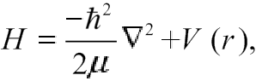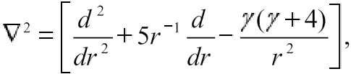
(1)
$\left[-\frac{ℏ^{2}}{2m_{1}}\left.∇_{r_{1}}^{2}-\frac{ℏ^{2}}{2m_{2}}∇_{r_{2}}^{2}-\frac{ℏ^{2}}{2m_{3}}∇_{r_{3}}^{2}\right.+V_{12}\left(r_{12}\right)+V_{23}\left(r_{23}\right)+V_{31}(r_{31}) \right]Ψ \left( r_{1 },r_{2},r_{3}\right)=EΨ \left( r_{1 },r_{2},r_{3}\right)$ (2)

We have to separate the center of mass from the relative coordinates using the Jacobi coordinates which are defined as [27,28]:

$\vec{R}=\frac{m_{1}{\vec{r}}_{1}+m_{2}{\vec{r}}_{2}+m_{3}{\vec{r}}_{3}}{M}, \vec{ρ}$₌$c_{1}\left({\vec{r}}_{1}-{\vec{r}}_{2}\right) and \vec{λ}=c_{2}\left(\frac{m_{1}{\vec{r}}_{1}+m_{2}{\vec{r}}_{2}}{M^{\acute{'}}}-{\vec{r}}_{3}\right)$ (3)
Where $M=m_{1}+m_{2}+m_{3}$; $M^{'}=m_{1}+m_{2}$; $c_{1}, c_{2}:constan$

Using natural units (h=C=1) and letting the coefficient of $∇_{ρ}^{2}$ and $∇_{λ}^{2}$ be equal to 𝐴, therefore, Schrödinger equation can be separated into the following two equations

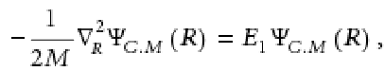 (4)
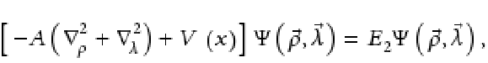 (5)

Where
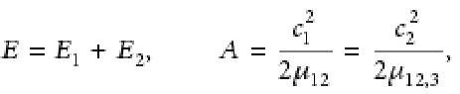 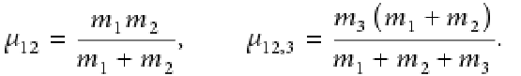 (6)

If Ψ𝛾(𝑥) and 𝑌𝛾(Ω) are nominated as the hyper radial part of the wave function and the hyper spherical harmonic function, $the wave function ψ(\vec{ρ},\vec{λ})$ can be shown as [8, 16, 17]

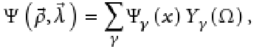 (7)
The symbol 𝛾 is called the grand angular quantum number and is given by

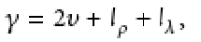 (8)

where 𝑙𝜌 and 𝑙𝜆 are the angular momenta associated with the 𝜌 and 𝜆 variables and 𝜐 is a nonnegative integer number. The hyper-radius 𝑥 is given as

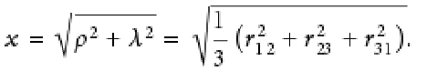 (9)
The potential (𝑥) can be assumed to depend on the hyper radius 𝑥 and 𝑒 space wave function is factored similar to the central potential [8].
Equation (5) can be rewritten as
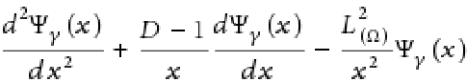 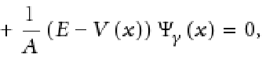 (10)

Where 𝐷 represents the dimension of the $\vec{x}$ and $L^{2}$(Ω) is the angular momentum operator whose eigenfunctions are [6, 9,11]
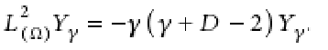 (11)
Now, applying the following transformation and new boundary conditions,
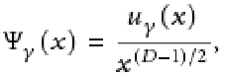 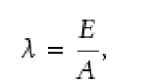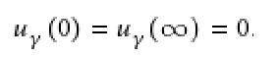 (12)
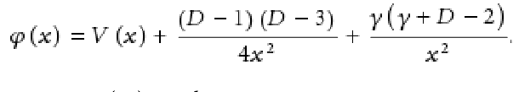 (13)
Considering D=6, using equation (12), equation (10) can be rewritten as

$\frac{d^{2}u_{γ(x)}}{dx^{2}}+2μ\left\{E-V\left(x\right)-\frac{\left(2γ+5\right)\left(2γ+3\right)}{8μx^{2}}\right\}u_{γ}\left(x\right)=0$ (14)

In this work, the potential interaction is assumed as

$$V\left(x\right)=-\frac{τ}{x}+κx^{2}+\frac{ε}{x^{3}}+c (15)$$

We suppose the following form for the wave function

$u_{γ}\left(x\right)=g\left(x\right)exp⁡[f\left(x\right)]$ (16)

For the functions f (r) and g (r) we make use of the ansatz [30-31]:

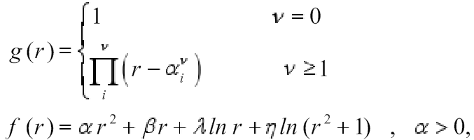 (17)

From equation (16) and (17) and r to x replacement we got

$u_{γ}\left(x\right)=\left\{f^{"}\left(x\right)+f^{'2}\left(x\right)+\frac{2f\left(x\right)g^{'}\left(x\right)+g^{"}\left(x\right)}{g\left(x\right)}\right\}u_{γ}(x)$ (18)

Using (17) and its derivations in (18) we have:

$u_{γ}^{"}\left(x\right)=\left\{4α\left({αx}^{2}+λ+2η+\frac{1}{2}+βx\right)+β^{2}+\frac{λ\left(1-λ\right)}{x^{2}}+\frac{2βλ}{x}+\frac{4η^{2}+4λη-2η-8αη+4ηβx}{x^{2}+1}+\frac{4η\left(1-η\right)}{(x^{2}+1)^{2}}\right\} u_{γ}(x)$

(19)
Replacing (19), (15), (13) in equation (14) we obtain and compare with Schrödinger equation :

E= λ (4α+1) + 8αη + 2α +$β^{2}$ , (20)
Because E depends on applied potential coefficients indirectly, we can earn M numerically or utilizing Spin , iso-Spin interactions or angular momentum system to correct the answers.

3. Spin dependent corrections
A simple dynamical calculation gives an estimate for the mass differences within the super-multiple. As an example SU(3)-violating matrix elements for decay into baryon are given by two parameters. First, we will estimate the mass differences among the members, arising from the medium-strong violations of SU(3), using a method similar to that employed by Dashen and Frautschi to calculate the mass splitting in the baryon octet and decuplet. we change the masses of the baryon octet (B), decuplet (Δ) and in an SU(3) symmetric way and look for the resulting first-order change. We can parametrize these octet changes by the coefficients a and b that appear in the Gell-Mann-Okubo.
Mass formula: $M=M_{0}+aY+b[I\left(I+1\right)-\frac{1}{4}Y^{2}]$ (21)
This mass formula has tested to be successful in the description of the ground state baryon masses, however, as stated by the authors themselves, it is not the most general mass formula that can be written on the basis of a broken SU (6) symmetry. Glashow has conjectured6 that the coefficients a and b which appear in the Gell-Mann-Okubo mass formula are the same for all supermultiplets with the same baryon number. One will note that our values for a35 and b36 are numerically very close to the values of a and b for the baryon octet. Finally, determining mo so that the I=5/2 , Y = 1 member of the 35 has the mass (1560 MeV) of the observed$p π^{+}π^{+}$ peak assuming it is a J =I=5/2 state, we obtain the masses given in Table I, where we also list the decomposition of the 35 into (Y,I) states. We define a partial width as $Γ={\left|M\right|}^{2}ρ$. Here, p is a factor which includes phase-space and orbital-angular-momentum barrier factors. A possible choice for p would be $ρ∝q[{q^{2}}/{(q^{2}{+μ}^{2}})]^{l}$
, μ is an appropriate interaction radius. The matrix element
$\left|M^{2}\right|=\left|γ^{2}\right|×\left|{Clebsch-Gordan coefficients }^{2}\right|$.
(22)
For example, the width of the Y = 1, I=5/2 state is estimated by Abers et al. to be ≈200 MeV, which seems to be compatible with experiment. The width of the Y=-1, I=3/2 state will be ≈100 MeV, since the Q value for the πΞ* decay is about the same as that of the Y = 1, I=5/2 state, whereas $\left|M^{2}\right|$ is≈ ${\left|γ^{2}\right|}/2$ compared to $\left|γ^{2}\right|$ [33].
In another view we can rewrite the equation (21) like below in correction mode.
(23)
Giannini and et al considered dynamical spin- flavor symmetry ${SU}_{SF}$(6) [9] and described the ${SU}_{SF}$(6) symmetry breaking mechanism by generalizing equation (21) as:

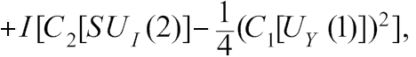 (24)

$CC_{2}\left[SU_{s}\left(2\right)\right]$ represents the spin-spin interactions, the flavor term $BC_{2}[SU_{F}\left(3\right)]$ Is the flavor dependence of the interactions, $SU_{SF}(6)$ in $AC_{2}[SU_{SF}\left(6\right)]$ depends on the permutation symmetry of the wave function. The last two terms $I[C_{2}\left[SU_{I}\left(2\right)\right]-1/4({C_{1}\left[U_{γ}\left(1\right)\right]}^{2}]$ shows the isospin and hypercharge dependence of the masses. In table 1, the Casimir operators ${SU}_{SF}$(6) and ${SU}_{F}$(3) for the allowed three-quark configurations are presented.

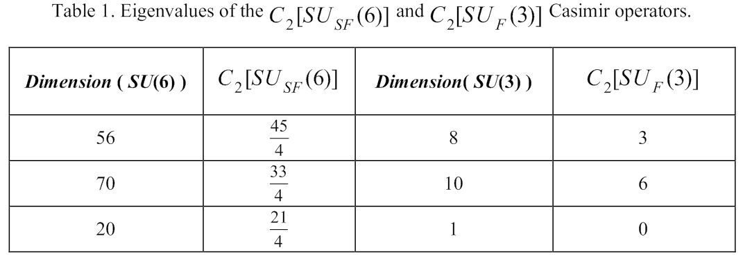
Table 1: eigenvalues of the ${C_{2}SU}_{SF}$(6) and ${C_{2}SU}_{F}$(3) Casimir operators.

The generalized Gürsey Radicati mass formula equation(24) can be used to describe the octet and decuplet baryons spectrum, provided that two conditions are fulfilled. The first condition is the feasibility of using the same splitting coefficients for different SU (6) multiplets. This seems actually to be the case, as shown by the algebraic approach to the baryon spectrum [1]. The second condition is given by the feasibility of getting reliable values for the unperturbed mass values M0 [26]. For this purpose we regarded the SU (6) invariant part of the hCQM, which provides a good description of the baryon spectrums and used the Gürsey Radicati inspired SU (6) breaking interaction to describe the splitting within each SU (6) multiplet. Therefore, the baryons masses are obtained by three quark masses and the Eigen energies E of the radial Schrödinger equation with the expectation values of $H_{GR}$ as follows:

$〈H_{GR}〉=AC_{2}\left[SU_{SF}\left(6\right)\right]+BC_{2}\left[SU_{F}\left(3\right)\right]+CC_{2}\left[SU_{s}\left(2\right)\right]+DC_{1}\left[U_{γ}\left(1\right)\right]+I[C_{2}\left[SU_{I}\left(2\right)\right]-1/4({C_{1}\left[U_{γ}\left(1\right)\right]}^{2}]$ (25)

M is the reduced mass: $M=m_{1}+m_{2}+m_{3}+E+〈H_{GR}〉$ (26)

In order to simplify the solving procedure, the constituent quarks masses are assumed to be same for Up, Down and Strange quark flavors ${m=m}_{u}=m_{d}=m_{s}$

$M=3m+E+AC_{2}\left[SU_{SF}\left(6\right)\right]+BC_{2}\left[SU_{F}\left(3\right)\right]+CC_{2}\left[SU_{s}\left(2\right)\right]+DC_{1}\left[U_{γ}\left(1\right)\right]+I[C_{2}\left[SU_{I}\left(2\right)\right]-1/4({C_{1}\left[U_{γ}\left(1\right)\right]}^{2}]$
(27)
3. Result and conclusion
Therefore, within this approximation, the SU (6) symmetry is only broken dynamically by the spin and flavor dependent terms in the Hamiltonian. We determined E by exact solution of the radial Schrödinger equation for the hyper central Potential equation (15). For calculating the baryons mass according to equation (27), we need to find the unknown parameters. For this purpose we choose a limited number of well-known resonances and express their mass differences using$H_{GR}$ and the Casimir operator expectation values:
N (1650)S 11 − N (1535)S 11= 3C , 4N (938)P11 - Σ(1193)P11−3Λ(1116)P 01 = 4D,
(Σ 1193)P11−Λ(1116)P 01= 2I . Leading to the numerical values: C = 38.3, D = -197.3 MeV and
I = 38.5 MeV. For determining m,α , β , d and η (in equation (20)) and the two coefficients A and B of equation (24) we have used the Newton-Raphson Method for solving the nonlinear equations. For our purpose we chose N (938) P11, Δ (1232) P33, Λ (1116) P01, Σ (1193) P11 , Λ (1810) P01, Δ (1700) D33 and Σ (1940) D13 which yielded the best reproduction (the maximum percentage of relative error is 0.33 %), then by solving seven nonlinear equations with seven unknown parameters we calculated the free parameters (m,α , β , d, η , A, B).The fitted parameters are reported in Table 2. The corresponding numerical values for 3 and 4 star baryons resonances are given in Tables 3 and 4, column $M_{our calculation}$ In Tables 3 and 4, column $M_{[35]calc}$, we’ve shown the numerical values of the calculated masses of baryon resonances by Giannini and et al, where they regarded the confinement potential as the Cornell potential. The solution of the hyper central the dynamic symmetry O (7) of the hyper Coulomb problem to obtain the hyper Coulomb Hamiltonian and Eigen functions analytically and also they regarded the linear term as a perturbation. Comparison Schrödinger equation with this potential cannot be obtained analytically [10], therefore Giannini and et al used between our results and the experimental masses [9] show that our model has improved the results of model in Ref [10], particularly in Λ (1810), Λ (2110) F05, Λ*(1405) S01, Λ*(1520) D01, Δ (1905) F35, Δ (1910) P31,Δ (1920) P33 and Σ (1775) D15 (refer to Tables 3 and 4.These improvements in reproduction of baryons resonance masses obtained by using a suitable form for confinement potential and exact analytical solution of the radial Schrödinger equation for our proposed potential. The percentage of relative error for our calculations is between 0 and 10 % (column 7, in Table 3 and 4). The corresponding numerical values for some of 1 and 2 star baryons resonances mass up to 2.1 GeV are given in Table 5, column $M_{our calc}$. The percentage of relative error for our calculations is between 0.07 and 9 % (column 6, in Table 5).
Parameter | A | B | C | D | I | m | α | β | d | η
Value | -19.616  MeV | 18.575  MeV | 38.3 | -197.3  MeV | 38.5  MeV | 272  MeV | -0.380  MeV 2 | 0.491 | 0.390 | 0.448

Table 2: Obtained values of parameters in equation (27) for N, Δ, Λ, Σ baryns, with resonances mass differences and global fit to the experimental resonance masses [34]

The coefficients τ and α are adjusted to fit the charmonium spectrum, but with the assumption that, it should be valid for all other heavy quarkonia. As such, the flavor dependence should arise solely from the mass of the bound quarks. However it has been found to be questionable about the numbers of free parameters and numbers of findings in any Potential Model. The success of a Phenomenological Model depends on reducing the free model parameters to obtain more precise values with proper arguments and analysis.

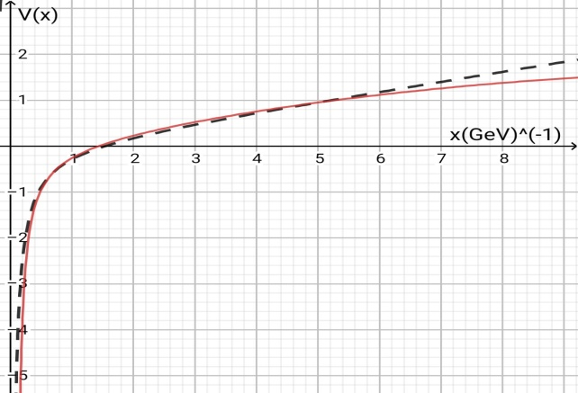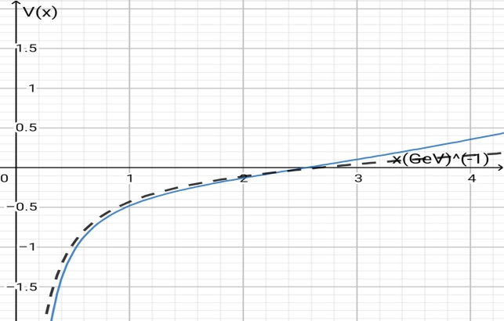
Cornell potential ----
Suggested potential
Figure 1: V(x) and Cornell potential Figure 2

In Figure 2, we show the variation of V (r) with the variation of model parameters α, β, c

Baryon | Status | M [9] Exp | State | M [35] Ca lc | M Our Ca lc | Percent of relative error for Our Calculation
N(938) P11 | **** | 938 | 281/2[56, 0+] | 938 | 938 | 0%
N(1535) S11 | **** | 1525-1545 | 281/2[70, 1-] | 1543.7 | 1538.79 | 0.90% - 0.40%
N(1650) S11 | **** | 1645-1670 | 481/2[70, 1-] | 1658.6 | 1643.69 | 0.07% - 1.57%
N(1700) D13 | *** | 1650-1750 | 483/2[70, 1-] | 1658.6 | 1643.69 | 0.38% - 6.07%
N(1710) P11 | *** | 1680-1740 | 281/2[56, 0+] | 1795.4 | 1786.16 | 6.31% - 2.65%
N(1720) P13 | **** | 1700-1750 | 283/2[56, 2+] | 1651.4 | 1678.57 | 1.26% - 4.08%
N(2190) G17 | **** | 2100-2200 | 287/2[70, 3-] | … | 2154.86 | 2.61% -2.05%
N(2220) H19 | **** | 2200-2300 | 289/2[56, 4+] | … | 2216.64 | 0.75% - 3.62%
Δ (1600) P33 | *** | 1500-1700 | 4103/2[56, 0+] | 1683 | 1669.35 | 11.29% - 1.80%
Δ (1620) S31 | **** | 1600-1660 | 2101/2[70, 1-] | 1722.8 | 1705.01 | 6.56% - 2.71%
Δ (1905) F35 | **** | 1855-1910 | 4105/2[56, 2+] | 1945.4 | 1893.85 | 2.09% - 0.84%
Δ (1910) P31 | **** | 1860-1910 | 4101/2[56, 2+] | 1945.4 | 1896.48 | 1.96% - 0.70%
Δ (1920) P33 | *** | 1900-1970 | 4103/2[56, 0+] | 2089.4 | 1975.62 | 3.98% - 0.28%
Δ (1930) D35 | *** | 1900-2000 | 2105/2[70, 2−] | … | 1951.97 | 2.73% - 2.40%
Δ (1950) D35 | **** | 1915-1950 | 4107/2[56, 2+] | 1945.4 | 1965.44 | 2.63% - 0.79%
Δ (2420) H3, 11 | **** | 2300-2500 | 41011/2[56,4+] | … | 2487.51 | 8.15% - 0.49%
Table 3: Mass spectrum of baryons resonances (in MeV) calculated with the mass formula equation (27)
Baryon | Status | M [9] Exp | State | M [35] Ca lc | M Our Ca lc | Percent of relative error for Our Calculation
Λ (1690)D03 | **** | 1685-1695 | 283/2[70, 1-] | 1721.7 | 1706.62 | 1.28%- 0.68%
Λ (1800)S01 | *** | 1720-1850 | 481/2[70, 1-] | 1836.6 | 1841.37 | 7.05% - 0.46%
Λ (1810)P01 | *** | 1750-1850 | 281/2[70, 0+] | 1973.4 | 1756.94 | 0.39% - 5.03%
Λ (1820) F05 | **** | 1815-1825 | 285/2[56, 2+] | 1829.4 | 1879.59 | 3.55% - 2.99%
Λ (1830)D05 | **** | 1810-1830 | 485/2[70, 1-] | 1836.6 | 1831.81 | 1.20% - 0.09%
Λ (2350) H09 | *** | 2340-2370 | 289/2[56, 4+] | … | 2364.76 | 1.05% - 0.22%
Λ*(1405) S01 | **** | 1402-1410 | 211/2[70, 1-] | 1657.9 | 1433.91 | 2.27% - 1.69%
Λ*(1520)D01 | **** | 1518-1520 | 213/2[70,1-] | 1657.9 | 1433.91 | 5.53% - 5.66%
Σ (1193) P11 | **** | 1193 | 281/2[56, 0+] | 1193 | 1232.68 | 3.32%
Σ (1660)P11 | *** | 1630-1690 | 281/2[56, 0+] | 1703.7 | 1636.61 | 0.40% - 3.15%
Σ (1670)D13 | **** | 1665-1685 | 283/2[70, 1-] | 1798.7 | 1791.56 | 7.60% - 6.32%
Σ (1750)S11 | *** | 1730-1800 | 281/2[70, 1-] | 1798.7 | 1743.48 | 0.77%-3.14%
Σ (1775) D15 | **** | 1770-1780 | 485/2[70, 1-] | 1913.6 | 1795.03 | 1.69% - 1.69%
Σ (1915)F15 | **** | 1900-1935 | 285/2[56, 2+] | 1906.4 | 1945.80 | 2.41% - 1.84%
Σ (1940)D13 | *** | 1900-1950 | 283/2[56, 1-] | 1913.6 | 1957.29 | 3.01% - 0.37%
Σ *(2030)F17 | **** | 2025-2040 | 4107/2[56, 2+] | 2085.0 | 2016.92 | 0.39% - 1.13%
Table 4: As Table 3 for Λ, Σ baryns

Baryon | Status | M [35] Exp | State | M Our Ca lc | Percent of relative error for Our Calculation
N(1860)F15 | ** | 1820-1960 | 285/2[70, 2+] | 1896.51 | 4.20% - 3.23%
N(1880)P11 | ** | 1835-1905 | 481/2[70, 2+] | 1984.63 | 8.15% -4.18 %
N(2040)P13 | * | 2031-2065 | 483/2[70, 2+] | 2001.98 | 1.42% - 3.05%
N(2060)D15 | ** | 2045-2075 | 485/2[70, 2−] | 1993.30 | 2.52% - 3.93%
Δ (1750)P31 | * | 1708-1780 | 2101/2[70, 0+] | 1759.12 | 2.99% - 1.17%
Δ (1900)S31 | ** | 1840-1920 | 2101/2[70, 1−] | 1905.73 | 3.57% - 0.74%
Δ (1940)D33 | ** | 1940-2060 | 2103/2[70, 1−] | 1930.57 | 0.48% - 6.28%
Δ (2000)F35 | ** | ≈ 2000 | 2105/2[70, 2+] | 2035.38 | 1.76%
Σ (1620)S11 | ** | ≈ 1620 | 281/2[70, 0−] | 1649.73 | 1.83%
Σ (1880)P11 | ** | ≈ 1880 | 281/2[20, 1+] | 1896.54 | 0.89%
Σ (2000)S11 | * | ≈ 2000 | 281/2[70, 1−] | 2018.67 | 0.93%
Σ *(1840)P13 | * | ≈ 1840 | 4103/2[56, 0+] | 1889.91 | 2.71%

Table 5 : Mass spectrum of some of 1 and 2 star baryons resonances (in MeV) up to 2.1 GeV with the parameters of Table 2
Taking into consideration the work of Isgur and Karl[24] about the use of non-relativistic quantum mechanics, and considering that the three quarks of a baryon are always on a plane, we consider that the system can be approximately described by three non-central and non-relativistic linear harmonic potentials. This is a calculation quite different from those found in the literature and explains almost all energy levels of baryons. Comparison between our results and the experimental masses[32] show that the baryon spectrums are, in general, fairly well reproduced. There are problems in
the reproduction of the experimental masses in Δ (1620) S31 and Σ (1670) D13 turn out to have
predicted mass about 100 MeV above the experimental value. A better agreement may be obtained
either using the square of the mass or trying to include a spatial dependence in the SU (6)-breaking
part.

References
[1] R. Bijker, F. Iachello and A. Leviatan, Ann. Phys. (N.Y.) 236, 69 (1994).
[2] L. I. Abou-Salem, “A systematic study on nonrelativistic quarkantiquark interactions,” International Journal ofModern Physics A, vol. 20, no. 17, p. 4113, 2005.
[3] L. I. Abou-Salem, M. S. M. Nour El-Din, and M. M. Moussa, “A study on breit interaction through heavy mesons spectra,” Turkish Journal of Physics, vol. 29, no. 2, pp. 69–77, 2005.
[4] C. Amsler, T. DeGrand, and B. Krusche, “Review of particle physics,” Physics Letters B, vol. 667, no. 1–5, pp. 1–6, 2008.
[5] B. Metsch, “Quark model description of hadrons,” AIP Conference Proceedings, vol. 717, no. 1, pp. 646–655, 2004.
[6] A. A. Rajabi, “A three-body force model for the harmonic and anharmonic oscillator,” Iranian Journal of Physics Research, vol. 5, no. 2, p. 37, 2005.
[7] A. A. Rajabi, “Exact analytical solution of the schr¨odinger equation for an N-identical body-force system,” Few-Body Systems, vol. 37, no. 4, pp. 197–213, 2005.
[8] E. Santopinto, F. Iachello, and M. M.Giannini, “Exactly solvable models of baryon spectroscopy,” Nuclear Physics A, vol. 623, no. 1-2, pp. 100–109, 1997.
[9] M. Ferraris, M. M. Giannini, M. Pizzo, E. Santopinto, and L. Tiator, “A three-body force model for the baryon spectrum,” Physics Letters B, vol. 364, no. 4, pp. 231–238, 1995.
[10] M. M. Giannini, E. Santopinto, and A. Vassallo, “Hypercentral constituent quark model and isospin dependence,” The European Physical Journal A, vol. 12, p. 447, 2001.
[11] I. M. Narodetskii and M. A. Trusov, “The doubly heavy baryons,” Nuclear Physics B: Proceedings Supplements, vol. 115, pp. 20–23, 2003.
[12] E. Santopinto, F. Iachello, and M. M. Giannini, “Nucleon form factors in a simple three-body quark model,” European Physical Journal A, vol. 1, no. 3, pp. 307–315, 1998.
[13] M.M. Giannini, E. Santopinto, and A. Vassallo, “An overview of the hypercentral constituent quark model,” Progress in Particle and Nuclear Physics, vol. 50, no. 2, pp. 263–272, 2003.
[14] R. Bijker, F. Iachello, and E. Santopinto, “Algebraic treatment of the hyper-Coulomb problem,” Journal of Physics A, vol. 31, no. 45, pp. 9041–9054, 1998.
[15] E. Cuervo-Reyes, M. Rigol, and J. Rubayo-Soneira, “Hadron spectra from a non-relativistic model with confining harmonic potential,” Revista Brasileira de Ensino de Fisica, vol. 25, no. 1, p. 18, 2003.
[16] J. S. Avery, “Harmonic polynomials, hyperspherical harmonics, and atomic spectra,” Journal of Computational and Applied Mathematics, vol. 233, no. 6, pp. 1366–1379, 2010.
[17] J. L. Ballot andM. Fabre de la Ripelle, “Application of the hyperspherical formalism to the trinucleon bound state problems,” Annals of Physics, vol. 127, no. 1, pp. 62–125, 1980.
[18] K. Nakamura, “Review of particle physics,” Journal of Physics G: Nuclear and Particle Physics, vol. 37, no. 7, Article ID075021, 2010.
[19] M. Abramomwitiz and I. A. Stegun,“Handbook of Mathematical Functions”,National Bureau of Standards U.S Gpo,Washington, DC, USA, 1972.
[20] J. H.Mathews and K. K. Fink, “NumericalMethods UsingMatlab,” 4th edition, 2004.
[21] A. R. Goulary and G. A. Watson,“Computational Methods for Matrix Eigen Problems”, JohnWiley & Sons, 1973.
[22] L. I. Abou-Salem,“ Study of Baryon Spectroscopy Using a New Potential Form”, Hindawi Publishing Corporation, 2014.
[23] S Gasiorowicz, J L Rosner, “Hadron spectra and quarks,” Am. J. Phys. 49, 954 (1981).
[24] N Isgur, G Karl P-wave baryons in the quark model, Phys. Rev. D 18, 4187 (1978).
[25] Jean-Marc Richard, “ THE NON-RELATIVISTIC THREE-BODY PROBLEM FOR BARYONS,”CERN, Theory Division CH 1211 Geneve 23 and Institut des Sciences Nucleaires,2001.
[26] Mario Everaldo de Souza ,Calculation of almost all energy levels of baryons,” 2011.
[27] I. M. Narodetskii and M. A. Trusov, “ Nuclear Physics B (Proc. Suppl.) 115, 20 (2003).
[28] E. Cuervo-Reyes, M. Rigol and J. Rubayo-Soneira, Revista Brasileira de Ensino de Fisica, 25, No.1, 18 (2003).
[29] D K Choudhury1 and Krishna Kingkar Pathak , “Comments on the perturbation of Cornell potential in a QCD potential model, ” Journal of Physics: Conference Series 481 (2014).
[30] M. Znojil, J., “ Math Phys. 31, (1990).
[31] A. A. Rajabi and N. Salehi, Iranian Journal of Physics Research, 8(3), 169-175 (2008).
[32] K.A. Olive et al., “Particle Data Group”, Chin. Phys. C 38, 090001 (2014).
[33] Roger F.Dashen and David H.Sharp, “ Properties of Baryon resonances in a Model with Broken SU(3), ” 1965
[34] R. L. Hall, N. Saad and O. Yesiltas, J., “ Phys . Math. Theory. ” 43, 465304, (2010).
[35] S. Gottlieb and S. Tamhankar, “ Nucl. Phys. Proc. ” Suppl. 119 (2003) 644.
[36] A. Faessler, T. Gutscher, “Light baryon magnetic moments and N⟶Delta gamma transition in a Lorentz covariant chiral quark approach, ” 2006.

